

|  |
| --- |
| **FPT UNIVERSITY** |
| Capstone Project Document |

**SMART MEDICINE DICTIONARY**

Report #4 – Software Design Document

|  |
| --- |
|  |
| |  |  | | --- | --- | | **Smart Medicine Dictionary** | | | **Group Members** | |  |  | | --- | --- | | Lê Thị Xuân | 01913 | | Phạm Huy Khôi | 01888 | | Phạm Minh Tú | 01770 | | Phạm Hà Hải | 01727 | | Ngô Hà Thu | 01522 | |  |  | | | **Supervisor** | Mr. Nguyễn Văn Sang | | **Project code** | SMD |   - Hanoi, 8/2013- |

Table Contents

1 Architecture Design 7

1.1 Choice of Architecture Design 7

1.1.1 MVC model overview 7

1.1.2 Three – tier model overview 9

1.2 Architectural Presentation 11

1.2.1 Struts 2 MVC – Presentation Layer 11

1.2.2 Spring 3 – Business Logic Layer 13

1.2.3 Hibernate – Data Access Layer 13

1.2.4 Android – Client Side 15

1.2.5 Web service – Server Side 15

1.3 Component Design 17

1.3.1 Web app Component 17

1.3.2 Mobile app Component 19

2 Detailed Design 20

2.1 Common Design 20

2.1.1 Class Diagram 20

2.1.2 Utilities 20

2.2 Search medicine on mobile 21

2.2.1 Class Diagram 21

2.2.2 Class Description 21

2.2.3 UC001-Search Medicine Home on Mobile 27

2.2.4 UC002 - Medicine Detail on Mobile 29

2.2.5 UC003 – Pharmacy Detail on Mobile 31

2.2.6 UC004 – Medicine Selling on Mobile 32

2.3 UC005 - Find the nearest pharmacy on mobile 34

2.3.1 Class Diagram 34

2.3.2 Class Desciption 34

2.3.3 Screen Design 37

2.3.4 Sequence Diagram 38

2.4 UC006 – Medical Usage Diary 38

2.4.1 Class Diagram 38

2.4.2 Class Description 38

2.4.3 Screen design 42

2.4.4 Sequence Diagram 45

2.5 UC 007 – Find Nearest Pharmacy (web version) 46

2.5.1 Class Diagram 46

2.5.2 Class Description 46

2.5.3 Screen Design 47

2.5.4 Sequence Diagram 48

2.6 UC 008 – Register 48

2.6.1 Class Diagram 48

2.6.2 Class Description 49

2.6.3 Screen Design 51

2.6.4 Sequence Diagram 54

2.7 UC 009 – Login 55

2.7.1 Class Diagram 55

2.7.2 Class Description 55

2.7.3 Screen Desgin 57

2.7.4 Sequence Diagram 58

2.8 UC 010 – Logout 59

2.8.1 Class Diagram 59

2.8.2 Class Description 59

2.8.3 Screen Design 59

2.8.4 Sequence Diagram 60

2.9 UC 011 – Reset Password 60

2.9.1 Class Diagram 60

2.9.2 Class Description 60

2.9.3 Screen Design 63

2.9.4 Sequence Diagram 64

2.10 UC 012 – Change Password 64

2.10.1 Class Diagram 64

2.10.2 Class Description 64

2.10.3 Screen Design 66

2.10.4 Sequence Diagram 67

2.11 Search Medicine 68

2.11.1 Class Diagram 68

2.11.2 Class Description 68

2.11.3 UC 013 - Normal Search 70

2.11.4 UC 014 - Advanced Search Medicine 71

2.12 Manage Medicine Information 73

2.12.1 Class Diagram 73

2.12.2 Class Description 73

2.12.3 UC 015 –Add Medicine 76

2.12.4 UC 016 - Update Medicine 79

2.12.5 UC 017 - Delete Medicine 82

2.12.6 UC 018 - Restore Medicine 85

2.13 Search Pharmacy 87

2.13.1 Class Diagram 87

2.13.2 Class Description 87

2.13.3 UC 019 – Normal Search Pharmacy 89

2.13.4 UC 020 - Advanced Search Pharmacy 90

2.14 Manage Pharmacy information 92

2.14.1 Class Diagram 92

2.14.2 Class Description 93

2.14.3 UC 021 – Accept Registered Pharmacy 95

2.14.4 UC 022 - Delete Pharmacy 96

2.14.5 UC 023 - Restore Pharmacy 98

2.15 UC 024 – Pharmacy Change Info 100

2.15.1 Class Diagram 100

2.15.2 Class Description 100

2.15.3 Screen Design 102

2.15.4 Sequence Diagram 103

2.16 Manage News 104

2.16.1 Class Diagram 104

2.16.2 Class Description 104

2.16.3 UC025 – Add News 106

2.16.4 UC 026 – Update News 108

2.16.5 UC 027 - Delete News 110

2.16.6 UC 028 – Restore News 112

2.16.7 UC 029 - Search News 113

2.16.8 UC 030 – View News 115

2.17 UC 031 – View Detail Medicine Info 116

2.17.1 Class Diagram 116

2.17.2 Class Description 116

2.17.3 Screen Design 119

2.17.4 Sequence Diagram 121

2.18 UC 032 – View Detail Pharmacy Info 122

2.18.1 Class Diagram 122

2.18.2 Class Description 122

2.18.3 Screen Design 124

2.18.4 Sequence Diagram 126

3 Database Design 126

3.1 Entity Relationship Diagram 126

3.2 Database Diagram 127

3.3 Table Descriptions 127

3.3.1 Table Medicine 127

3.3.2 Table Pharmacy 129

3.3.3 Table Pharmacy_Medicine 131

3.3.4 Table SMD_User 131

3.3.5 Table Representative 132

3.3.6 Table Medicine_Type 133

3.3.7 Table City 133

3.3.8 Table District 134

3.3.9 Table News 135

3.3.10 Table Type_Of_Business 135

3.3.11 Table Visit_Time 136

3.3.12 Table Diary_Title 136

3.3.13 Table Diary_Medicine 136

# Architecture Design

## Choice of Architecture Design

The main function of SMD system provides users the ability to search medicine, pharmacy by name even advanced search by many criteria. SMD system needs to listen to user’s request and retrieve appropriate data from the data storage and display it for the user. The system is structured basing on MVC combined with multi-tier layers architecture. In addition, the system is built based on the integration of three frameworks: Struts2, Spring3 and Hibernate3. The all functions on the mobile are made through web server that is built by integrate JAX – WS standard and Spring framework. Therefore, the most suitable architecture model for this system is combined by the MVC model and three – tier model.

### MVC model overview

#### What is the MVC

MVC stands for model – view – controller pattern. Trygve Reenskaug introduced MVC into Smalltalk-76 while visiting Xeroc Parc, in the 70s; next, in the 80s, Jim Althoff and others implemented a version of MVC for the Smalltalk-80 class library. Only later MVC was expressed as a general concept, in a 1988 article.

MVC is a software architecture pattern which separates the representation of information from user’s interaction with it. The model consists of application data, business rules, logic and functions. A view can be any output representation of data, such as a chart or a diagram. Multiple views of the same data are possible, such as bar chart for management and a tabular view for accountants. The controller mediates input, converting it to commands for the model or view. The central ideas behind MVC are code reusability and separation of concerns.

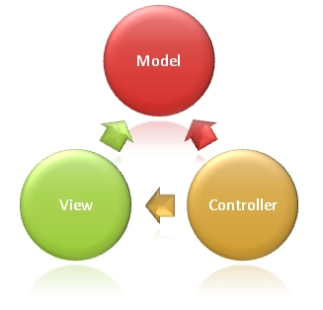

**Figure 4-1:** MVC Model

In addition to dividing the application into three kinds of components, the MVC design defines the interactions between them:

* **A controller:** can send commands to its associated view to change the view's presentation of the model (e.g., by scrolling through a document). It can also send commands to the model to update the model's state (e.g., editing a document).
* **A model:** notifies its associated views and controllers when there has been a change in its state. This notification allows the views to produce updated output, and the controllers to change the available set of commands. A *passive* implementation of MVC omits these notifications, because the application does not require them or the software platform does not support them.
* **A view:** requests from the model the information that it needs to generate an output representation to the user.

#### Advantages and disadvantages

* **Advantages:** the MVC model demonstrates professionalism in programming and design analysis. It is divided into independent components to help develop applications faster, simpler, easier upgrades and maintenance.
* **Disadvantages:** for small projects applying MVC model caused cumbersome, time consuming in development process. Time consuming to transits data between components.

#### The reason of choosing MVC model

* The first thing is that it fits the pattern of SMD systems: receive request from the user, call appropriate action, retrieve data and display on view for the user.
* Easily manage the complexity of application by dividing the application into three components: model, view and controller.
* Better support for test driven development.
* SMD system uses struts 2 framework.
* SMD system is not complete system, now. We built the system that towards extensibility and maintainability in the future.
* It is good support for application built by project team has many developers and designers but still managed application features.

### Three – tier model overview

#### What is the three – tier model

A three – tier architecture is a client-server architecture in which the functional process logic, data access, computer data storage and user interface are developed and maintained as independent modules on separate platforms. Three-tier architecture is a software design pattern and a well – established software architecture. Its three tiers are the presentation tier, application tier and data tier.

It was developed by John J. Donovan in Open Environment Corporation (OEC), a tools company he founded in Cambridge, Massachusetts.

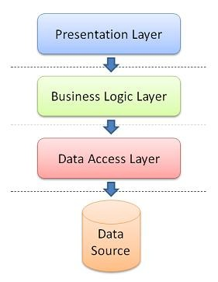

**Figure 4-2:** Three – tier model

* **Presentation Tier:** This is the topmost level of the application. The presentation tier displays information related to services. It communicates with other tiers by outputting results to the browser/client tier and all other tiers in the network. (In simple terms it's a layer which users can access directly such as a web page, or an operating systems GUI).
* **Business Logic Tier:** Also called the middle tier, logic tier or application tier, this tier is pulled from the presentation tier. It controls application functionality by performing detailed processing.
* **Data tier:** This tier consists of database servers. Here information is stored and retrieved. This tier keeps data neutral and independent from application servers or business logic. Giving data its own tier also improves scalability and performance.

#### Advantages and disadvantages

**Advantages:**

* Managing data is independent from the physical storage.
* Migration to new graphical environments is faster.
* It is possible to make changes on the presentation level without affecting the other two (business or data access layer).
* As each tier is independent it is possible to use different sets of developers.
* Since the client doesn’t have direct access to the database business logic is more secure.
* When one tier fails there is no data loss, because you are always secure by accessing the other tier.

**Disadvantages:**

* It is more complex structure.
* More difficult to set up and maintain it as well.
* The physical separation of the tiers may affect the performance between the three.
* It is more difficult to build a 3-tier application.

#### The reason of choosing three – tier model

* The SMD system is integrated by three frameworks Struts 2, Spring 3 and Hibernate 3. Struts 2 presents presentation layer, Spring presents business logic layer and Hibernate presents data access layer.
* Some modules need to reuse shared business logic layer.
* Functions on mobile are performed through webserver based on client – server model.
* Need to make the application that is easy to maintain. So, presentation can change without affecting the other two.

## Architectural Presentation

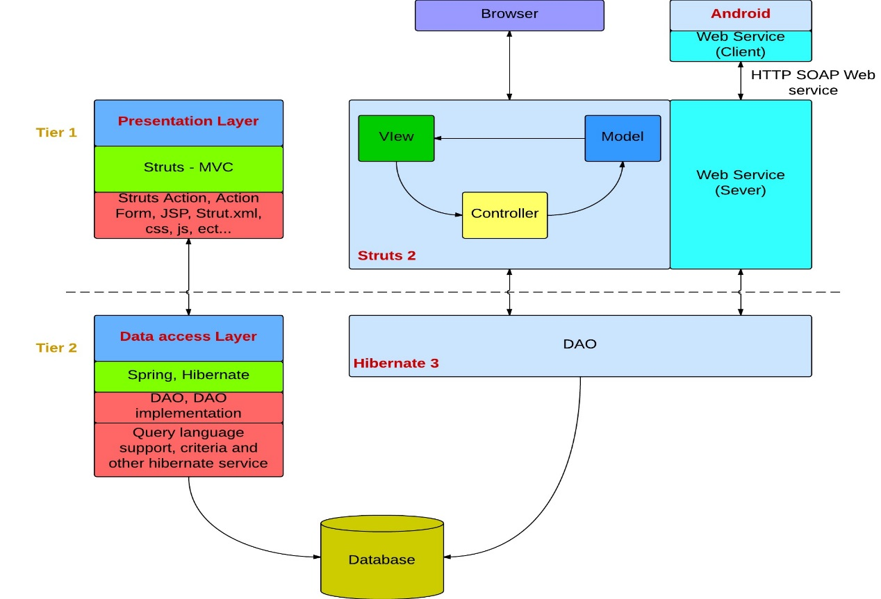

**Figure 4-3:** System overview

### Struts 2 MVC – Presentation Layer

In the overall architecture of the SMD system, struts2 acts as the presentation layer. Action Form receiving web form submission data to be processed, struts.xml is configured to call corresponding action, and then through the result to the appropriate web page.

Struts 2 Architecture is based on Web Work 2 framework. It leverages the standard JEE technologies such as Java Filters, JavaBeans, Resource Bundles, Locales, and XML etc… in its architecture. Following is its framework diagram.

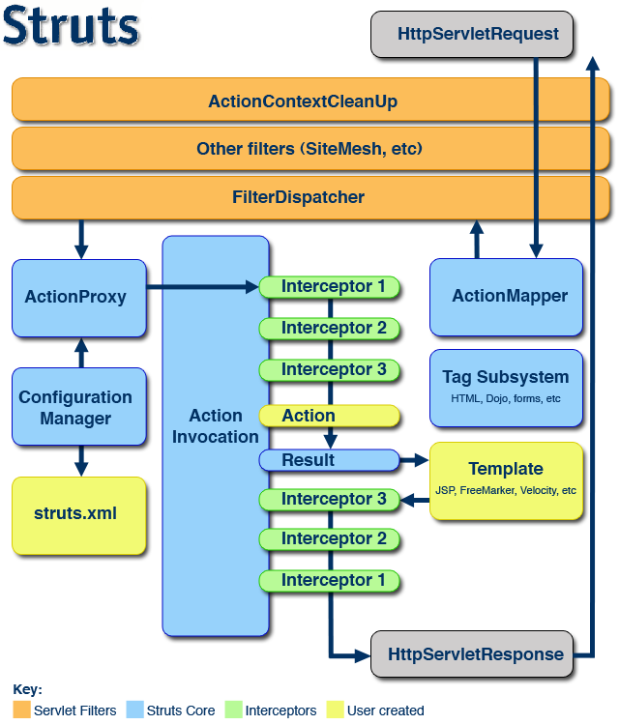

**Figure 4-4:** Struts2 architecture

**The view** in struts MVC is the user interface that is created with JSP files and does not contain any business logic. SMD user uses SMD interface (JSP files include CSS and JS, other techniques such as tilts, velocity, free maker, etc…) to submit request. The lifecycle of struts begins when the request is send from client.

**The interceptors** are responsible for most of the request processing. They are invoked by the controller before and after invoking action, thus they sit between the controller and action. Interceptors perform tasks such as Logging, Validation, File Upload, Double-submit guard etc. In SMD system, the interceptor is used to check authentication and count the number of visit time.

**The Filter Dispatcher** is configured in web.xml. It is called which consults the action mapped to determine whether an Action should be invoked.

**The Controller**‘s job is to map incoming HTTP requests to actions. Those mapping are defined by using XML-based configuration (**struts.xml**) or Java annotations. Forms and hyperlinks in the user interface that require business logic to be executed are submitted to a request URI that is mapped to an action. One instance of this class exists and receives and processes all requests that change the state of a user's interaction with the application. This component represents

**The Model** in Struts 2 is actions. Each action is defined and implemented by following the framework defined contract. Model component consist the data storage and business logic. Each action is an encapsulation of requests and is placed Value Stack.

### Spring 3 – Business Logic Layer

**Spring** is a solution to many J2EE development FAQ and powerful lightweight framework that can replace the EJB technology. The core of the Spring Framework controls flip IoC (Inversion of Control) / Dependency Injection the DI (Dependence Injection) mechanism. IoC is the relationship between the components (controlled by the container, the container is a standardized component provides a specific service and technical support runtime environment) rather than the traditional implementation of direct manipulation by the program code, this will control the right to transfer to the outer container by the program code.

**Spring responsible** for the management of the business layer in SMD system. SpringBeans.xml is used to configure database connection, Hibernate session factory, mapping resources, action beans and DAO. Spring integrates with JAX-WS standard to create Web service.

The service statistics for action call interface encapsulates the DAO persistence layer. We write some of our own business methods.

Declarative transaction management and integrated hibernate.

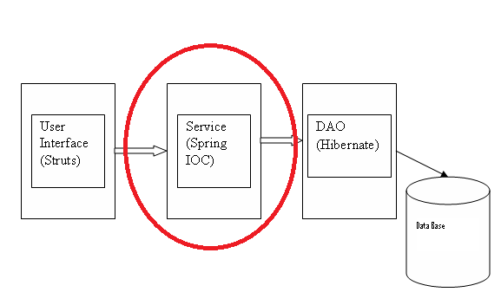

**Figure 4-5:** Spring in SSH architecture

### Hibernate – Data Access Layer

**Hibernate** is the most popular O / R mapping framework, an automatic mapping between relational database and Java objects, so that the operation of the database programmers can achieve in a very simple way.

Hibernate is responsible for the persistence layer to complete the database CRUD operations. It has a set of hbm.xml files and POJO corresponding with appearances in the database. And then define the DAO, these classes dealing with the database, they will use the PO.

Programmers to access the database needs to be done is the preparation for the persistent object xml mapping file. For example City table in MySQL is represented by City.hbm.xml file. City table has the following attributes: city name, city code, latitude, longitude, telephone area code. Then, programmer needs to create getter and setter method for all of these attributes.

The underlying database changes simply change the initial configuration file (database.properties). It not has an impact on the application.

Has its own object-oriented query language HQL in Hibernate HQL features powerful support most of the major databases, such as Oracle, DB2, MySQL, Microsoft SQL.

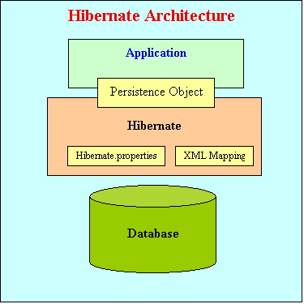

**Figure 4-6:** Hibernate architecture

Hibernate architecture has three main components:

* **Connection Management**: Hibernate Connection management service provide efficient management of the database connections. Database connection is the most expensive part of interacting with the database as it requires a lot of resources of open and close the database connection.
* **Transaction management**: Transaction management service provides the ability to the user to execute more than one database statements at a time.
* **Object relational mapping**: Object relational mapping is technique of mapping the data representation from an object model to a relational data model. This part of hibernate is used to select, insert, update and delete the records form the underlying table. When we pass an object to a Session.save() method, Hibernate reads the state of the variables of that object and executes the necessary query.

### Android – Client Side

It base on android platform with the kSOAP2 library to send/receive data from web service.

* The ksoap2-android project provides a lightweight and efficient SOAP client library.
* The ksoap2-android has been consistently enhanced and expanded with more features. It is actively maintained and we welcome bug fixes and contributions. Releases are done semi regularly with community contributions in the form of enhancements and more.

Application is not only storage and query data from server on Internet. But also, it saves data to client by SQLite

* SQLite is a relational database management system contained in a small programming library.
* In contrast to other database management systems, SQLite is not a separate process that is accessed from the client application, but an integral part of it.
* SQLite is ACID-compliant and implements most of the SQL standard, using a dynamically and weakly typed SQL syntax that does not guarantee the domain integrity.
* SQLite is a popular choice as embedded database for local/client storage in application software such as web browsers. It is arguably the most widely deployed database engine, as it is used today by several widespread browsers, operating systems, and embedded systems, among others. SQLite has many bindings to programming languages.

### Web service – Server Side

System combined JAX-WS with spring to create web service. Spring provides remoting support for web services via JAX-WS. The server and client communicate using XML to send messages or use remote procedure calls to exchange data between client and service provider. JAX-WS has many advantages to use:

* JAX-WS is typically used in conjunction with other technologies.
* JAX-WS represents remote procedure calls or messages using XML-based protocols such as SOAP, but hides Soap's innate complexity behind a Java-based API.
* The JAX-WS runtime system converts API calls and matching replies to and from SOAP messages.
* Invoking Web services asynchronously.
* The platform independence of the Java programming language.
* JAX-WS is not restrictive: a JAX-WS client can access a web service that is not running on the Java platform and vice versa.
* This flexibility is possible because JAX-WS uses technologies defined by the World Wide Web Consortium (W3C): HTTP, SOAP, and the Web Service Description Language (WSDL).
* WSDL specifies an XML format for describing a service as a set of endpoints operating on messages.

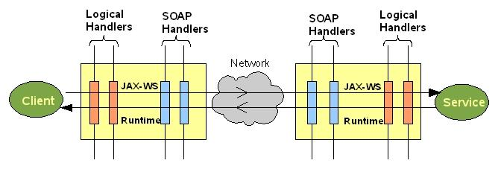

**Figure 4-7:** JAX-WS

## Component Design

### Web app Component

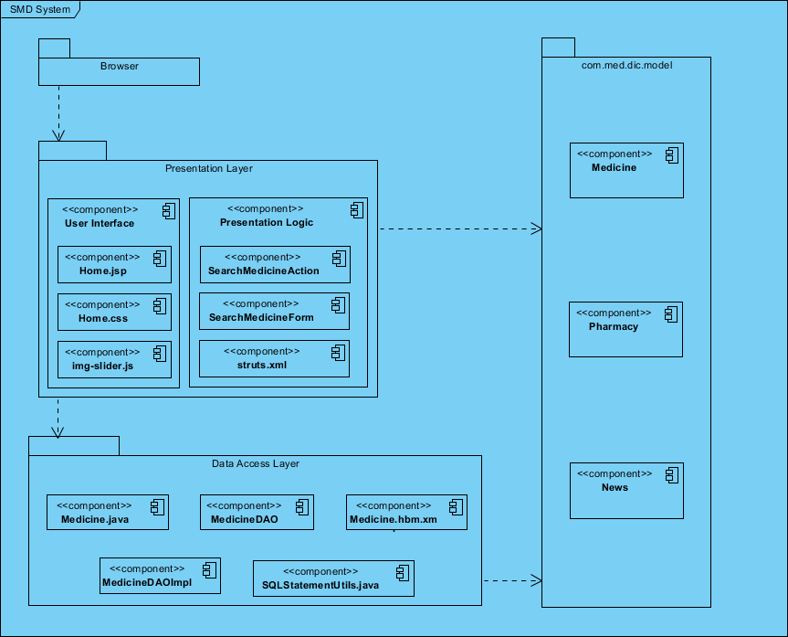

**Figure 4-8:** Web app Component Architecture

* **Browser:** We would like to mention all people who use the services of SMD on web application such as normal user, pharmacy user or administrator. Refers to report 1 to have more information about those types of users.
* **Presentation layer:** It covers the entire architecture of struts2. As mentioned in the previous section, our team used struts2 to develop presentation layer based on MVC model.
  + **User interface** is the view component in MVC model. It is expressed by combination of JSP, CSS and JS. UI is the only part visible to the users. Users can use button, link to send desired request to server.
  + **Presentation logic** contains Struts Action, Action Form, struts xml file. The struts.xml file contains the configuration information that you will be modifying as actions are developed. The action class contains business logic, retrieve resource bundle, hold the data, validation, and select the view result page that should send back to the user. It’s the heart of the Struts 2. Action Form contains getter, setter methods for all fields in view and extends from Base Action.
* **Data Access layer:**
* **Configuration:** It is represented by SpringBeans.xml. This is the actual container which instantiates, configures, and manages a number of beans. These beans typically collaborate with one another, and thus have dependencies between themselves. These dependencies are reflected in the configuration data.
* **Transaction:** Comprehensive transaction support is among the most compelling reasons to use the Spring Framework. The Spring Framework provides a consistent abstraction for transaction management. Transaction management is required to ensure the data integrity and consistency in database such as rollback, committed or timeout.
* **Hibernate session management:** Sessions are a Hibernate construct used to mediate connections with the database. The session opens a single database connection when it is created, and holds onto it until the session is closed. Every object that is loaded by Hibernate from the database is associated with the session, allowing Hibernate to automatically persist objects that are modified, and allowing Hibernate to implement functionality such as lazy-loading. The session opens a single database connection when it is created, and holds onto it until the session is closed. Every object that is loaded by Hibernate from the database is associated with the session, allowing Hibernate to automatically persist objects that are modified, and allowing Hibernate to implement functionality such as lazy-loading.
* **DAO Interface:** DAO is Data Access Object that is an object provides an abstract interface to some type of database of SMD system. Based on user’s request, appropriate DAO will be called. DAOs provide some specific data operations without exposing details of the database.
* **DAO Implementation:** This component implements above interface. This component is responsible to get data from the SMD data source.
* **Model or Value Object:** This object is simple POJO containing get/set methods to store data retrieved using DAO class.
* **HBM file:** It is Hibernate XML mapping file contains the mapping relationship between Java class and database table. This is always named “xx.hbm.xml” and declared in the “SpringBeans.xml” configuration file.

### Mobile app Component

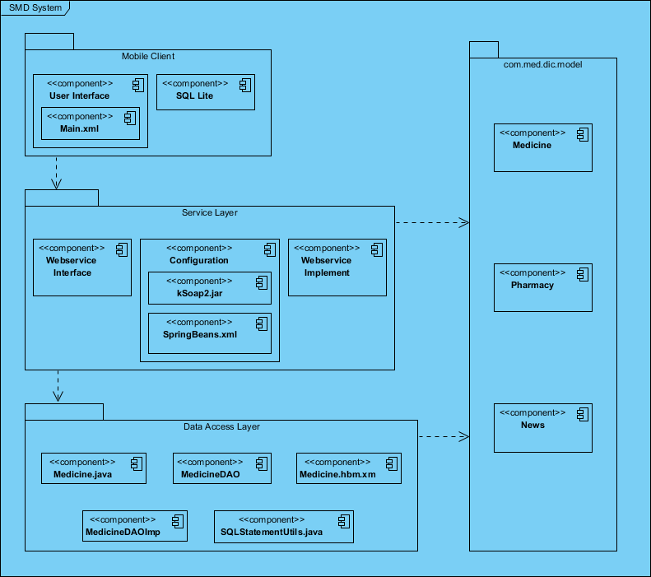

**Figure 4-9:** Hibernate architecture

* **Mobile Client:** We would like to mention all people who use the services of SMD on mobile application such as normal user. Refers to report 1 to have more information about those types of users.
* **Services layer**: web service is built based on JAX-WS standard integrated to Spring3. A web service operation invocation is represented by an XML – based protocol (**SOAP**). The SOAP specification defines the envelope structure, encoding rules, and conventions for representing web service invocations and responses. These calls and responses are transmitted as SOAP messages over HTTP.
* **SMD web service interface:** define all web method with return type, name and parameters using SOAP binding with style RPC.
* **SMD web service implementation:** implement the above SMD web service interface (end point interface refers to web service interface package). All methods in web service interface will be implemented to call appropriate action through business logic layer and retrieve data from data sources to return to clients through hibernate.
* **Technologies:** HTTP, SOAP, WSDL.

# Detailed Design

## Common Design

### Class Diagram

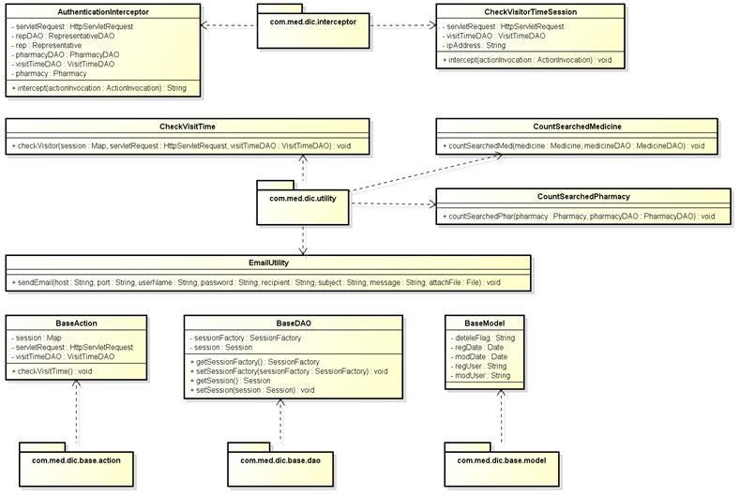

**Figure 4-10:** Class diagram- Common design

### Utilities

|  |  |
| --- | --- |
| Name | Description |
| AuthenticationInterceptor.java | Intercept the authentication illegal. |
| CheckVisitorTimeSession.java | Check the visitor’s session is lives or dies. |
| CheckVisitTime.java | Count the number of visits to website. |
| CountSearchedMedicine.java | Count the number of data queries in medicine |
| CountSearchedPharmacy.java | Count the number of data queries in pharmacy |
| EmailUtility.java | Auto sends email to user when the information changes need to confirm. |
| BaseAction.java | Build object base for all action class. |
| BaseDAO.java | Build object base for all data access object class |
| BaseModel.java | Build object contain common attributes for all object class |
| struts.properties | Define the value of parameter can override in struts.xml |
| ApplicationResources.properties | Define the name of message throw and name of label in JSP page |

## Search medicine on mobile

### Class Diagram

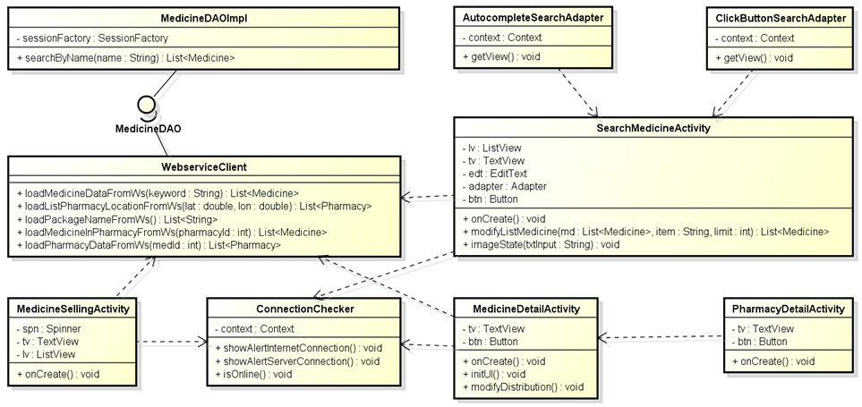

**Figure 4-11:** Class diagram- Search medicine on mobile

### Class Description

#### SearchMedicineActivity

|  |  |  |  |  |
| --- | --- | --- | --- | --- |
| Class | SearchMedicineActivity | | | |
| **Description** | Searchmedicine information | | | |
| **Base Class** | Activity | | | |
| **Constructor** | N/A | | | |
| **Prototype** | N/A | | | |
| **Source File** | SearchMedicineActivity.java | | | |
| **Namespace** | com.med.dic.search.medicine | | | |
| **Attributes** | lv, tv, edt, adapter, btn… (see Figure 4-11) | | | |
| **Methods** | Name | Input | Output | Description |
| modifyListMedicine | obj, item, limit | List<Medicine> | List medicine limited after typing medicine’s name. |
| imageState | string | Void | Modify the number of medicine display |
| onCreate |  | Void | Override from Activity extend |

#### MedicineDetailActivity

|  |  |  |  |  |
| --- | --- | --- | --- | --- |
| Class | MedicineDetailActivity | | | |
| **Description** | Show medicine information | | | |
| **Base Class** | Activity | | | |
| **Constructor** | N/A | | | |
| **Prototype** | N/A | | | |
| **Source File** | MedicineDetailActivity.java | | | |
| **Namespace** | com.med.dic.search.medicine | | | |
| **Attributes** | tv, lv… (see Figure 4-11) | | | |
| **Methods** | Name | Input | Output | Description |
| modifyDistribution |  | Void | Modify the number of distribution display. |
| onCreate |  | Void | Override from Activity extend |
| initUI |  | Void | Get view of component |

#### MedicineSellingActivity

|  |  |  |  |  |
| --- | --- | --- | --- | --- |
| Class | MedicineSellingActivity | | | |
| **Description** | Medicines are selling on pharmacy | | | |
| **Base Class** | Activity | | | |
| **Constructor** | N/A | | | |
| **Prototype** | N/A | | | |
| **Source File** | MedicineSellingActivity.java | | | |
| **Namespace** | com.med.dic.search.medicine | | | |
| **Attributes** | spn, tv, btn… (see Figure 4-11) | | | |
| **Methods** | Name | Input | Output | Description |
| onCreate |  | Void | Override from Activity extend |

#### PharmacyDetailActivity

|  |  |  |  |  |
| --- | --- | --- | --- | --- |
| Class | PharmacyDetailActivity | | | |
| **Description** | Pharmacy detail information | | | |
| **Base Class** | Activity | | | |
| **Constructor** | N/A | | | |
| **Prototype** | N/A | | | |
| **Source File** | PharmacyDetailActivity.java | | | |
| **Namespace** | com.med.dic.search.medicine | | | |
| **Attributes** | tv, btn… (see Figure 4-11) | | | |
| **Methods** | Name | Input | Output | Description |
| onCreate |  | Void | Override from Activity extend |

#### ClickButtonSearchAdapter

|  |  |  |  |  |
| --- | --- | --- | --- | --- |
| Class | ClickButtonSearchAdapter | | | |
| **Description** | Display the listview on mobile screen | | | |
| **Base Class** | ArrayAdapter | | | |
| **Constructor** | N/A | | | |
| **Prototype** | N/A | | | |
| **Source File** | ClickButtonSearchAdapter.java | | | |
| **Namespace** | com.med.dic.search.medicine | | | |
| **Attributes** | Context… (see Figure 4-11) | | | |
| **Methods** | Name | Input | Output | Description |
| getView | N/A | N/A | Customize item shows on view. |

#### AutocompleteSearchAdapter

|  |  |  |  |  |
| --- | --- | --- | --- | --- |
| Class | AutocompleteSearchAdapter | | | |
| **Description** | Display the listview on mobile screen | | | |
| **Base Class** | ArrayAdapter | | | |
| **Constructor** | N/A | | | |
| **Prototype** | N/A | | | |
| **Source File** | AutocompleteSearchAdapter.java | | | |
| **Namespace** | com.med.dic.search.medicine | | | |
| **Attributes** | Context… (see Figure 4-11) | | | |
| **Methods** | Name | Input | Output | Description |
| getView | N/A | N/A | Customize item shows on view. |

#### SMDWebService

|  |  |  |  |  |
| --- | --- | --- | --- | --- |
| Class | SMDWebService | | | |
| **Description** | Load data from Database server using SOAP | | | |
| **Base Class** | N/A | | | |
| **Constructor** | N/A | | | |
| **Prototype** | N/A | | | |
| **Source File** | SMDWebService.java | | | |
| **Namespace** | com.med.dic | | | |
| **Attributes** | N/A | | | |
| **Methods** | Name | Input | Output | Description |
| loadPharmacyDataFromWS | Id | List<Pharmacy> | Load list Pharmacy from database by web service |
| loadMedicinesInPharmacyFromWS | Id | List<Medicine> | Load list medicines from database by web service |
| loadMedicinesDataFromWS | Id | List<Medicine> | Load list medicines from database by web service |

#### MedicineDAOImpl

|  |  |  |  |  |
| --- | --- | --- | --- | --- |
| Class | MedicineDAOImpl | | | |
| **Description** | Implement MedicineDAOInterface | | | |
| **Base Class** | N/A | | | |
| **Constructor** | N/A | | | |
| **Prototype** | N/A | | | |
| **Source File** | MedicineDAOImpl.java | | | |
| **Namespace** | com.med.dic.dao.impl | | | |
| **Attributes** | sessionFactory (see figure 4-11) | | | |
| **Methods** | Name | Input | Output | Description |
|  | searchMedicineByName | Name | Void | Search medicine by name execute |

#### ConnectionChecker

|  |  |  |  |  |
| --- | --- | --- | --- | --- |
| Class | ConnectionChecker | | | |
| **Description** | Check internet connection | | | |
| **Base Class** | N/A | | | |
| **Constructor** | N/A | | | |
| **Prototype** | N/A | | | |
| **Source File** | ConnectionChecker.java | | | |
| **Namespace** | com.med.dic | | | |
| **Attributes** | N/A | | | |
| **Methods** | Name | Input | Output | Description |
| showAlertInternetConnecttion | id | Void | Display message when connection fail |
| showAlertServerConnection |  | Void | Display message when connection fail |
| isOnline |  | boolean | Check connection status |

### UC001-Search Medicine Home on Mobile

#### Screen Design

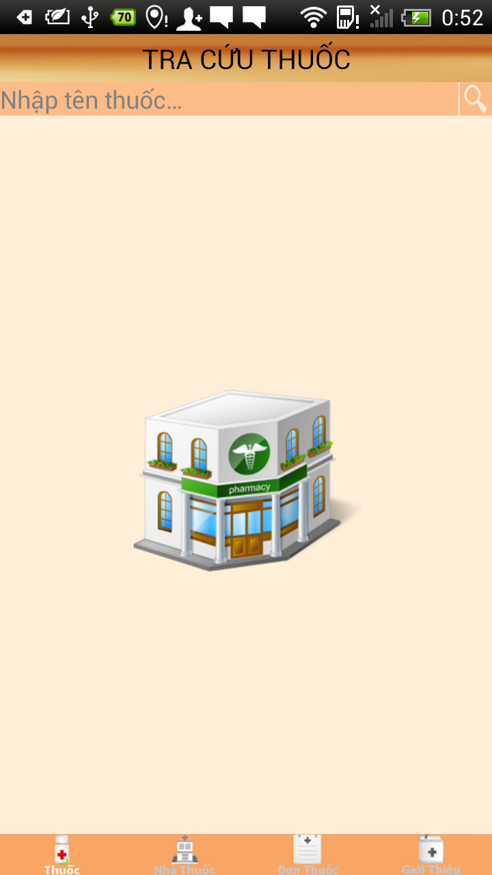

**Figure 4-12:** Search medicine home

**Table 4-1:** Search medicine home

|  |  |  |  |  |  |  |
| --- | --- | --- | --- | --- | --- | --- |
| **No** | **Object/ Control Name** | **Object/ Control Name in English** | **Type** | **Required** | **Length** | **Description** |
| 1 | Nhập tên thuốc | Medicine input | EditText (autocomplete) | N | 50 | Search bar with text hint |
| 2 | Tra cứu thuốc | Search medicine | TextView | N | N/A | Search medicine title bar |
| 3 | Tìm kiếm | Search | Button | Y | N/A | Search button for medicine |
| 4 | Quảng cáo | Advertise | Image | N | N/A | Advertising on first screen |

#### Sequence Diagram

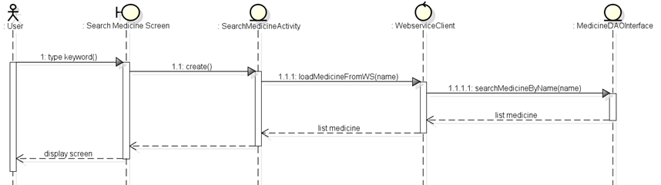

**Figure 4-13:** Sequence diagram- Search medicine on mobile

### UC002 - Medicine Detail on Mobile

#### Screen Design

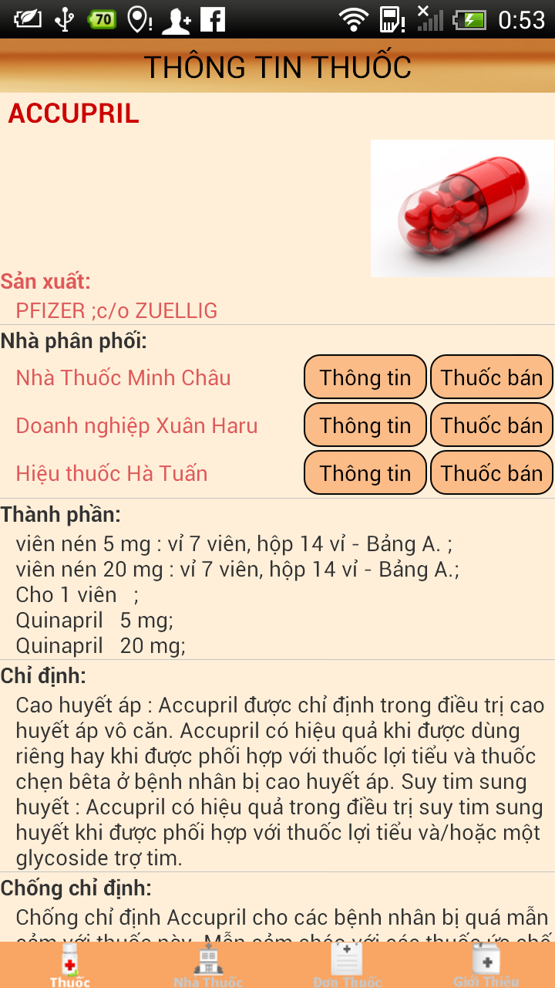

**Figure 4-14:** Medicine detail on mobile

**Table 4-2:** Medicine detail on mobile

|  |  |  |  |  |  |  |
| --- | --- | --- | --- | --- | --- | --- |
| **No** | **Object/ Control Name** | **Object/ Control Name in English** | **Type** | **Required** | **Length** | **Description** |
| 1 | Thông tin thuốc | Medicine information | TextView | Y | N/A | Medicine detail title bar |
| 2 | Ảnh thuốc | Medicine image | Image | Y | N/A | Medicine’s image |
| 3 | Sản xuất | Manufacture | TextView | Y | N/A | Medicine’s manufacture |
| 4 | Nhà phân phối | Distribution | TextView | Y | N/A | Medicine’s distribution |
| 5 | Thành phần | Ingredient | TextView | Y | N/A | Medicine’s ingredient |
| 6 | Chỉ định | Indication | TextView | Y | N/A | Medicine’s indication |
| 7 | Chống chỉ định | Contraindication | TextView | Y | N/A | Medicine’s contraindication |
| 8 | Liều lượng và cách dung | Dosing and use | TextView | Y | N/A | Medicine’s dosing and use |
| 9 | Dạng bao gói | Type of package | TextView | Y | N/A | Medicine’s type |
| 10 | Cảnh báo | Warning | TextView | Y | N/A | Medicine’s warning |
| 11 | Bảo quản | Storage | TextView | Y | N/A | Medicine’s storage |
| 12 | Tương tác | Interaction | TextView | Y | N/A | Medicine’s interaction |

#### Sequence Diagram

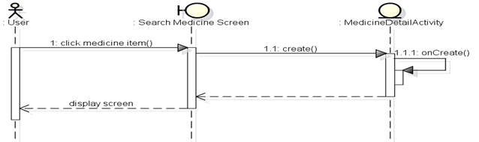

**Figure 4-15:** Sequence diagram- detail medicine on mobile

### UC003 – Pharmacy Detail on Mobile

#### Screen Design

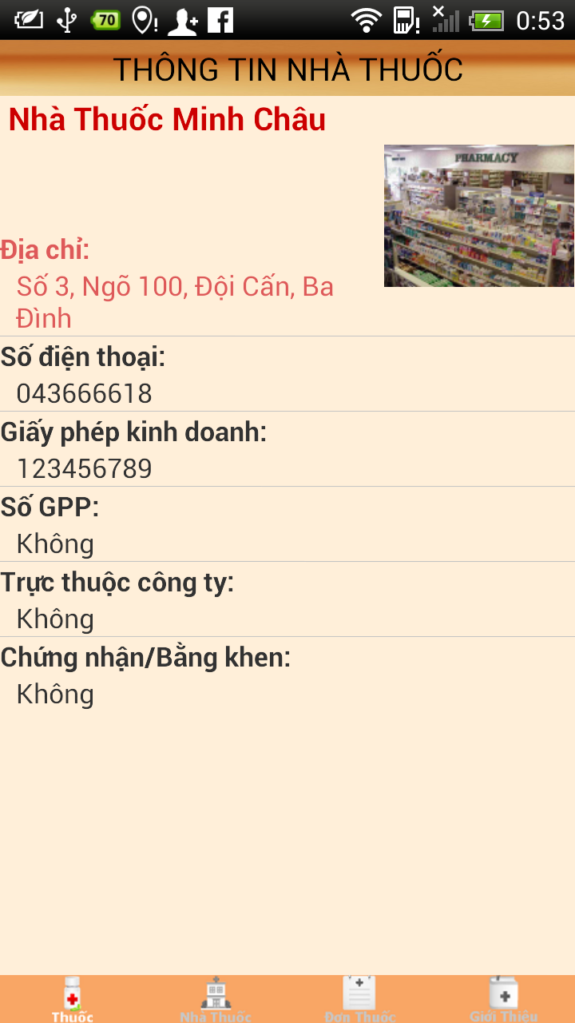

**Figure 4-16:** Pharmacy detail on mobile

**Table 4-3:** Pharmacy detail on mobile

|  |  |  |  |  |  |  |
| --- | --- | --- | --- | --- | --- | --- |
| **No** | **Object/ Control Name** | **Object/ Control Name in English** | **Type** | **Required** | **Length** | **Description** |
| 1 | Thông tin nhà thuốc | Pharmacy information | TextView | Y | N/A | Pharmacy detail title bar |
| 2 | Ảnh nhà thuốc | Pharmacy image | Image | Y | N/A | Pharmacy’s image |
| 3 | Địa chỉ | Address | TextView | Y | N/A | Pharmacy’s address |
| 4 | Số điện thoại | Phone number | TextView | Y | N/A | Pharmacy’s phone number |
| 5 | Giấy phép kinh doanh | Business license | TextView | Y | N/A | Pharmacy’s business license |
| 6 | Số GPP | GPP no | TextView | Y | N/A | Pharmacy’s GPP no |
| 7 | Trực thuộc công ty | Pharmaceutical company | TextView | Y | N/A | Pharmacy’s group |
| 8 | Chứng nhận /Bằng khen | Notes | TextView | Y | N/A | Pharmacy’s notes |
| 9 | Vị trí | Location | TextView | Y | N/A | Pharmacy’s location |

#### Sequence diagram

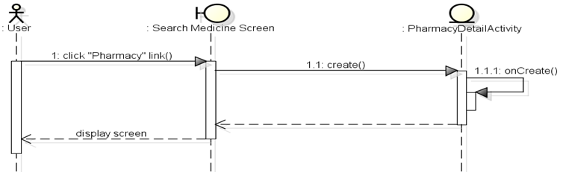

**Figure 4-17:** Sequence diagram- Pharmacy detail on mobile

### UC004 – Medicine Selling on Mobile

#### Screen Design

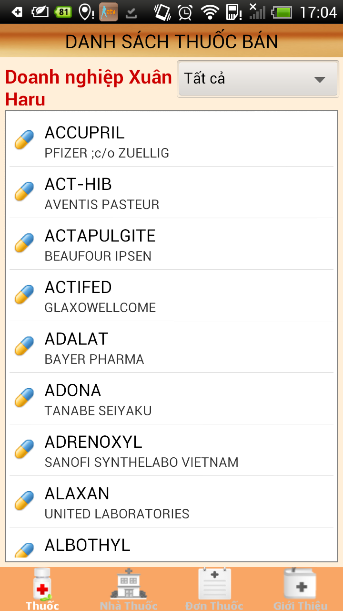

**Figure 4-18:** Medicine selling

**Table 4-4:** Medicine selling

|  |  |  |  |  |  |  |
| --- | --- | --- | --- | --- | --- | --- |
| **No** | **Object/ Control Name** | **Object/ Control Name in English** | **Type** | **Required** | **Length** | **Description** |
| 1 | Danh sách thuốc bán | Medicine selling on pharmacy | TextView | Y | N/A | Medicine selling title bar |
| 2 | Tên nhà thuốc | Pharmacy name | TextView | Y | N/A | Pharmacy’s name |
| 3 | Dạng bao gói | Type of package | Spinner | Y | N/A | Pharmacy’s type |
| 4 | Danh sách thuốc | Medicine list | ListView | Y | N/A | Medicine on pharmacy |

#### Sequence Diagram

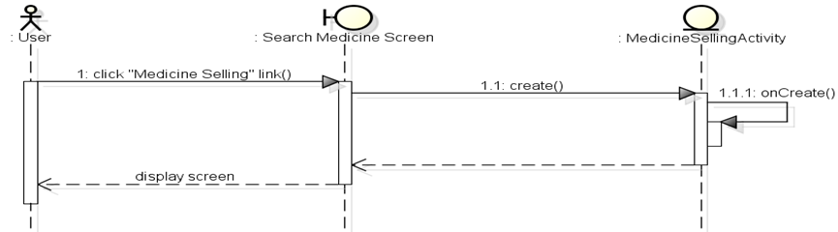

**Figure 4-19:** Sequence diagram- Medicine selling

## UC005 - Find the nearest pharmacy on mobile

### Class Diagram

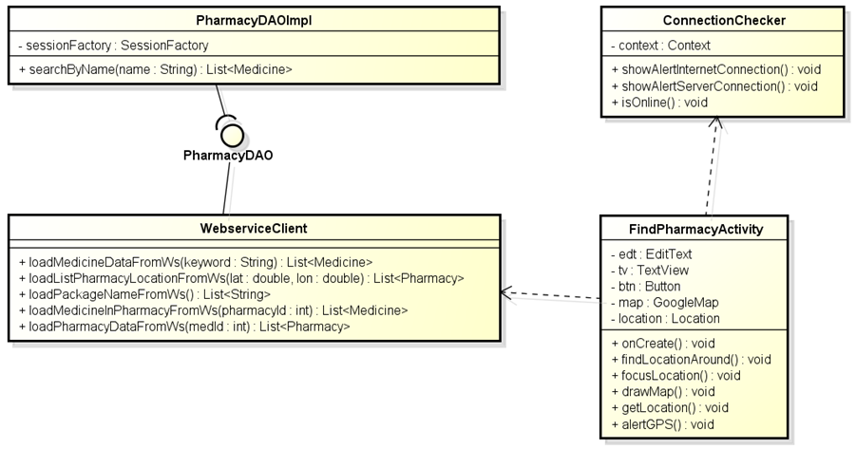

**Figure 4-20:** Class diagram- Find pharmacy on mobile

### Class Desciption

#### FindPharmacyActivity

|  |  |  |  |  |
| --- | --- | --- | --- | --- |
| Class | FindPharmacyActivity | | | |
| **Description** | Display the pharmacy location on map | | | |
| **Base Class** | Fragment Activity | | | |
| **Constructor** | N/A | | | |
| **Prototype** | N/A | | | |
| **Source File** | FindPharmacyActivity.java | | | |
| **Namespace** | com.med.dic.find.pharmacy | | | |
| **Attributes** | edt, tv, btn, map, location… (see Figure 4-20) | | | |
| **Methods** | Name | Input | Output | Description |
| findLocationAround | Latitude, longitude, address | Void | Find pharmacy around the location |
| drawMap | N/A | Void | Draw line between the location and pharmacy location |
| getLocation | N/A | Void | Get current location using GPS or location Manager |
| focusLoaction | Latitude, longitude, address | Void | Zoom camera to the location |

#### SMDWebService

|  |  |  |  |  |
| --- | --- | --- | --- | --- |
| Class | SMDWebService | | | |
| **Description** | Load data from Database using SOAP | | | |
| **Base Class** | N/A | | | |
| **Constructor** | N/A | | | |
| **Prototype** | N/A | | | |
| **Source File** | SMDWebService.java | | | |
| **Namespace** | com.med.dic | | | |
| **Attributes** | N/A | | | |
| **Methods** | Name | Input | Output | Description |
| loadListPharmacyLocationFromWS | Latitude, longitude, address | List<Pharmacy> | Load list medicines from database by web service |

#### PharmacyDAOImpl

|  |  |  |  |  |
| --- | --- | --- | --- | --- |
| Class | PharmacyDAOImpl | | | |
| **Description** | Implement PharmacyDAOInterface | | | |
| **Base Class** | N/A | | | |
| **Constructor** | N/A | | | |
| **Prototype** | N/A | | | |
| **Source File** | PharmacyDAOImpl.java | | | |
| **Namespace** | com.med.dic.dao.impl | | | |
| **Attributes** | sessionFactory… (see Figure 4-20) | | | |
| **Methods** | Name | Input | Output | Description |
|  | searchListPharmacyLocation | latitude, longitude | List<Pharmacy> | Search pharmacy by location execute |

#### ConnectionChecker

|  |  |  |  |  |
| --- | --- | --- | --- | --- |
| Class | ConnectionChecker | | | |
| **Description** | Check internet connection | | | |
| **Base Class** | N/A | | | |
| **Constructor** | N/A | | | |
| **Prototype** | N/A | | | |
| **Source File** | ConnectionChecker.java | | | |
| **Namespace** | com.med.dic | | | |
| **Attributes** | N/A | | | |
| **Methods** | Name | Input | Output | Description |
| showAlertInternetConnecttion | id | Void | Display message when connection fail |
| showAlertServerConnection |  | Void | Display message when connection fail |
| isOnline |  | boolean | Check connection status |

### Screen Design

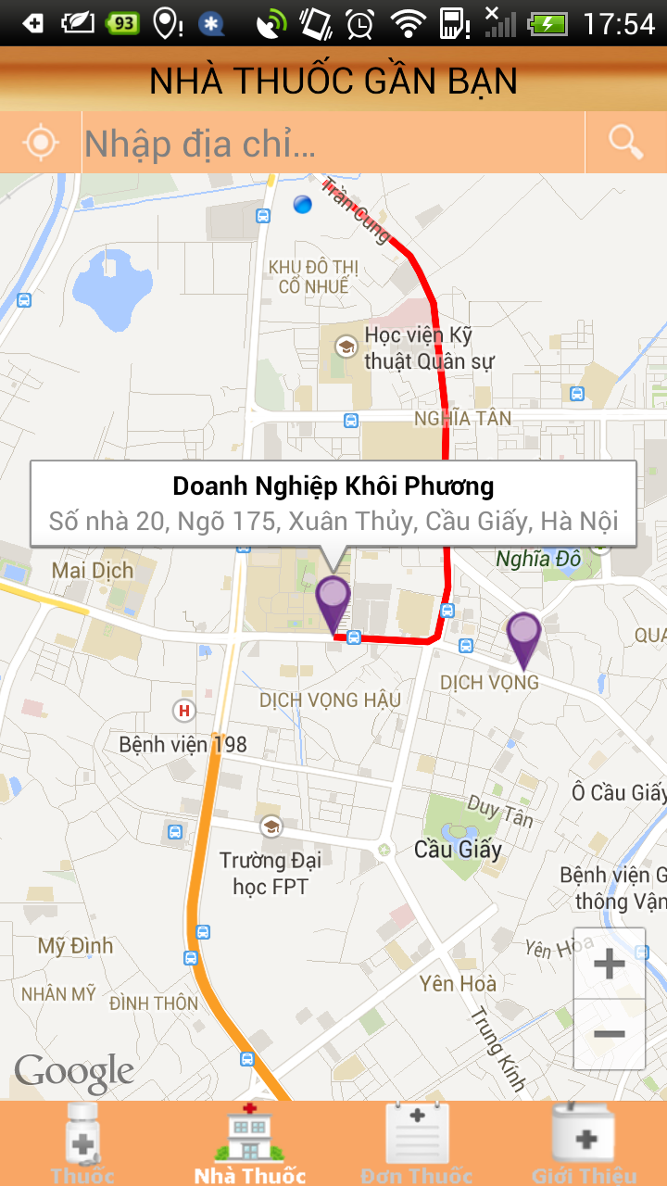

**Figure 4-21:** Find the nearest pharmacy on mobile

**Table 4-5:** Find the nearest pharmacy on mobile

|  |  |  |  |  |  |  |
| --- | --- | --- | --- | --- | --- | --- |
| **No** | **Object/ Control Name** | **Object/ Control Name in English** | **Type** | **Required** | **Length** | **Description** |
| 1 | Nhà thuốc gần bạn | Nearest pharmacy | TextView | Y | N/A | Nearest pharmacy title bar |
| 2 | Nhập địa chỉ | Address input | TextView | Y | 100 | User input address |
| 3 | Tìm kiếm | Search | Button | Y | N/A | Search button for pharmacy |
| 4 | Vị trí của tôi | My location | Button | Y | N/A | Show the current location |

### Sequence Diagram

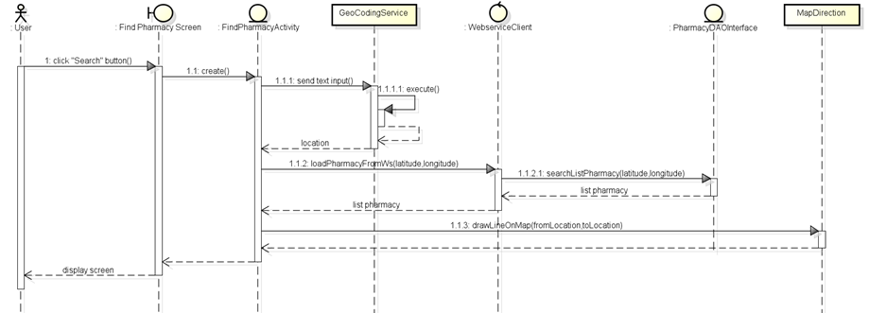

**Figure 4-22:** Sequence diagram- Find the nearest pharmacy on mobile.

## UC006 – Medical Usage Diary

### Class Diagram

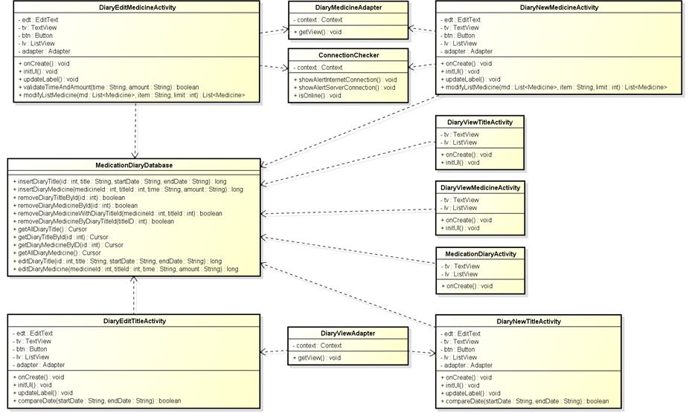

**Figure 4-23:** Class diagram- Medical usage diary

### Class Description

#### MedicationDiaryActivity

|  |  |  |  |  |
| --- | --- | --- | --- | --- |
| Class | MedicationDiaryActivity | | | |
| **Description** | Medication diary with diary’s title. | | | |
| **Base Class** | Activity | | | |
| **Constructor** | N/A | | | |
| **Prototype** | N/A | | | |
| **Source File** | MedicationDiaryActivity.java | | | |
| **Namespace** | com.med.dic.diary.using | | | |
| **Attributes** | tv, lv… (see Figure 4-22) | | | |
| **Methods** | Name | Input | Output | Description |
| findLocationAround | N/A | void | Find pharmacy around the location |

#### DiaryEditTitleActivity, DiaryNewTitleActivity

|  |  |  |  |  |
| --- | --- | --- | --- | --- |
| Class | DiaryEditTitleActivity, DiaryNewTitleActivity | | | |
| **Description** | Medication diary edits and adds new diary’s title. | | | |
| **Base Class** | Activity | | | |
| **Constructor** | N/A | | | |
| **Prototype** | N/A | | | |
| **Source File** | DiaryEditTitleActivity.java, DiaryNewTitleActivity.java | | | |
| **Namespace** | com.med.dic.diary.using | | | |
| **Attributes** | edt, tv, btn, lv, adapter… (see Figure 4-23) | | | |
| **Methods** | Name | Input | Output | Description |
| updateLabel | N/A | void | Convert time to string on label |
| compareDate | Start, end | boolean | Compare between time start and time end. |

#### DiaryEditMedicineActivity, DiaryNewMedicineActivity

|  |  |  |  |  |
| --- | --- | --- | --- | --- |
| Class | DiaryEditMedicineActivity , DiaryNewMedicineActivity | | | |
| **Description** | Medication diary edits and adds new medicine | | | |
| **Base Class** | N/A | | | |
| **Constructor** | N/A | | | |
| **Prototype** | N/A | | | |
| **Source File** | DiaryEditMedicineActivity.java, DiaryNewMedicineActivity.java | | | |
| **Namespace** | com.med.dic.diary.using | | | |
| **Attributes** | edt, tv, lv, btn, adapter… (see Figure 4-23) | | | |
| **Methods** | Name | Input | Output | Description |
| modifyListMedicine | obj, item, limit | List<Medicine> | Modify the number of medicine display |
| validateTimeAndAmount | time, amount | boolean | Validate time and mount of diary medicine |
| updateLabel | N/A | void | Convert time to string on label |

#### DiaryMedicineAdapter, DiaryTitleAdapter

|  |  |  |  |  |
| --- | --- | --- | --- | --- |
| Class | DiaryMedicineAdapter, DiaryTitleAdapter | | | |
| **Description** | Adapter to customize the diary’s title result display on screen | | | |
| **Base Class** | ArrayAdapter | | | |
| **Constructor** | N/A | | | |
| **Prototype** | N/A | | | |
| **Source File** | DiaryMedicineAdapter.java, DiaryTitleAdapter | | | |
| **Namespace** | com.med.dic.diary.using | | | |
| **Attributes** | context … (see Figure 4-23) | | | |
| **Methods** | Name | Input | Output | Description |
| getView | N/A | void | Customize item shows on view |

#### DiaryViewMedicineActivity, DiaryViewTitleActivity

|  |  |  |  |  |
| --- | --- | --- | --- | --- |
| Class | DiaryViewMedicineActivity, DiaryViewTitleActivity | | | |
| **Description** | Adapter to customize the diary’s medicine result display on screen | | | |
| **Base Class** | ArrayAdapter | | | |
| **Constructor** | N/A | | | |
| **Prototype** | N/A | | | |
| **Source File** | DiaryViewMedicineActivity.java, DiaryViewTitleActivity.java | | | |
| **Namespace** | com.med.dic.diary.using | | | |
| **Attributes** | tv, lv… (see Figure 4-23) | | | |
| **Methods** | Name | Input | Output | Description |
| N/A | N/A | N/A | N/A |

#### ConnectionChecker

|  |  |  |  |  |
| --- | --- | --- | --- | --- |
| Class | ConnectionChecker | | | |
| **Description** | Check internet connection | | | |
| **Base Class** | N/A | | | |
| **Constructor** | N/A | | | |
| **Prototype** | N/A | | | |
| **Source File** | ConnectionChecker.java | | | |
| **Namespace** | com.med.dic | | | |
| **Attributes** | N/A | | | |
| **Methods** | Name | Input | Output | Description |
| showAlertInternetConnecttion | id | Void | Display message when connection fail |
| showAlertServerConnection |  | Void | Display message when connection fail |
| isOnline |  | boolean | Check connection status |

### Screen design

#### Medication Diary

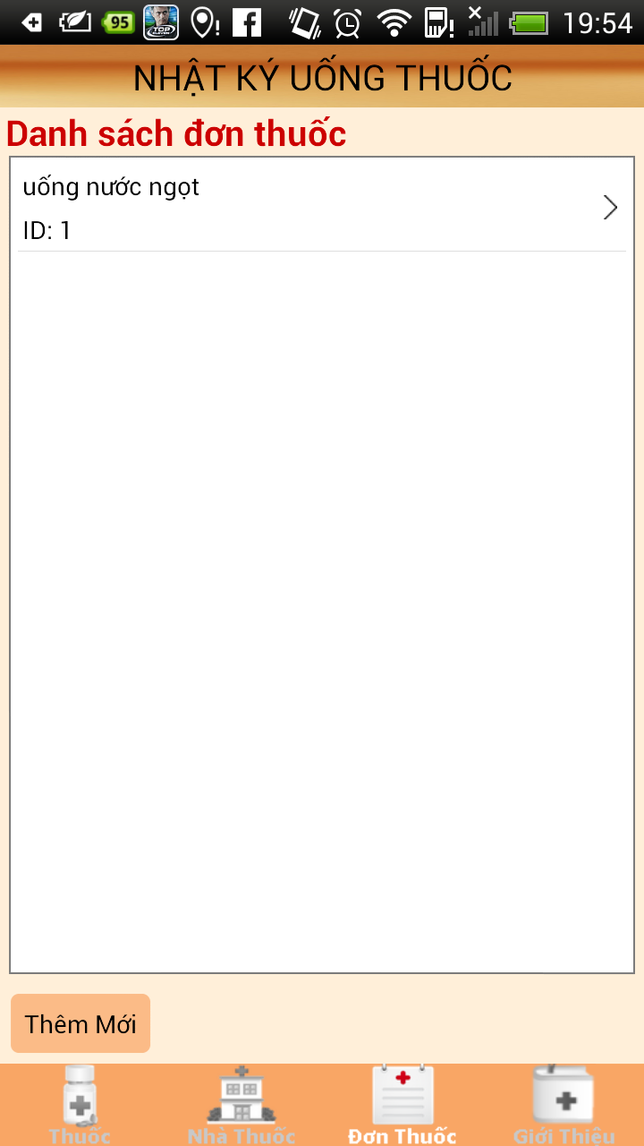

**Figure 4-24:** Medicine diary

**Table4-6:** Medicine diary

|  |  |  |  |  |  |  |
| --- | --- | --- | --- | --- | --- | --- |
| **No** | **Object/ Control Name** | **Object/ Control Name in English** | **Type** | **Required** | **Length** | **Description** |
| 1 | Nhật ký uống thuốc | Medicine usage diary | TextView | Y | N/A | Medicine usage diary title bar |
| 2 | Danh sách đơn thuốc | List prescription | TextView | Y | N/A | List prescription in diary |
| 3 | Thêm mới | Add new | Button | Y | N/A | Add new for diary |

#### Diary Title

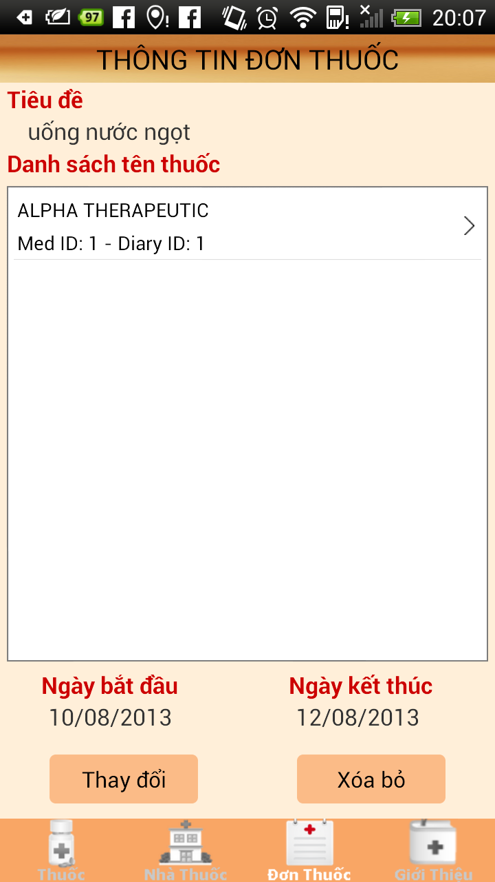

**Figure 4-25:** Diary title

**Table 4-7:** Diary title

|  |  |  |  |  |  |  |
| --- | --- | --- | --- | --- | --- | --- |
| **No** | **Object/ Control Name** | **Object/ Control Name in English** | **Type** | **Required** | **Length** | **Description** |
| 1 | Thông tin đơn thuốc | Prescription information | TextView | Y | N/A | Prescription information title bar |
| 2 | Tiêu đề | Title | TextView | Y | 100 | Title for diary |
| 3 | Danh sách tên thuốc | List medicine’s name | TextView | Y | N/A | List medicine’s name in diary |
| 4 | Ngày bắt đầu | Date start | TextView | Y | N/A | Start date for diary |
| 5 | Ngày kết thúc | Date end | TextView | Y | N/A | End date for diary |
| 6 | Thay đổi | Edit | Button | Y | N/A | Edit diary title |
| 7 | Xóa bỏ | Delete | Button | Y | N/A | Delete diary title |

#### Diary Medicine

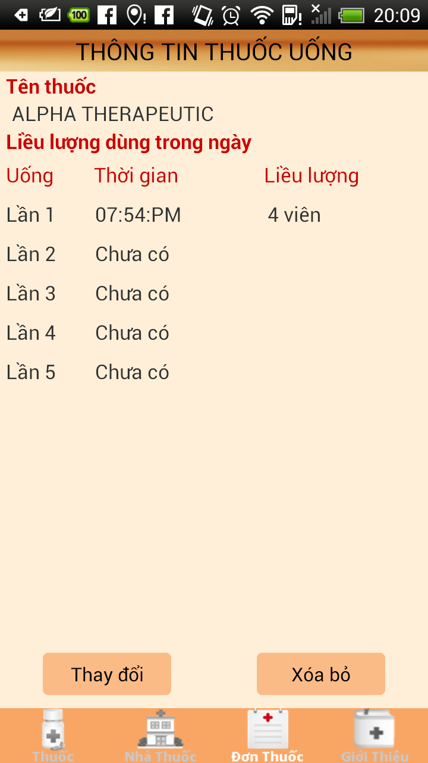

**Figure 4-26:** Diary medicine

**Table 4-8:** Diary medicine

|  |  |  |  |  |  |  |
| --- | --- | --- | --- | --- | --- | --- |
| **No** | **Object/ Control Name** | **Object/ Control Name in English** | **Type** | **Required** | **Length** | **Description** |
| 1 | Thông tin thuốc uống | Medicine usage information | TextView | Y | N/A | Medicine usage information title bar |
| 2 | Tên thuốc | Medicine name | TextView | Y | N/A | Medicine name for diary |
| 3 | Liều lượng dung trong ngày | Dosing on day | TextView | Y | N/A | Dosing for diary on day |
| 4 | Uống | Drink | TextView | Y | N/A | Drink for diary |
| 5 | Thời gian | Time | TextView | Y | N/A | Time for diary |
| 6 | Liều lượng | Dosing | TextView | Y | N/A | Dosing for diary |
| 7 | Thay đổi | Edit | Button | Y | N/A | Edit diary medicine |
| 8 | Xóa bỏ | Delete | Button | Y | N/A | Delete diary medicine |

### Sequence Diagram

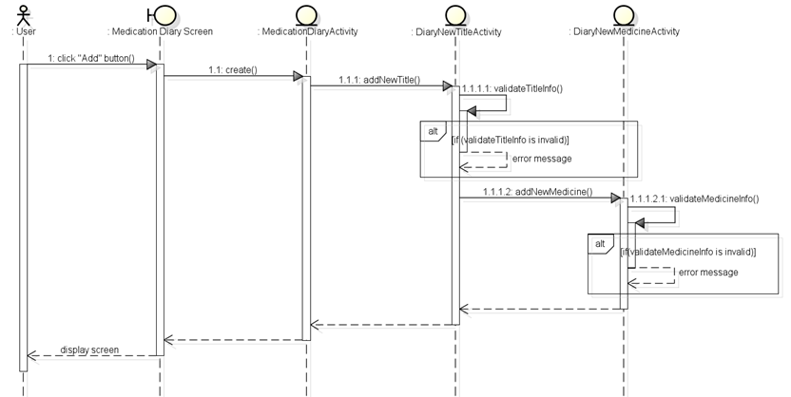

**Figure 4-27:** Sequence diagram- Medical usage diary

## UC 007 – Find Nearest Pharmacy (web version)

### Class Diagram

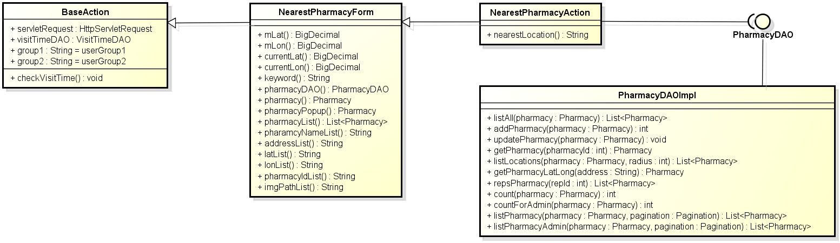

**Figure 4-28:** Class diagram- Find nearest pharmacy (web version)

### Class Description

#### NearestPharmacyForm

|  |  |  |  |  |
| --- | --- | --- | --- | --- |
| Class | NearestPharmacyForm | | | |
| **Description** | Contains declare and constructor for all NearestPharmacyAction’s attributes. | | | |
| **Base Class** | BaseAction | | | |
| **Constructor** | N/A | | | |
| **Prototype** | N/A | | | |
| **Source File** | NearestPharmacyForm.java | | | |
| **Namespace** | com.med.dic.form | | | |
| A**ttributes** | mLat, mLong… (see Figure 4-28) | | | |
| **Methods** | Name | Input | Output | Description |
| N/A | N/A | N/A | N/A |

#### NearestPharmacyAction

|  |  |  |  |  |
| --- | --- | --- | --- | --- |
| Class | NearestPharmacyAction | | | |
| **Description** | Contains nearest pharmacy methods. | | | |
| **Base Class** | NearestPharmacyForm | | | |
| **Constructor** | N/A | | | |
| **Prototype** | N/A | | | |
| **Source File** | NearestPharmacyAction.java | | | |
| **Namespace** | com.med.dic.action | | | |
| A**ttributes** | N/A | | | |
| **Methods** | Name | Input | Output | Description |
| nearestLocation | N/A | String | Methods search nearest pharmacy location. |

#### PharmacyDAOImpl

|  |  |  |  |  |
| --- | --- | --- | --- | --- |
| Class | PharmacyDAOImpl | | | |
| **Description** | Implement all PharmacyDAO interface’s methods. | | | |
| **Base Class** | N/A | | | |
| **Constructor** | N/A | | | |
| **Prototype** | N/A | | | |
| **Source File** | PharmacyDAOImpl.java | | | |
| **Namespace** | com.med.dic.dao.impl | | | |
| A**ttributes** | N/A | | | |
| **Methods** | Name | Input | Output | Description |
| listLocation | Pharmacy, radius | List<Pharmacy> | Methods list pharmacy by keywords. |

### Screen Design

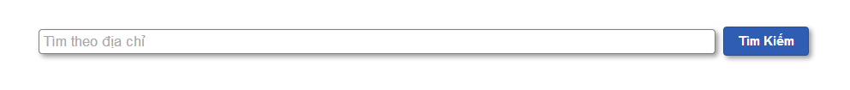

**Figure 4-29:** Find nearest pharmacy (web version)

**Table 4-9:**Find nearest pharmacy (web version)

|  |  |  |  |  |  |  |
| --- | --- | --- | --- | --- | --- | --- |
| No | **Object/Control Name** | **Object/Control Name in English** | **Type** | **Required** | **Length** | **Description** |
| 1 | Địa chỉ nhà thuốc | Pharmacy address | Text width auto complete | N | 300 | Keywords user use to search pharmacy |
| 2 | Tìm kiếm | Search | Button | Y | N/A | Start search pharmacy inside system |

### Sequence Diagram

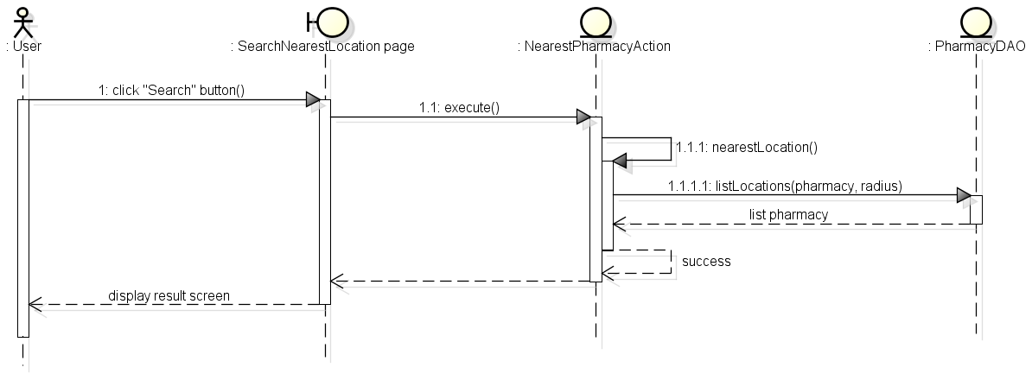

**Figure 4-30:** Sequence diagram- Find nearest pharmacy (web version)

## UC 008 – Register

### Class Diagram

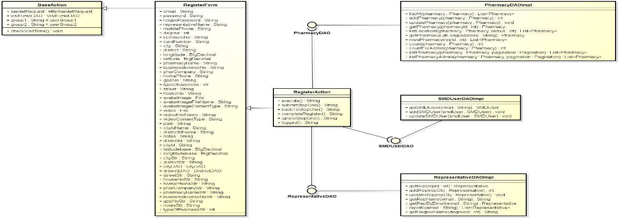

**Figure 4-31:** Class diagram- Register

### Class Description

#### RegisterForm

|  |  |  |  |  |
| --- | --- | --- | --- | --- |
| Class | RegisterForm | | | |
| **Description** | Contains declare and constructor for all RegisterAction’s attributes. | | | |
| **Base Class** | BaseAction | | | |
| **Constructor** | N/A | | | |
| **Prototype** | N/A | | | |
| **Source File** | RegisterForm.java | | | |
| **Namespace** | com.med.dic.form | | | |
| A**ttributes** | email,password… (see Figure 4-30) | | | |
| **Methods** | Name | Input | Output | Description |
| N/A | N/A | N/A | N/A |

#### RegisterAction

|  |  |  |  |  |
| --- | --- | --- | --- | --- |
| Class | RegisterAction | | | |
| **Description** | Contains register methods. | | | |
| **Base Class** | RegisterForm | | | |
| **Constructor** | N/A | | | |
| **Prototype** | N/A | | | |
| **Source File** | RegisterAction.java | | | |
| **Namespace** | com.med.dic.action | | | |
| A**ttributes** | N/A | | | |
| **Methods** | Name | Input | Output | Description |
| validate | N/A | boolean | Validate input keywords. |
| submitStepOne | N/A | String | Methods submit step1 register. |
| completeRegister | N/A | String | Methods complete registation. |

#### SMDUserDAOImpl

|  |  |  |  |  |
| --- | --- | --- | --- | --- |
| Class | SMDUserDAOImpl | | | |
| **Description** | Implement all SMDUserDAO interface’s methods. | | | |
| **Base Class** | N/A | | | |
| **Constructor** | N/A | | | |
| **Prototype** | N/A | | | |
| **Source File** | SMDUserDAOImpl.java | | | |
| **Namespace** | com.med.dic.dao.impl | | | |
| A**ttributes** | N/A | | | |
| **Methods** | Name | Input | Output | Description |
| getSMDUser | email | SMDUser | Methods get SMDUser by email. |
| addSMDUser | SMDUser | void | Methods add SMDUser into DB. |

#### RepresentativeDAOImpl

|  |  |  |  |  |
| --- | --- | --- | --- | --- |
| Class | RepresentativeDAOImpl | | | |
| **Description** | Implement all RepresentativeDAO interface’s methods. | | | |
| **Base Class** | N/A | | | |
| **Constructor** | N/A | | | |
| **Prototype** | N/A | | | |
| **Source File** | RepresentativeDAOImpl.java | | | |
| **Namespace** | com.med.dic.dao.impl | | | |
| A**ttributes** | N/A | | | |
| **Methods** | Name | Input | Output | Description |
| addRep | representative | void | Methods add representative info into DB. |

#### PharmacyDAOImpl

|  |  |  |  |  |
| --- | --- | --- | --- | --- |
| Class | PharmacyDAOImpl | | | |
| **Description** | Implement all PharmacyDAO interface’s methods. | | | |
| **Base Class** | N/A | | | |
| **Constructor** | N/A | | | |
| **Prototype** | N/A | | | |
| **Source File** | PharmacyDAOImpl.java | | | |
| **Namespace** | com.med.dic.dao.impl | | | |
| A**ttributes** | N/A | | | |
| **Methods** | Name | Input | Output | Description |
| addPharmacy | pharmacy | int | Methods add new pharmacy into DB. |

### Screen Design

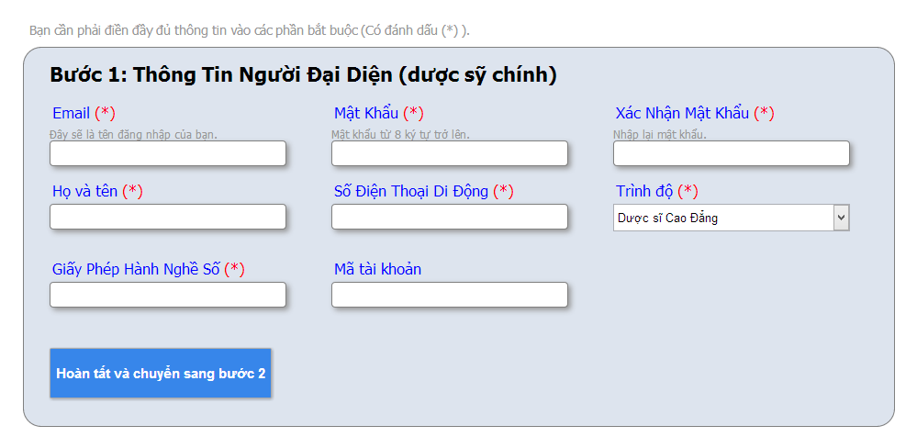

**Figure 4-32:** Register – Step1

**Table 4-10:** Register step1

|  |  |  |  |  |  |  |
| --- | --- | --- | --- | --- | --- | --- |
| No | **Object/Control Name** | **Object/Control Name in English** | **Type** | **Required** | **Length** | **Description** |
| 1 | Email | Email | Text | Y | 150 | Email of representative use to login to system |
| 2 | Mật khẩu | Password | Password | Y | 24 | Password user use to login to system |
| 3 | Nhập lại mật khẩu | Retype password | Password | Y | 24 | Retype password to user check the correctness of password |
| 4 | Họ và tên | Full name | Text | Y | 150 | Name of representative |
| 5 | Số điện thoại di động | Mobile phone | Number | Y | 15 | Mobile phone number of representative |
| 6 | Trình độ | Degree | Combo box | Y | N/A | Degree of representative |
| 7 | Giấy phép hành nghề | Licensure No | Text | Y | 100 | Licensure No of representative |
| 8 | Mã tài khoản | Card number | Text | N | 45 | Card number of representative |

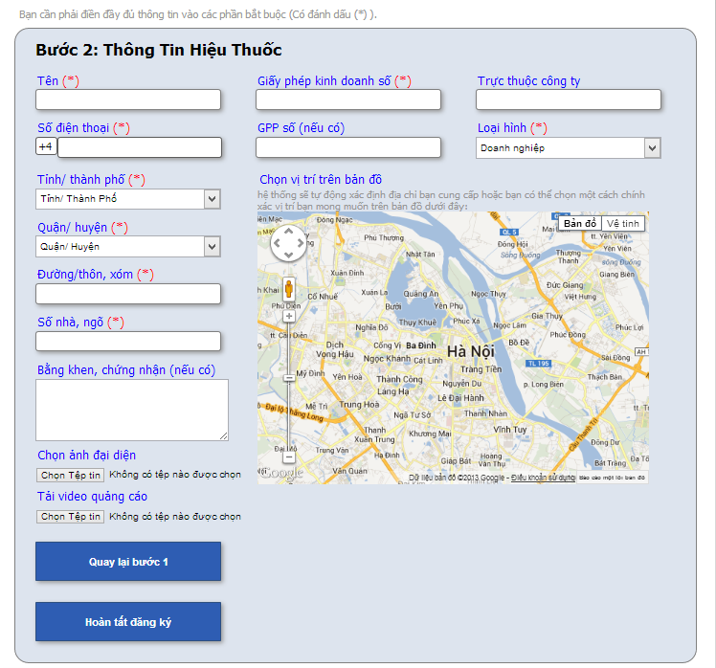

**Figure 4-33:** Register – Step2

**Table 4-11:** Register – step2

|  |  |  |  |  |  |  |
| --- | --- | --- | --- | --- | --- | --- |
| No | **Object/Control Name** | **Object/Control Name in English** | **Type** | **Required** | **Length** | **Description** |
| 1 | Tên | Pharmacy name | Text | Y | 200 | Name of pharmacy |
| 2 | Số giấy phép kinh doanh | Business licensure No | Text | Y | 100 | Business licensure No of pharmacy |
| 3 | Trực thuộc công ty | Pharmaceutical company | Text | N | 200 | Name of Pharmaceutical company |
| 4 | Số điện thoại | Home phone | Number | Y | 15 | Home phone number of pharmacy |
| 5 | Số GPP | GPP number | Number | Y | 45 | GPP number of pharmacy |
| 6 | Loại hình | Type of business | Combo box | Y | N/A | Pharmacy business type |
| 7 | Tỉnh/ Thành phố | Province/ City | Text | Y | 100 | Province name or city name of pharmacy |
| 8 | Quận/ huyện | District | Text | Y | 100 | District name of pharmacy |
| 9 | Đường/Thôn, xóm | Street | Text | Y | 100 | Street of pharmacy |
| 10 | Số nhà, ngõ | House No | Text | Y | 50 | House number of pharmacy |
| 11 | Bằng khen, chứng nhận | Note | Text area | N | 5000 | Pharmacy notes |

### Sequence Diagram

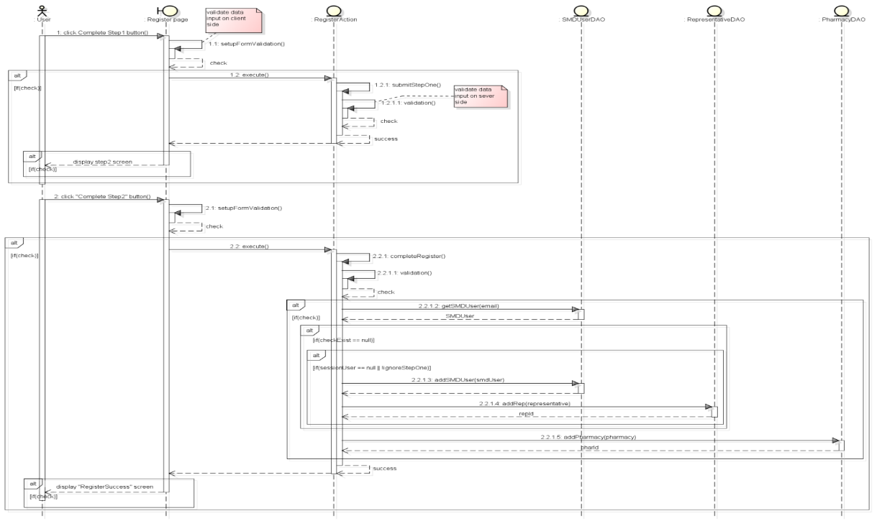

**Figure 4-34:** Sequence diagram- Register

## UC 009 – Login

### Class Diagram

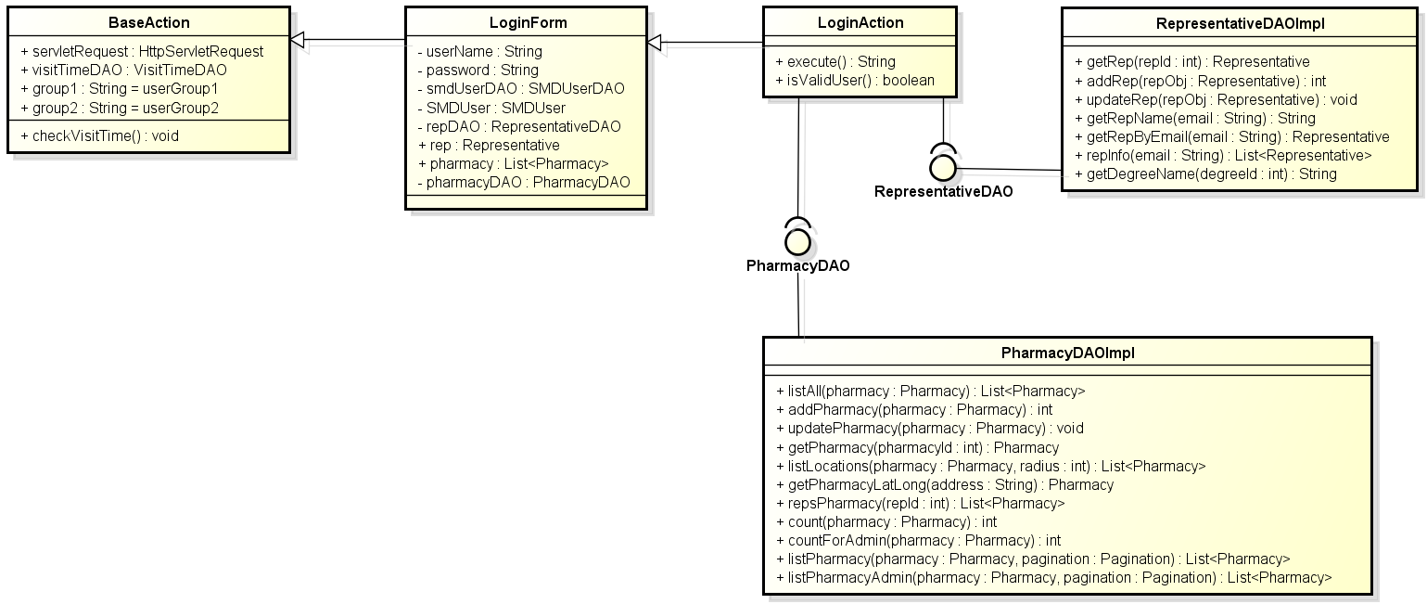

**Figure 4-35:** Class diagram- Login

### Class Description

#### LoginForm

|  |  |  |  |  |
| --- | --- | --- | --- | --- |
| Class | LoginForm | | | |
| **Description** | Contains declare and constructor for all LoginAction’s attributes. | | | |
| **Base Class** | BaseAction | | | |
| **Constructor** | N/A | | | |
| **Prototype** | N/A | | | |
| **Source File** | LoginForm.java | | | |
| **Namespace** | com.med.dic.form | | | |
| A**ttributes** | username… … (see Figure 4-34) | | | |
| **Methods** | Name | Input | Output | Description |
| N/A | N/A | N/A | N/A |

#### LoginAction

|  |  |  |  |  |
| --- | --- | --- | --- | --- |
| Class | LoginAction | | | |
| **Description** | Contains login methods. | | | |
| **Base Class** | LoginForm | | | |
| **Constructor** | N/A | | | |
| **Prototype** | N/A | | | |
| **Source File** | LoginAction.java | | | |
| **Namespace** | com.med.dic.action | | | |
| A**ttributes** | N/A | | | |
| **Methods** | Name | Input | Output | Description |
| execute | N/A | String | Is a root method of all other methods in class, responsibility counts visitor and execute login function. |

#### PharmacyDAOImpl

|  |  |  |  |  |
| --- | --- | --- | --- | --- |
| Class | PharmacyDAOImpl | | | |
| **Description** | Implement all PharmacyDAO interface’s methods. | | | |
| **Base Class** | N/A | | | |
| **Constructor** | N/A | | | |
| **Prototype** | N/A | | | |
| **Source File** | PharmacyDAOImpl.java | | | |
| **Namespace** | com.med.dic.dao.impl | | | |
| A**ttributes** | N/A | | | |
| **Methods** | Name | Input | Output | Description |
| repsPharmacy | repId | int | Methods list all pharmacy represent by repId. |

#### RepresentativeDAOImpl

|  |  |  |  |  |
| --- | --- | --- | --- | --- |
| Class | RepresentativeDAOImpl | | | |
| **Description** | Implement all RepresentativeDAO interface’s methods. | | | |
| **Base Class** | N/A | | | |
| **Constructor** | N/A | | | |
| **Prototype** | N/A | | | |
| **Source File** | RepresentativeDAOImpl.java | | | |
| **Namespace** | com.med.dic.dao.impl | | | |
| A**ttributes** | N/A | | | |
| **Methods** | Name | Input | Output | Description |
| getRepByEmail | email | List<Pharmacy> | Methods list all pharmacy by email. |

### Screen Desgin



**Figure 4-36:** Login

**Table 4-12:** Login

|  |  |  |  |  |  |  |
| --- | --- | --- | --- | --- | --- | --- |
| **No** | **Object/Control Name** | **Object/Control Name in English** | **Type** | **Required** | **Length** | **Description** |
| 1 | Email | Email | Text | Y | 150 | Email address of representative use to login to system |
| 2 | Mật Khẩu | Password | Text | Y | 150 | Password of user use to login to system, and text view as * |
| 3 | Đăng nhập | Login | Button | Y | N/A | Login user to system |

### Sequence Diagram

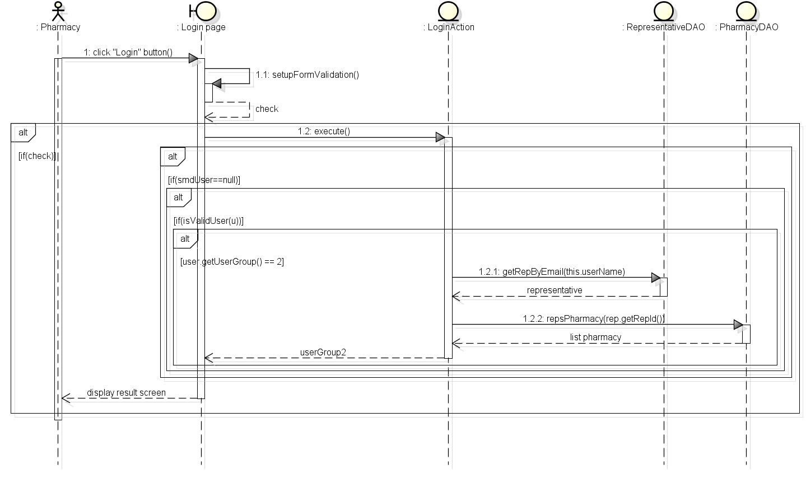

**Figure 4-37:** Sequence diagram- Login

## UC 010 – Logout

### Class Diagram

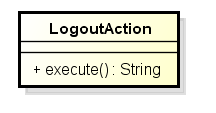

**Figure 4-38:** Class diagram- Logout

### Class Description

#### LogoutAction

|  |  |  |  |  |
| --- | --- | --- | --- | --- |
| Class | LogoutAction | | | |
| **Description** | Contains logout methods. | | | |
| **Base Class** | N/A | | | |
| **Constructor** | N/A | | | |
| **Prototype** | N/A | | | |
| **Source File** | LogoutAction.java | | | |
| **Namespace** | com.med.dic.action | | | |
| A**ttributes** | N/A | | | |
| **Methods** | Name | Input | Output | Description |
| execute | N/A | String | Methods logout. |

### Screen Design

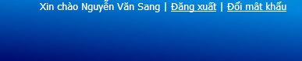

**Figure 4-39:** Logout

**Table 4-13:** Logout

|  |  |  |  |  |  |  |
| --- | --- | --- | --- | --- | --- | --- |
| **No** | **Object/Control Name** | **Object/Control Name in English** | **Type** | **Required** | **Length** | **Description** |
| 1 | Đăng xuất | Logout | Link | Y | N/A | Logout use from system |

### Sequence Diagram

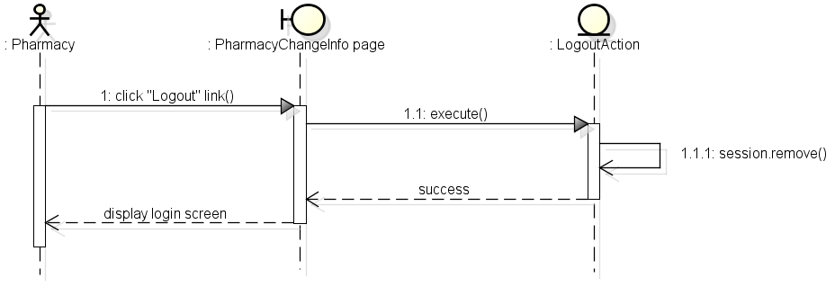

**Figure 4-40:** Sequence diagram- Logout

## UC 011 – Reset Password

### Class Diagram

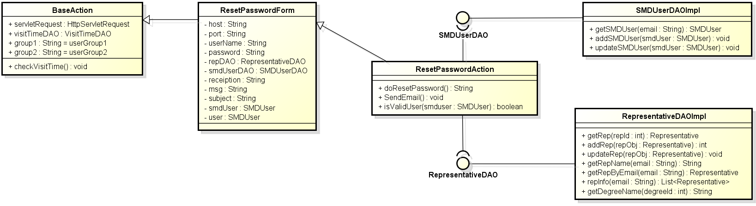

**Figure 4-41:** Class diagram- Reset password

### Class Description

#### ResetPasswordForm

|  |  |  |  |  |
| --- | --- | --- | --- | --- |
| Class | ResetPasswordForm | | | |
| **Description** | Contains declare and constructor for all ResetPasswordAction’s attributes. | | | |
| **Base Class** | BaseAction | | | |
| **Constructor** | N/A | | | |
| **Prototype** | N/A | | | |
| **Source File** | ResetPasswordForm.java | | | |
| **Namespace** | com.med.dic.form | | | |
| A**ttributes** | Host… (see Figure 4-40) | | | |
| **Methods** | Name | Input | Output | Description |
| N/A | N/A | N/A | N/A |

#### ResetPasswordAction

|  |  |  |  |  |
| --- | --- | --- | --- | --- |
| Class | ResetPasswordAction | | | |
| **Description** | Contains reset password methods. | | | |
| **Base Class** | ResetPasswordForm | | | |
| **Constructor** | N/A | | | |
| **Prototype** | N/A | | | |
| **Source File** | ResetPasswordAction.java | | | |
| **Namespace** | com.med.dic.action | | | |
| A**ttributes** | N/A | | | |
| **Methods** | Name | Input | Output | Description |
| doResetPassword | N/A | String | Methods reset password. |

#### SMDUserDAOImpl

|  |  |  |  |  |
| --- | --- | --- | --- | --- |
| Class | SMDUserDAOImpl | | | |
| **Description** | Implement all SMDUserDAO interface’s methods. | | | |
| **Base Class** | N/A | | | |
| **Constructor** | N/A | | | |
| **Prototype** | N/A | | | |
| **Source File** | SMDUserDAOImpl.java | | | |
| **Namespace** | com.med.dic.dao.impl | | | |
| A**ttributes** | N/A | | | |
| **Methods** | Name | Input | Output | Description |
| updateSMDUser | SMDUser | Void | Methods update SMDUser info. |

#### RepresentativeDAOImpl

|  |  |  |  |  |
| --- | --- | --- | --- | --- |
| Class | RepresentativeDAOImpl | | | |
| **Description** | Implement all RepresentativeDAO interface’s methods. | | | |
| **Base Class** | N/A | | | |
| **Constructor** | N/A | | | |
| **Prototype** | N/A | | | |
| **Source File** | RepresentativeDAOImpl.java | | | |
| **Namespace** | com.med.dic.dao.impl | | | |
| A**ttributes** | N/A | | | |
| **Methods** | Name | Input | Output | Description |
| getRepName | email | String | Methods get rename by email. |

### Screen Design



**Figure 4-42:** Reset password

**Table 4-14:** Class diagram- Register

|  |  |  |  |  |  |  |
| --- | --- | --- | --- | --- | --- | --- |
| **No** | **Object/Control Name** | **Object/Control Name in English** | **Type** | **Required** | **Length** | **Description** |
| 1 | Email | Email | Text | Y | 150 | Email address of representative use to login to system |
| 2 | Cấp lại | Send | Button | Y | N/A | Reset user password and send email to representative |

### Sequence Diagram

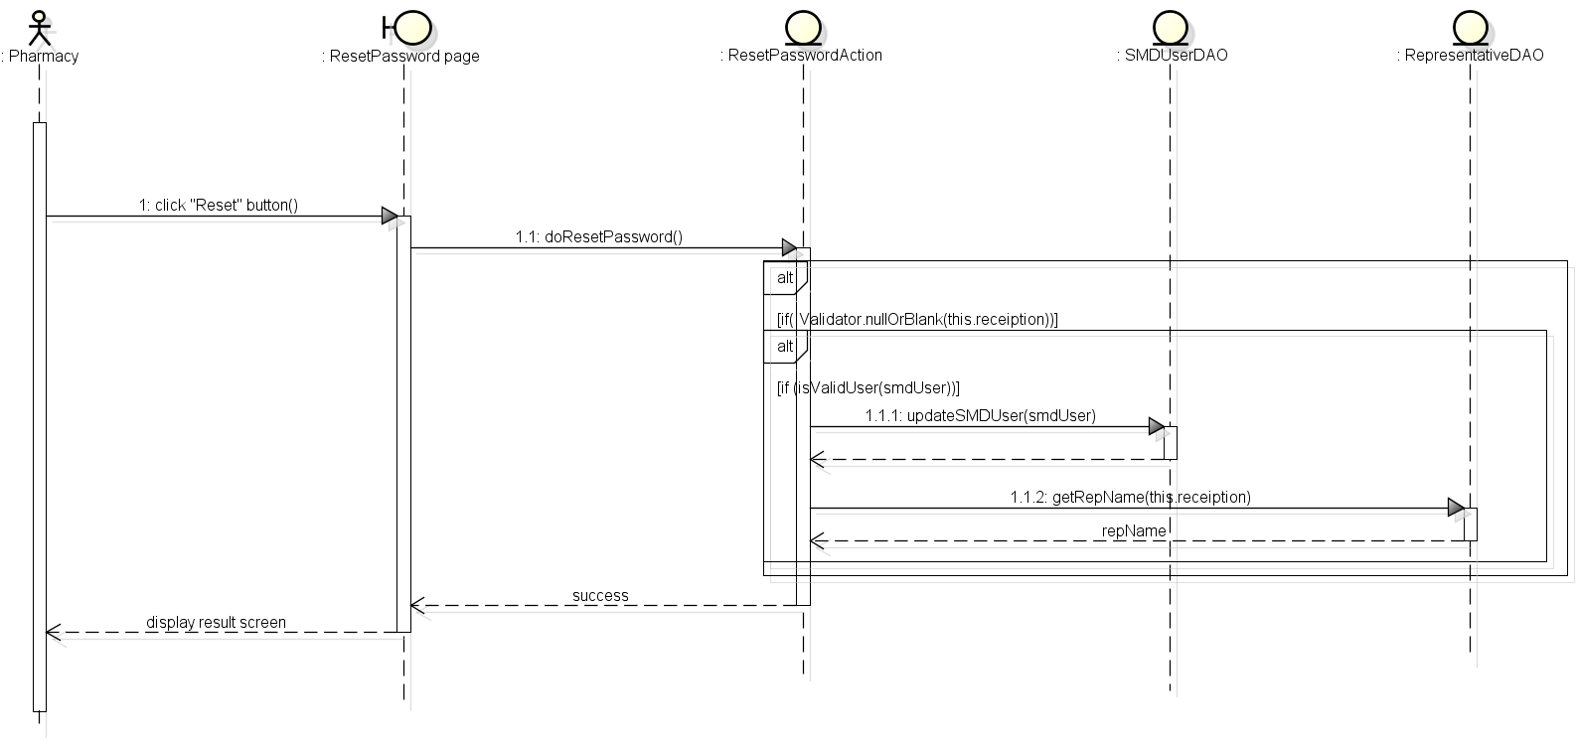

**Figure 4-43:** Sequence diagram- Reset password

## UC 012 – Change Password

### Class Diagram

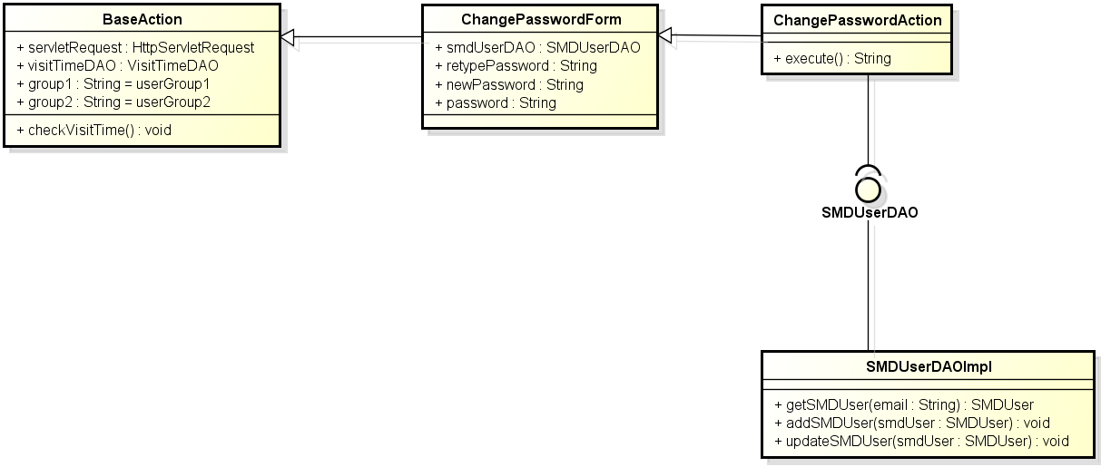

**Figure 4-44:** Class diagram- Change password

### Class Description

#### Change Password Form

|  |  |  |  |  |
| --- | --- | --- | --- | --- |
| Class | ChangePasswordForm | | | |
| **Description** | Contains declare and constructor for all ChangePasswordAction’s attributes. | | | |
| **Base Class** | BaseAction | | | |
| **Constructor** | N/A | | | |
| **Prototype** | N/A | | | |
| **Source File** | ChangePasswordForm.java | | | |
| **Namespace** | com.med.dic.form | | | |
| A**ttributes** | smdUserDAO… (see Figure 4-43) | | | |
| **Methods** | Name | Input | Output | Description |
| N/A | N/A | N/A | N/A |

#### Change Password Action

|  |  |  |  |  |
| --- | --- | --- | --- | --- |
| Class | ChangePasswordAction | | | |
| **Description** | Contains change password methods. | | | |
| **Base Class** | ChangePasswordForm | | | |
| **Constructor** | N/A | | | |
| **Prototype** | N/A | | | |
| **Source File** | ChangePasswordAction.java | | | |
| **Namespace** | com.med.dic.action | | | |
| A**ttributes** | N/A | | | |
| **Methods** | Name | Input | Output | Description |
| execute | N/A | String | Is a root method of all other methods in class, responsibility counts visitor and change password. |

#### SMDUserDAOImpl

|  |  |  |  |  |
| --- | --- | --- | --- | --- |
| Class | SMDUserDAOIpml | | | |
| **Description** | Implement all SMDUserDAO interface’s methods. | | | |
| **Base Class** | N/A | | | |
| **Constructor** | N/A | | | |
| **Prototype** | N/A | | | |
| **Source File** | SMDUserDAOImpl.java | | | |
| **Namespace** | com.med.dic.dao.impl | | | |
| A**ttributes** | N/A | | | |
| **Methods** | Name | Input | Output | Description |
| updateSMDUser | SMDUser | void | Methods update user info. |

### Screen Design



**Figure 4-45:** Change password

**Table 4-15:**Change password

|  |  |  |  |  |  |  |
| --- | --- | --- | --- | --- | --- | --- |
| **No** | **Object/Control Name** | **Object/Control Name in English** | **Type** | **Required** | **Length** | **Description** |
| 1 | Mật khẩu hiện tại | Current password | Text | Y | 150 | User current password |
| 2 | Mật khẩu mới | New password | Text | Y | 150 | User new password |
| 3 | Nhập lại mật khẩu mới | Retype new password | Text | Y | 150 | User retype password to verify the correctness of password |
| 4 | Lưu thay đổi | Save | Button | Y | N/A | Change user password to system |

### Sequence Diagram

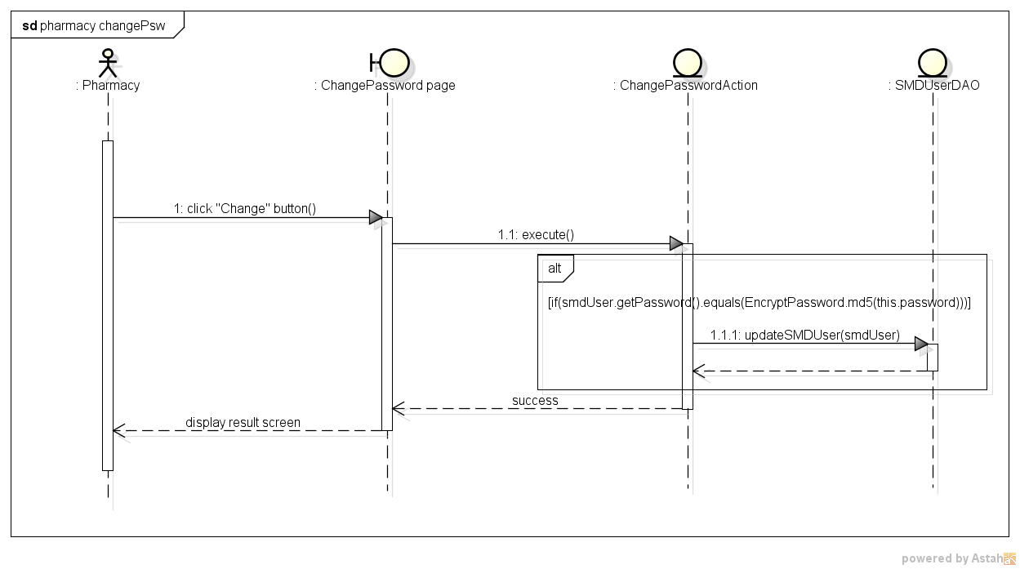

**Figure 4-46:** Sequence diagram- Change password

## Search Medicine

### Class Diagram

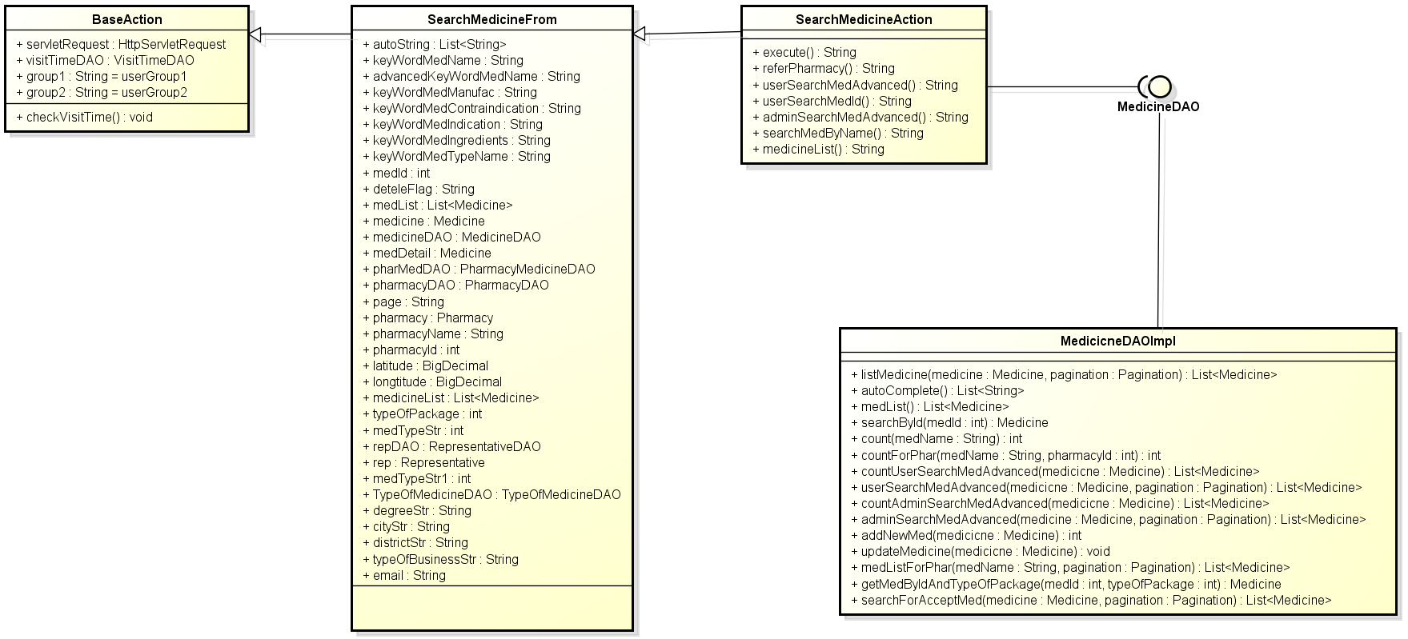

**Figure 4-47:** Class diagram- Search medicine

### Class Description

#### Search Medicine Form

|  |  |  |  |  |
| --- | --- | --- | --- | --- |
| Class | SearchMedicineForm | | | |
| **Description** | Contains declare and constructor for all SearchMedicineAction’s attributes. | | | |
| **Base Class** | BaseAction | | | |
| **Constructor** | N/A | | | |
| **Prototype** | N/A | | | |
| **Source File** | SearchMedicineForm.java | | | |
| **Namespace** | com.med.dic.form | | | |
| A**ttributes** | autoString, keyWordMedName… (see Figure 4-46) | | | |
| **Methods** | Name | Input | Output | Description |
| N/A | N/A | N/A | N/A |

#### SearchMedicineAction

|  |  |  |  |  |
| --- | --- | --- | --- | --- |
| Class | SearchMedicineAction | | | |
| **Description** | Contains searching medicine methods. | | | |
| **Base Class** | SearchMedicineActionForm | | | |
| **Constructor** | N/A | | | |
| **Prototype** | N/A | | | |
| **Source File** | SearchMedicineAction.java | | | |
| **Namespace** | com.med.dic.action | | | |
| A**ttributes** | N/A | | | |
| **Methods** | Name | Input | Output | Description |
| execute | N/A | String | Is a root method of all other methods in class, responsibility counts visitor. |
| userSearchMedByName | N/A | String | Method search medicines by name. |
| userSearchMedAdvanced | N/A | String | Method search medicine advanced. |
| SearchMedId | N/A | String | Methods search medicine id. |

#### MedicineDAOImpl

|  |  |  |  |  |
| --- | --- | --- | --- | --- |
| Class | MedicineDAOImpl | | | |
| **Description** | Implement MedicineDAO interface’s methods | | | |
| **Base Class** | N/A | | | |
| **Constructor** | N/A | | | |
| **Prototype** | N/A | | | |
| **Source File** | MedicineDAOImpl.java | | | |
| **Namespace** | com.med.dic.dao.impl | | | |
| A**ttributes** | Name | Type | Description | |
| N/A | N/A | N/A | |
| **Methods** | Name | Input | Output | Description |
| searchById | medId | Medicine | Method search medicine by id |
| countUserSearchMedAdvanced | medicine | int | Method count number of medicine contains keywords. |
| count | medName | int | Method count number of medicine contains keywords. |
| listMedicine | Medicine, pagination | List<medicine> | Method list all medicines contain keywords. |
| userSearchMedAdvanced | Medicine, pagination | List<Medicine> | Method search all medicines contains keywords. |

### UC 013 - Normal Search

#### Screen Design

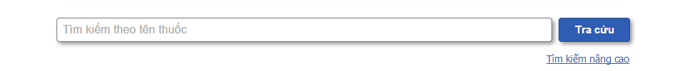

**Figure 4-48:** Search medicine- Normal search

**Table 4-16:** Search medicine- Normal search

|  |  |  |  |  |  |  |
| --- | --- | --- | --- | --- | --- | --- |
| **No** | **Object/Control Name** | **Object/Control Name in English** | **Type** | **Required** | **Length** | **Description** |
| 1 | Tìm kiếm theo tên thuốc | Search by medicine name | Text width auto complete | N | 100 | Name of medicine user use to search |
| 2 | Tra cứu | Search | Button | Y | N/A | Start search medicine inside system |
| 3 | Tìm kiếm nâng cao | Advanced search | Link | N | N/A | Switch to advanced search medicine mode |

#### Sequence Diagram

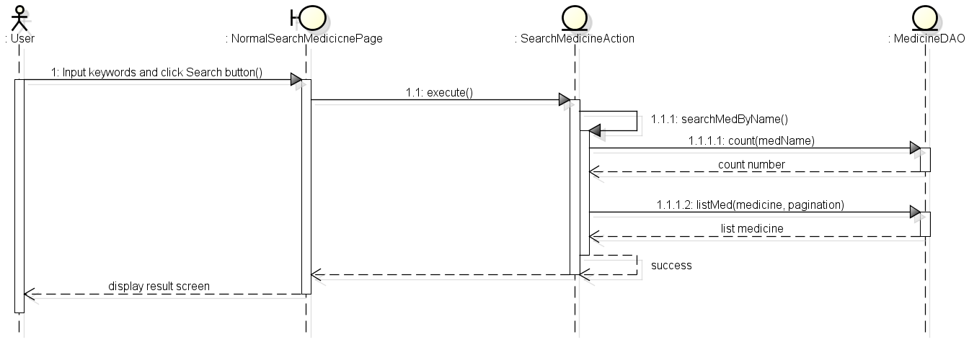

**Figure 4-49:** Sequence diagram- Normal search medicine

### UC 014 - Advanced Search Medicine

#### Screen Diagram

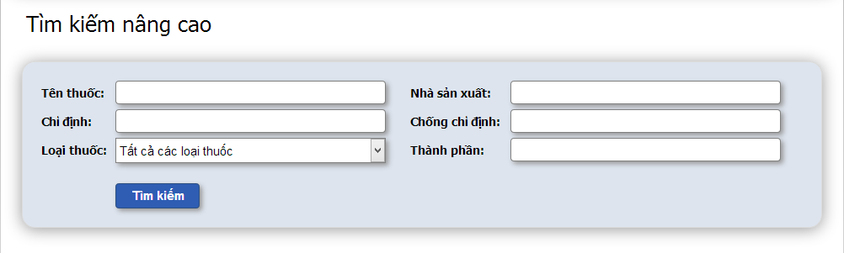**Figure 4-50:** Search medicine- Advanced search

**Table 4-17:** Search medicine- Advanced search

|  |  |  |  |  |  |  |
| --- | --- | --- | --- | --- | --- | --- |
| **No** | **Object/Control Name** | **Object/Control Name in English** | **Type** | **Required** | **Length** | **Description** |
| 1 | Tên thuốc | Medicine name | Text | N | 100 | Name of medicine user use to search medicine |
| 2 | Nhà sản xuất | Manufacturer | Text | N | 100 | Name of manufacturer user use to search medicine |
| 3 | Chỉ định | Indication | Text | N | 3000 | Indications of medicine user use to search medicine |
| 4 | Chống chỉ định | Contraindication | Text | N | 1000 | Contraindications of medicine user use to search medicine |
| 5 | Loại thuốc | Types of medicine | Combo box | N | N/A | Types of medicine user choose to search |
| 6 | Thành phần | Ingredient | Text | N | 1000 | Ingredients of medicine user use to search |

#### Sequence Diagram

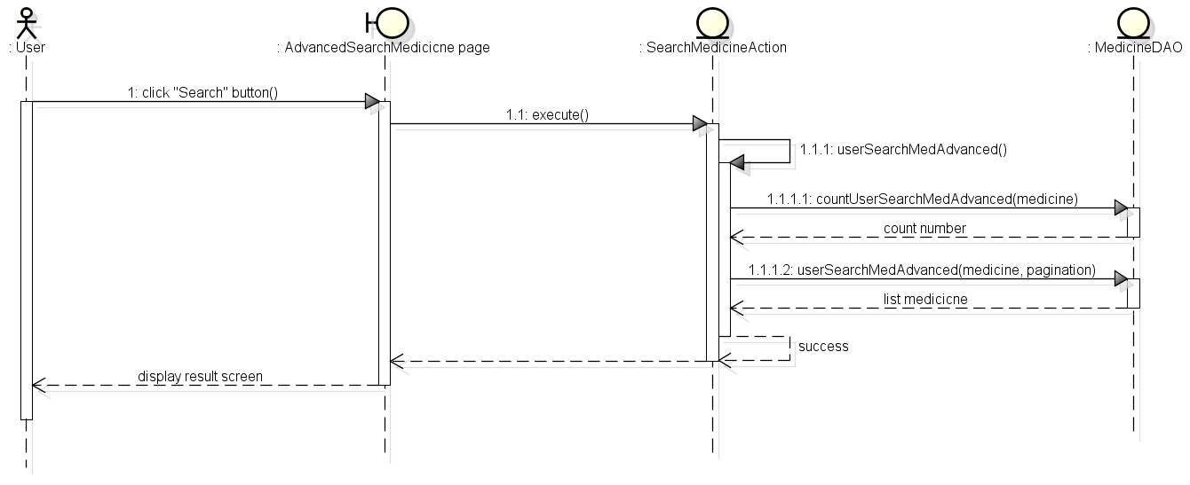

**Figure 4-51:** Sequence diagram- Search medicine

## Manage Medicine Information

### Class Diagram

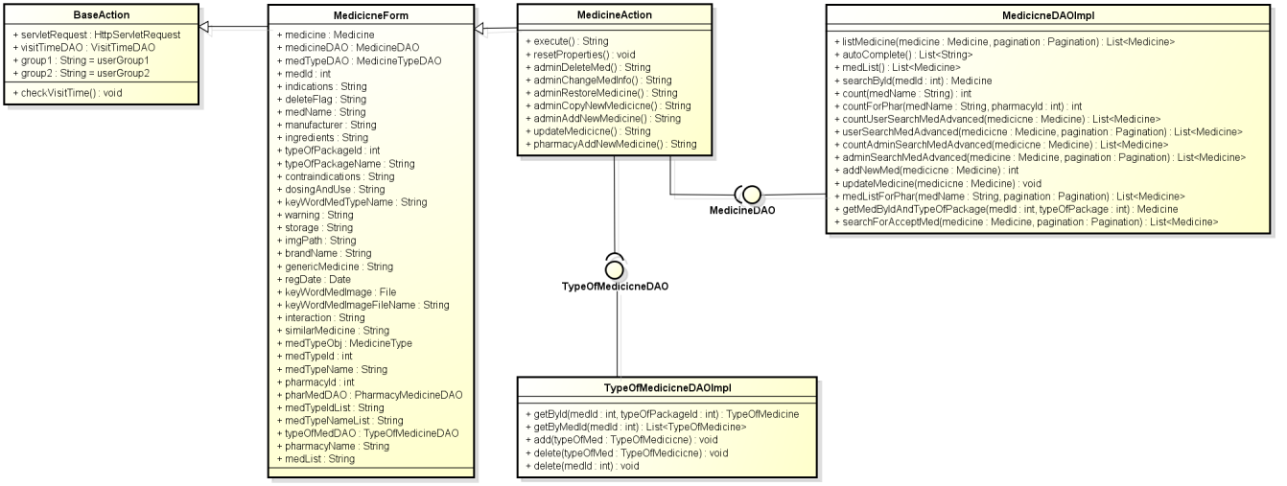

**Figure 4-52:** Class diagram- Manage medicine information

### Class Description

#### MedicineFromAction

|  |  |  |  |  |
| --- | --- | --- | --- | --- |
| Class | MedicineFormAction | | | |
| **Description** | Contains thedeclare and constructor for all MedicineAction’s attribute. | | | |
| **Base Class** | BaseAction | | | |
| **Constructor** | N/A | | | |
| **Prototype** | N/A | | | |
| **Source File** | MedicineFormAction.java | | | |
| **Namespace** | com.med.dic.form | | | |
| **Attributes** | Medicine, MedicineDAO… (See Figure 4-51) | | | |
| **Methods** | Name | Input | Output | Description |
| N/A | N/A | N/A | N/A |

#### MedicineAction

|  |  |  |  |  |
| --- | --- | --- | --- | --- |
| Class | MedicineAction | | | |
| **Description** | Contains medicine’s modify methods | | | |
| **Base Class** | MedicineFormAction | | | |
| **Constructor** | N/A | | | |
| **Prototype** | N/A | | | |
| **Source File** | MedicineAction.java | | | |
| **Namespace** | com.med.dic.action | | | |
| **Attributes** | N/A | | | |
| **Methods** | Name | Input | Output | Description |
| execute | N/A | String | Is a root method of all other methods in class, responsibility counts visitor. |
| validateMedicineInfo | N/A | boolean | Methods check validation of medicine. |
| adminDeleteMed | N/A | String | Method to delete a medicine (update deleteFlag become Y) |
| adminRestoreMed | N/A | String | Method to restore a deleted medicine |
| adminAddNewMed | N/A | String | Method to create new a medicine |
| updateMedicine | N/A | String | Method to update medicine info |

#### MedicineDAOImpl

|  |  |  |  |  |
| --- | --- | --- | --- | --- |
| Class | MedicineDAOImpl | | | |
| **Description** | Implement MedicineDAO interface’s methods | | | |
| **Base Class** | N/A | | | |
| **Constructor** | N/A | | | |
| **Prototype** | N/A | | | |
| **Source File** | MedicineDAOImpl.java | | | |
| **Namespace** | com.med.dic.dao.impl | | | |
| **Attributes** | N/A | | | |
| **Methods** | Name | Input | Output | Description |
| addNewMed | medicine | Medicine | Methods add new medicine into DB. |
| searchMedById | medId | Medicine | Method get medicine info by id. |
| updateMedicine | Medicine | void | Methods update medicine info DB by id. |

#### TypeOfMedicineDAOImpl

|  |  |  |  |  |
| --- | --- | --- | --- | --- |
| Class | TypeOfMedicineDAOImpl | | | |
| **Description** | Implement TypeOfMedicineDAO interface’s methods | | | |
| **Base Class** | N/A | | | |
| **Constructor** | N/A | | | |
| **Prototype** | N/A | | | |
| **Source File** | TypeOfMedicineDAOImpl.java | | | |
| **Namespace** | com.med.dic.dao.impl | | | |
| A**ttributes** | N/A | | | |
| **Methods** | Name | Input | Output | Description |
| add | typeOfMedicine | void | Methodsadd types for a medicine. |
| delete | typeOfMedicine | void | Methodsdelete all types of a medicine. |

### UC 015 –Add Medicine

#### Screen Design

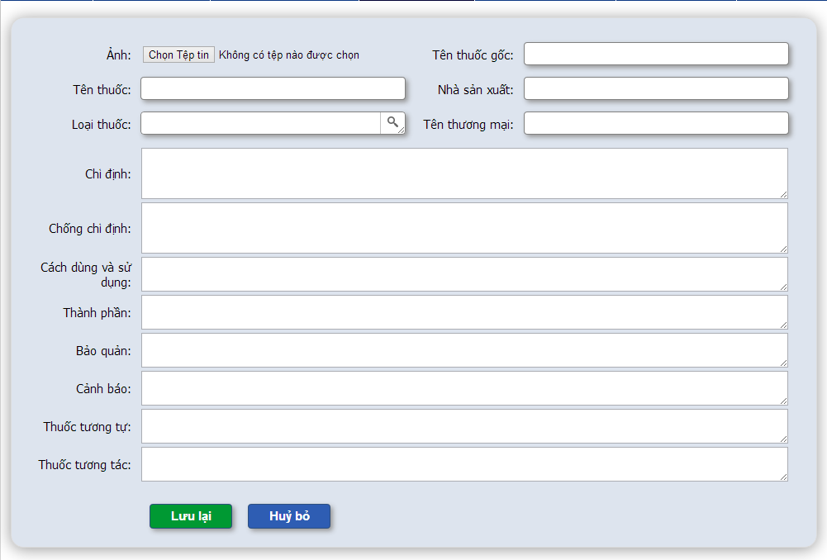

**Figure 4-53:** Manage medicine information- Add medicine

**Table 4-18:** Manage medicine information- Add medicine

|  |  |  |  |  |  |  |
| --- | --- | --- | --- | --- | --- | --- |
| **No** | **Object/Control Name** | **Object/Control Name in English** | **Type** | **Required** | **Length** | **Description** |
| 1 | Ảnh | Image | File | N | N/A | Image of medicine |
| 2 | Tên thuốc gốc | Generic medicine | Text | Y | 100 | Generic medicine name |
| 3 | Tên thuốc | Medicine name | Text | Y | 100 | Name of medicine |
| 4 | Nhà sản xuất | Manufacturer | Text | Y | 100 | Medicine manufacture name |
| 5 | Loại thuốc | Types of package | Text area auto resize + popup | Y | 100 | Type(s) of medicine |
| 6 | Tên thương mại | Brandname | Text | N | 100 | Medicine brand name |
| 7 | Chỉ định | Indications | Text area + auto resize | Y | 3000 | Medicine indication |
| 8 | Chống chỉ định | Contraindication | Text area + auto resize | N | 1000 | Medicine contraindication |
| 9 | Cách dùng và sử dụng | Dosing and use | Text area + auto resize | Y | 1000 | Medicine dosing and use |
| 10 | Thành Phần | Ingredients | Text area + auto resize | Y | 1000 | Medicine ingredient |
| 11 | Bảo quản | Storage | Text area + auto resize | N | 1000 | Medicine storage |
| 12 | Cảnh báo | Warring | Text area + auto resize | N | 1000 | Medicine warring |
| 13 | Tương tự | Similar medicine | Text area + auto resize | N | 1000 | Similar medicines |
| 14 | Tương tác | Interaction medicine | Text area + auto resize | N | 100 | Interaction medicines |
| 15 | Lưu lại | Save | Button | N | N/A | Add new medicine into system |
| 16 | Hủy bỏ | Cancel | Button | N | N/A | Cancel add new medicine |

#### Sequence Diagram

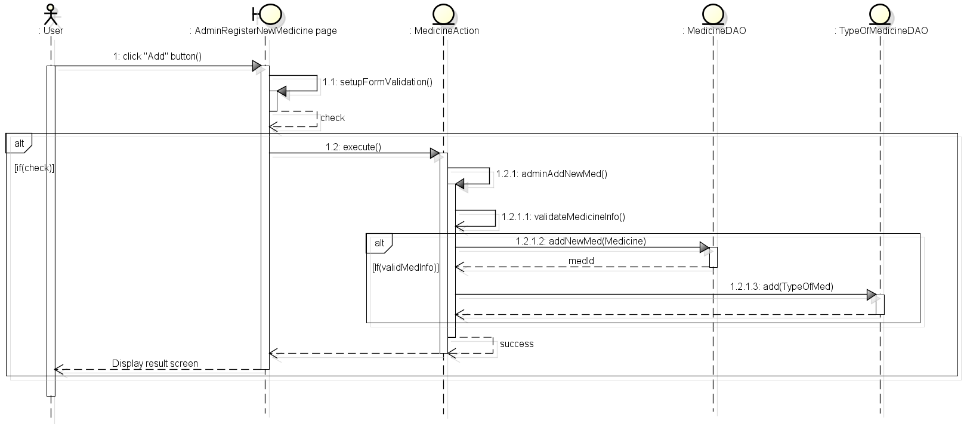

**Figure 4-54:** Sequence diagram- Manage medicine information- Add medicine

### UC 016 - Update Medicine

#### Screen Design

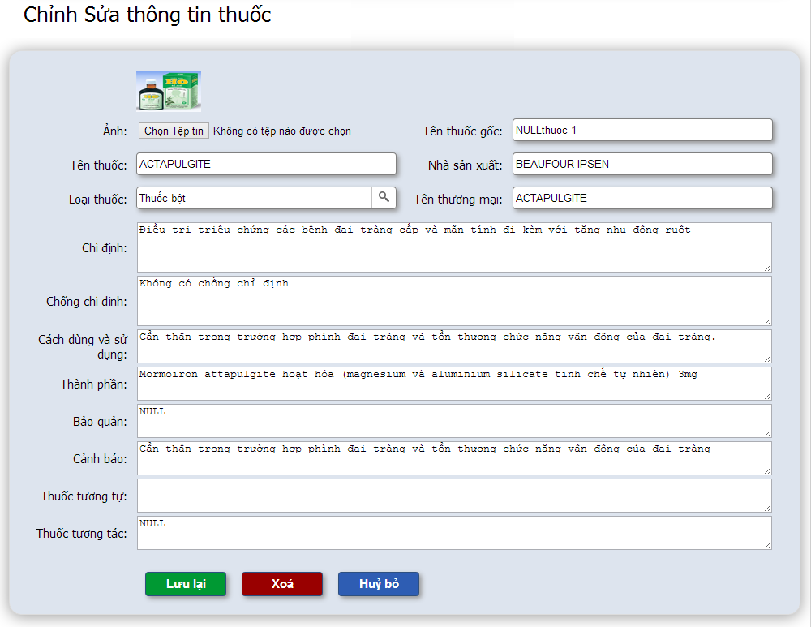

**Figure 4-55:** Manage medicine information- Update medicine

**Table 4-19:** Manage medicine information- Update medicine

|  |  |  |  |  |  |  |
| --- | --- | --- | --- | --- | --- | --- |
| **No** | **Object/Control Name** | **Object/Control Name in English** | **Type** | **Required** | **Length** | **Description** |
| 1 | Ảnh | Image | File | N | N/A | Image of medicine |
| 2 | Tên thuốc gốc | Generic medicine | Text | Y | 100 | Generic medicine name |
| 3 | Tên thuốc | Medicine name | Text | Y | 100 | Name of medicine |
| 4 | Nhà sản xuất | Manufacturer | Text | Y | 100 | Medicine manufacture name |
| 5 | Loại thuốc | Types of package | Text area auto resize + popup | Y | 100 | Type(s) of medicine |
| 6 | Tên thương mại | Brandname | Text | N | 100 | Medicine brand name |
| 7 | Chỉ định | Indications | Text area + auto resize | Y | 3000 | Medicine indication |
| 8 | Chống chỉ định | Contraindication | Text area + auto resize | N | 1000 | Medicine contraindication |
| 9 | Cách dùng và sử dụng | Dosing and use | Text area + auto resize | Y | 1000 | Medicine dosing and use |
| 10 | Thành Phần | Ingredients | Text area + auto resize | Y | 1000 | Medicine ingredient |
| 11 | Bảo quản | Storage | Text area + auto resize | N | 1000 | Medicine storage |
| 12 | Cảnh báo | Warring | Text area + auto resize | N | 1000 | Medicine warring |
| 13 | Tương tự | Similar medicine | Text area + auto resize | N | 1000 | Similar medicines |
| 14 | Tương tác | Interaction medicine | Text area + auto resize | N | 100 | Interaction medicines |
| 15 | Lưu lại | Save | Button | Y | N/A | Update new medicine information into system |
| 16 | Xóa | Delete | Button + confirm popup | N | N/A | Update deleteFlag of medicine to “Y” |
| 17 | Hủy bỏ | Cancel | Button | N | N/A | Cancel edit medicine |

#### Sequence Diagram

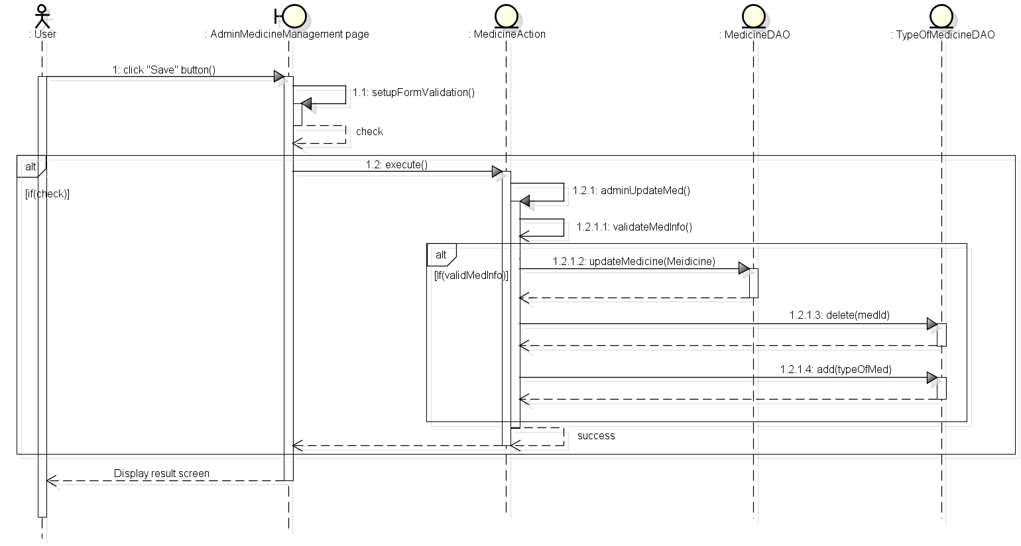

**Figure 4-56:** Sequence diagram- Manage medicine information- Update medicine

### UC 017 - Delete Medicine

#### Screen Design



**Figure 4-57:** Manage medicine information- Delete medicine

**Table 4-20:** Manage medicine information- Delete medicine

|  |  |  |  |  |  |  |
| --- | --- | --- | --- | --- | --- | --- |
| **No** | **Object/Control Name** | **Object/Control Name in English** | **Type** | **Required** | **Length** | **Description** |
| 1 | Ảnh | Image | File | N | N/A | Image of medicine |
| 2 | Tên thuốc gốc | Generic medicine | Text | N | 100 | Generic medicine name |
| 3 | Tên thuốc | Medicine name | Text | N | 100 | Name of medicine |
| 4 | Nhà sản xuất | Manufacturer | Text | N | 100 | Medicine manufacture name |
| 5 | Loại thuốc | Types of package | Text area auto resize + popup | N | 100 | Type(s) of medicine |
| 6 | Tên thương mại | Brandname | Text | N | 100 | Medicine brand name |
| 7 | Chỉ định | Indications | Text area + auto resize | N | 3000 | Medicine indication |
| 8 | Chống chỉ định | Contraindication | Text area + auto resize | N | 1000 | Medicine contraindication |
| 9 | Cách dùng và sử dụng | Dosing and use | Text area + auto resize | N | 1000 | Medicine dosing and use |
| 10 | Thành Phần | Ingredients | Text area + auto resize | N | 1000 | Medicine ingredient |
| 11 | Bảo quản | Storage | Text area + auto resize | N | 1000 | Medicine storage |
| 12 | Cảnh báo | Warring | Text area + auto resize | N | 1000 | Medicine warring |
| 13 | Tương tự | Similar medicine | Text area + auto resize | N | 1000 | Similar medicines |
| 14 | Tương tác | Interaction medicine | Text area + auto resize | N | 100 | Interaction medicines |
| 15 | Lưu lại | Save | Button | N | N/A | Save medicine information into system |
| 16 | Xóa | Delete | Button + confirm popup | Y | N/A | Update deleteFlag of medicine to “Y” |
| 17 | Hủy bỏ | Cancel | Button | N | N/A | Cancel edit medicine |

#### Sequence diagram

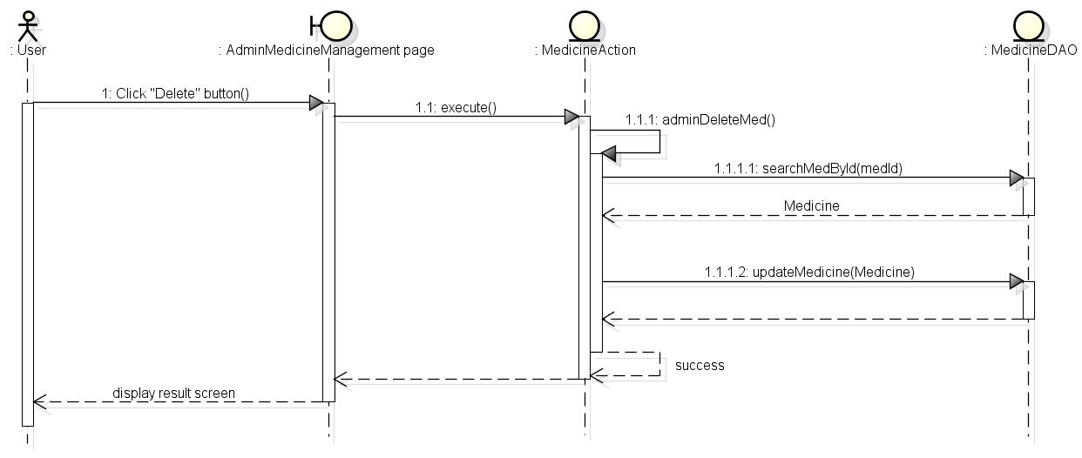

**Figure 4-58:** Sequence diagram- Manage medicine information- Delete medicine

### UC 018 - Restore Medicine

#### Screen Design

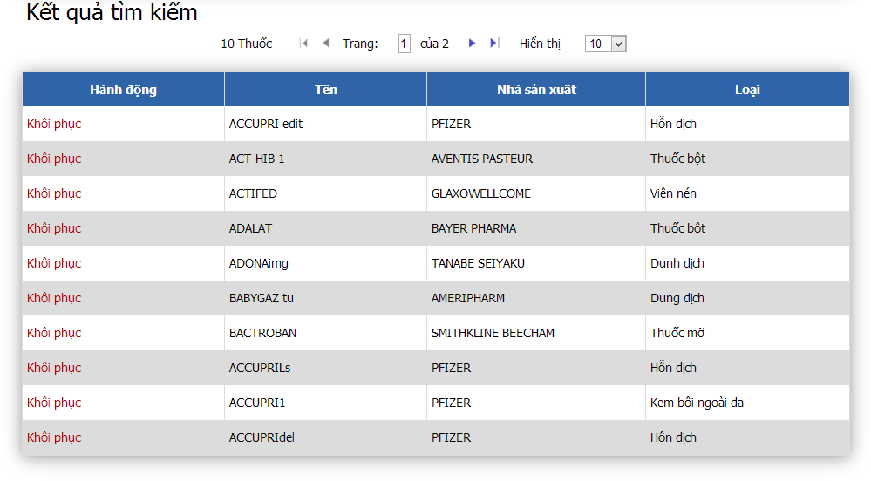

**Figure 4-59:** Manage medicine information- Restore medicine

**Table 4-21:** Manage medicine information- Restore medicine

|  |  |  |  |  |  |  |
| --- | --- | --- | --- | --- | --- | --- |
| **No** | **Object/Control Name** | **Object/Control Name in English** | **Type** | **Required** | **Length** | **Description** |
| 1 | Khôi phục | Restore | Link | Y | N/A | Update deleteFlag of medicine to “N” |
| 2 | Tên | Name | Text | N | N/A | Name of medicine |
| 3 | Nhà sản xuất | Manufacturer | Text | N | N/A | Name of manufacturer |
| 4 | Loại | Types | Text | N | N/A | Types of medicine |

#### Sequence Diagram

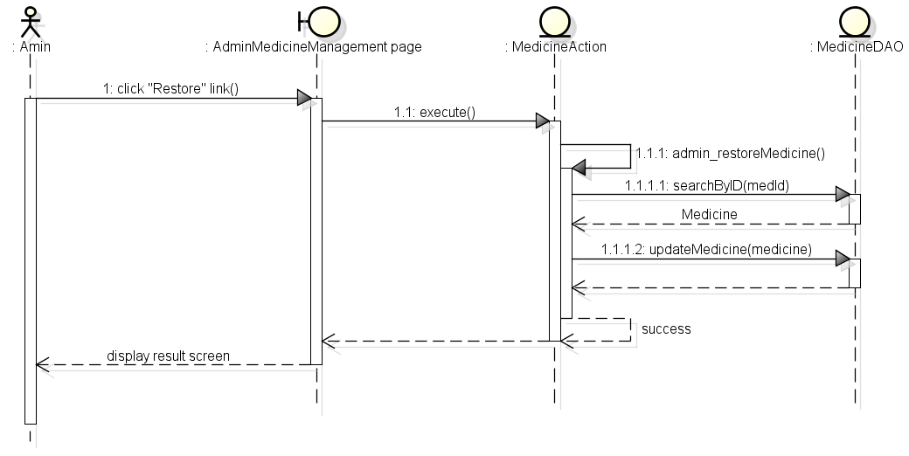

**Figure 4-60:** Sequence diagram- Manage medicine information- Restore medicine

## Search Pharmacy

### Class Diagram

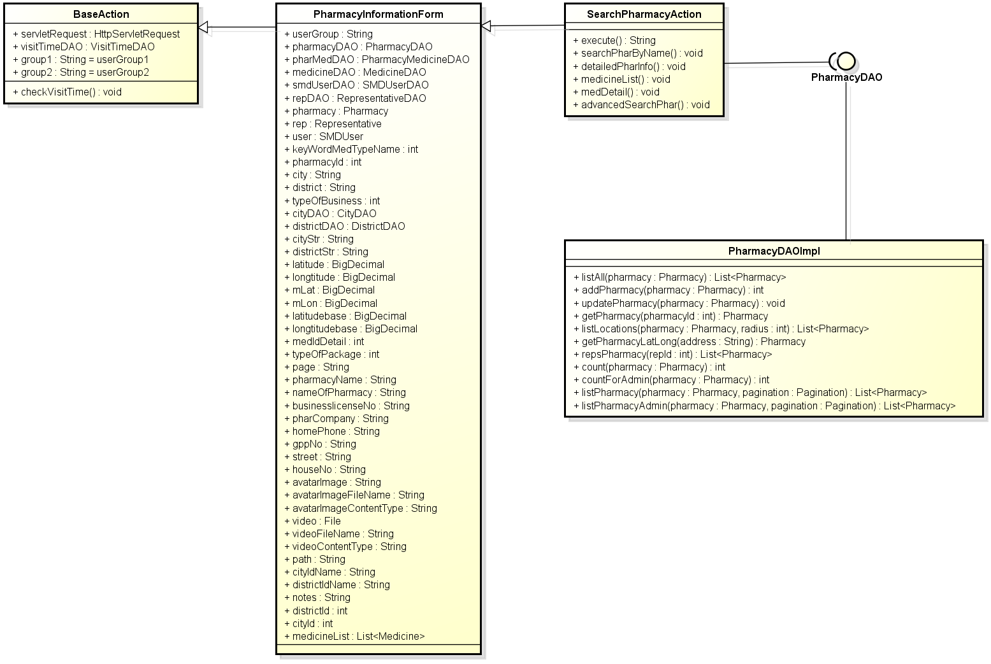

**Figure 4-61:** Class diagram- Search pharmacy

### Class Description

#### PharmacyInformarionForm

|  |  |  |  |  |
| --- | --- | --- | --- | --- |
| Class | PharmacyInfomationForm | | | |
| **Description** | Contains declare and constructor for all PharmacyInfomationAction’s attributes. | | | |
| **Base Class** | BaseAction | | | |
| **Constructor** | N/A | | | |
| **Prototype** | N/A | | | |
| **Source File** | PharmacyInfomationForm.java | | | |
| **Namespace** | com.med.dic.form | | | |
| A**ttributes** | userGroup… (see Figure 4-60) | | | |
| **Methods** | Name | Input | Output | Description |
| N/A | N/A | N/A | N/A |

#### SearchPharmacyAction

|  |  |  |  |  |
| --- | --- | --- | --- | --- |
| Class | SearchPharmacyAction | | | |
| **Description** | Contains search pharmacy methods. | | | |
| **Base Class** | PharmacyInfomationForm | | | |
| **Constructor** | N/A | | | |
| **Prototype** | N/A | | | |
| **Source File** | SearchPharmacyAction.java | | | |
| **Namespace** | com.med.dic.action | | | |
| A**ttributes** | N/A | | | |
| **Methods** | Name | Input | Output | Description |
| execute | N/A | String | Is a root method of all other methods in class, responsibility counts visitor. |
| searchPharAdvanced | N/A | String | Methods advanced search pharmacy. |
| searchPharByname | N/A | String | Methods search pharmacy by name. |

#### PharmacyDAOImpl

|  |  |  |  |  |
| --- | --- | --- | --- | --- |
| Class | PharmacyDAOImpl | | | |
| **Description** | Implements all PharmacyDAO interface’s methods. | | | |
| **Base Class** | N/A | | | |
| **Constructor** | N/A | | | |
| **Prototype** | N/A | | | |
| **Source File** | PharmacyDAOImpl.java | | | |
| **Namespace** | com.med.dic.dao.impl | | | |
| A**ttributes** | N/A | | | |
| **Methods** | Name | Input | Output | Description |
| countForAdmin | pharmacy | int | Methods count number of pharmacy contains keywords |
| count | pharmacy | int | Methods count number of pharmacy contains keywords |
| listPharmacy | Pharmacy, pagination | List<Pharmacy> | Methods list pharmacy by keywords. |
| listPharmacyAdmin | Pharmacy, pagination | List<Pharmacy> | Methods list pharmacy by keywords. |

### UC 019 – Normal Search Pharmacy

#### Screen Design

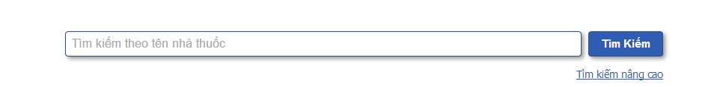

**Figure 4-62:** Search pharmacy- Normal search

**Table 4-22:** Search pharmacy- Normal search

|  |  |  |  |  |  |  |
| --- | --- | --- | --- | --- | --- | --- |
| No | **Object/Control Name** | **Object/Control Name in English** | **Type** | **Required** | **Length** | **Description** |
| 1 | Tìm kiếm theo tên nhà thuốc | Search by pharmacy name | Text width auto complete | N | 200 | Keywords user use to search pharmacy |
| 2 | Tìm kiếm | Search | Button | Y | N/A | Start search pharmacy inside system |
| 3 | Tìm kiếm nâng cao | Advanced search | Link | N | N/A | Switch to advanced search pharmacy |

#### Sequence Diagram

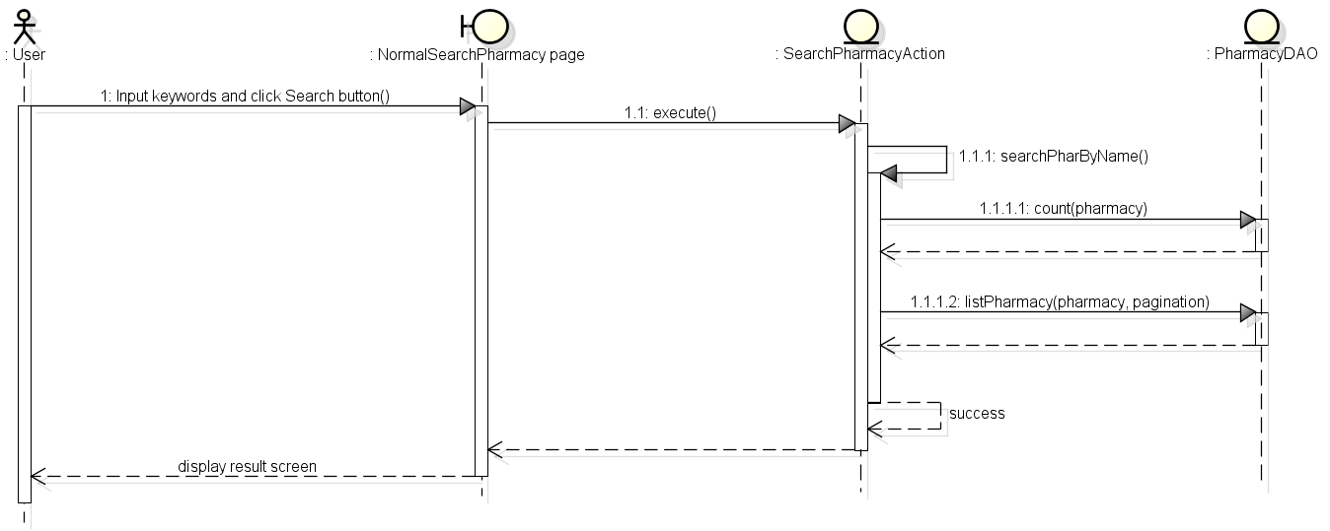

**Figure 4-63:** Sequence diagram- Search pharmacy- Normal search

### UC 020 - Advanced Search Pharmacy

#### Screen Diagram

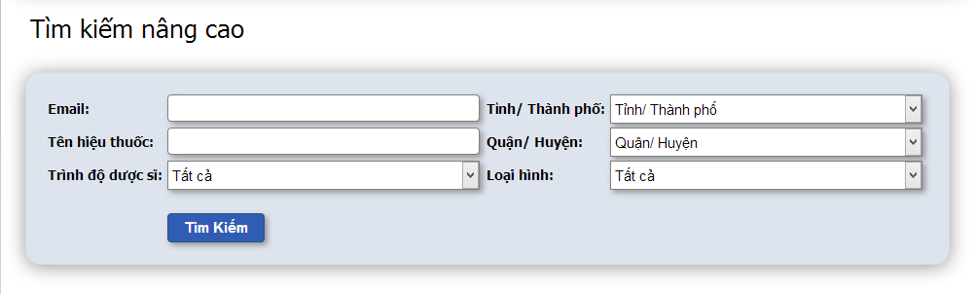

**Figure 4-64:** Search pharmacy- Advanced search

**Table 4-23:** Search pharmacy- Advanced search

|  |  |  |  |  |  |  |
| --- | --- | --- | --- | --- | --- | --- |
| No | **Object/Control Name** | **Object/Control Name in English** | **Type** | **Required** | **Length** | **Description** |
| 1 | Email | Email | Text | N | 150 | Email the representative of pharmacies user used to search |
| 2 | Tỉnh/ Thành phố | Province/ City | Combo box | N | N/A | Name province or city user choose to search |
| 3 | Tên hiệu thuốc | Pharmacy name | Text | N | 200 | Name of pharmacy user use to search |
| 4 | Quận/ Huyện | District | Combo box | N | N/A | Name of district user choose to search |
| 5 | Trình độ dược sĩ | Degree | Combo box | N | N/A | Degree the representative of pharmacy user choose to search |
| 6 | Loại hình | Type of business | Combo box | N | N/A | Type of business user use to search |
| 7 | Tìm kiếm | Search | Button | N | N/A | Search pharmacy into system |

#### Sequence Diagram

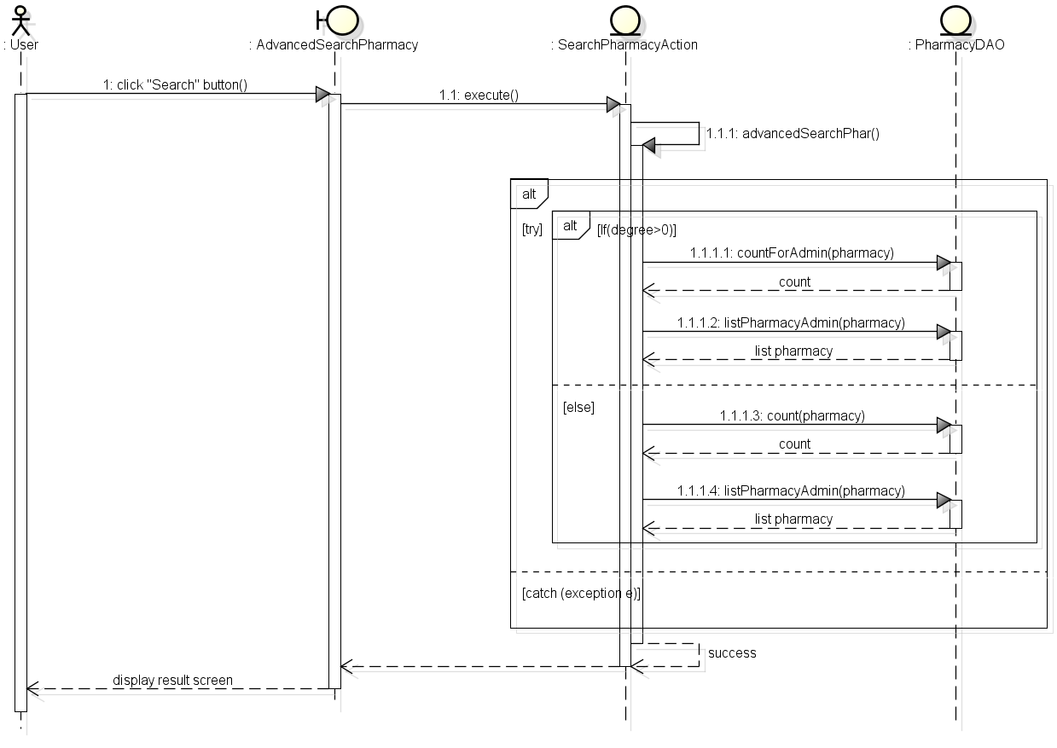

**Figure 4-65:** Sequence diagram- Search pharmacy- Advanced search

## Manage Pharmacy information

### Class Diagram

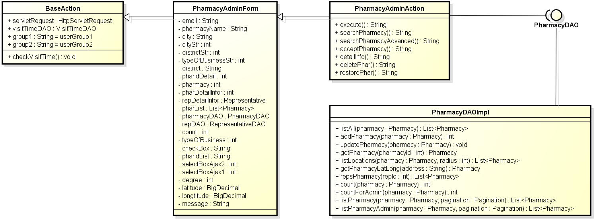

**Figure 4-66:** Class diagram- Manage pharmacy information

### Class Description

#### PharmacyAdminForm

|  |  |  |  |  |
| --- | --- | --- | --- | --- |
| Class | PharmacyAdminForm | | | |
| **Description** | Contains declare and constructor for all PharmacyAdminAction’s attributes. | | | |
| **Base Class** | BaseAction | | | |
| **Constructor** | N/A | | | |
| **Prototype** | N/A | | | |
| **Source File** | PharmacyAdminForm.java | | | |
| **Namespace** | com.med.dic.form | | | |
| A**ttributes** | email… (see Figure 4-65) | | | |
| **Methods** | Name | Input | Output | Description |
| N/A | N/A | N/A | N/A |

#### PharmacyAdminAction

|  |  |  |  |  |
| --- | --- | --- | --- | --- |
| Class | PharmacyAdminAction | | | |
| **Description** | Contains Pharmacy’s modify methods (delete, restore and update pharmacy) | | | |
| **Base Class** | PharmacyAdminForm | | | |
| **Constructor** | N/A | | | |
| **Prototype** | N/A | | | |
| **Source File** | PharmacyAdminAction.java | | | |
| **Namespace** | com.med.dic.action | | | |
| A**ttributes** | N/A | | | |
| **Methods** | Name | Input | Output | Description |
| execute | N/A | String | Is a root method of all other methods in class, responsibility counts visitor. |
| deletePhar | N/A | String | Method delete pharmacy. |
| acceptPharmacy | N/A | String | Method accept pharmacy. |
| restorePhar | N/A | String | Method restore pharmacy. |

#### PharmacyDAOImpl

|  |  |  |  |  |
| --- | --- | --- | --- | --- |
| Class | PharmacyDAOImpl | | | |
| **Description** | Implement all PharmacyDAO interface’s methods. | | | |
| **Base Class** | N/A | | | |
| **Constructor** | N/A | | | |
| **Prototype** | N/A | | | |
| **Source File** | PharmacyDAOImpl.java | | | |
| **Namespace** | com.med.dic.dao.impl | | | |
| A**ttributes** | N/A | | | |
| **Methods** | Name | Input | Output | Description |
| addPharmacy | pharmacy | int | Method add new pharmacy into DB. |
| getPharmacy | pharmacyId | Pharmacy | Method get pharmacy by id. |
| UpdatePharmacy | pharmacy | void | Method delete-restore pharmacy. |

### UC 021 – Accept Registered Pharmacy

#### Screen Design

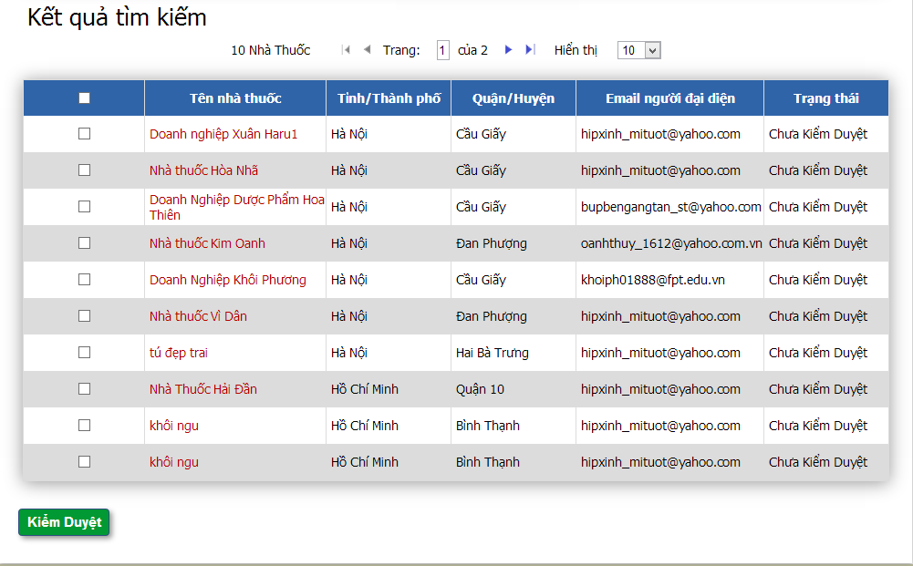

**Figure 4-67:** Manage pharmacy information- Accept pharmacy

**Table 4-24:** Manage pharmacy information- Accept pharmacy

|  |  |  |  |  |  |  |
| --- | --- | --- | --- | --- | --- | --- |
| **No** | **Object/Control Name** | **Object/Control Name in English** | **Type** | **Required** | **Length** | **Description** |
| 1 | Chọn | Tick | Check box | Y | N/A | Tick pharmacy to accept |
| 2 | Tên nhà thuốc | Pharmacy name | Text | N | N/A | Name of pharmacy |
| 3 | Tỉnh/ Thành phố | Province/ City | Text | N | N/A | Name of province or city of pharmacy |
| 4 | Quận/ Huyện | District | Text | N | N/A | District of pharmacy |
| 5 | Email người đại diện | Representative’s email | Text | N | N/A | Representative’s email |
| 6 | Trạng thái | Status | Text | N | N/A | Pharmacy status |
| 7 | Kiểm duyệt | Accept | Button | Y | N/A | Accept the ticked pharmacies |

#### Sequence Diagram

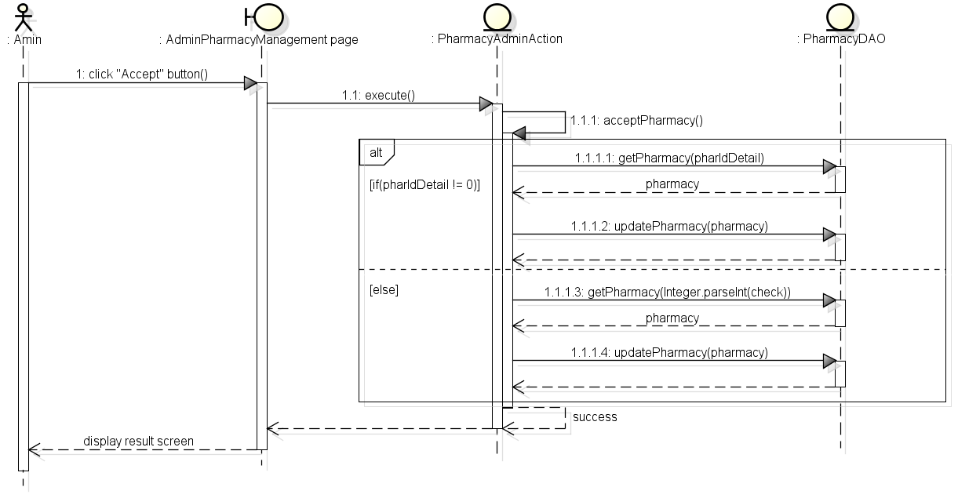

**Figure 4-68:** Sequence diagram- Manage pharmacy information- Accept pharmacy

### UC 022 - Delete Pharmacy

#### Screen Design

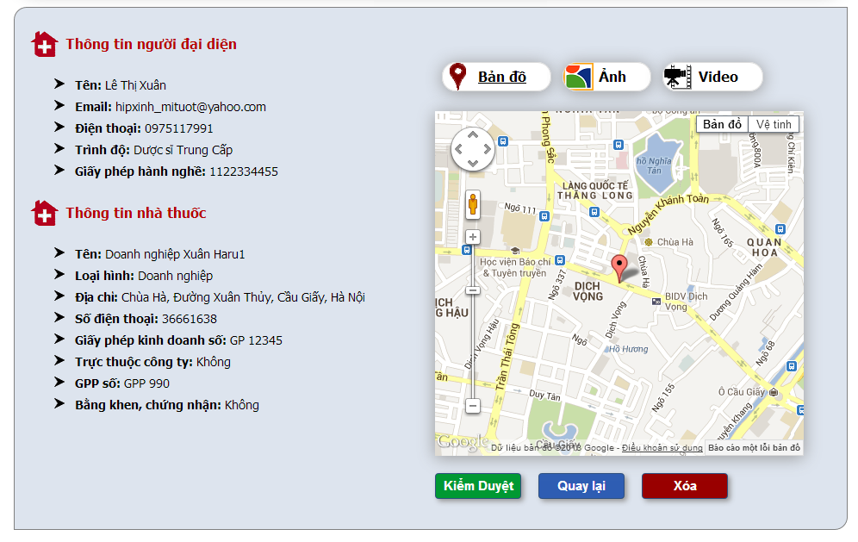

**Figure 4-69:** Manage pharmacy information- Delete pharmacy

**Table 4-25:** Manage pharmacy information- Delete pharmacy

|  |  |  |  |  |  |  |
| --- | --- | --- | --- | --- | --- | --- |
| **No** | **Object/Control Name** | **Object/Control Name in English** | **Type** | **Required** | **Length** | **Description** |
| 1 | Thông tin người đại diện | Representative information | Form | N | N/A | Representative form with 5 detail info ‘Tên’, ‘Email’, ‘Điện thoại’, ‘Trình độ’ and ‘Giấy phép hành nghề’ |
| 2 | Thông tin nhà thuốc | Pharmacy information | Form | N | N/A | Pharmacy information with 8 detail info ‘Tên’, ‘Loại hình’, ‘Địa chỉ’, ‘Số điện thoại’, ‘Giấy phép kinh doanh số’, ‘Trực thuộc công ty’, ‘GPP số’ and ‘Bằng khen, chứng nhận’ |
| 3 | Bản đồ | Map | Tab | N | N/A | Show pharmacy location on google map |
| 4 | Hình ảnh | Image | Tab | N | N/A | Show pharmacy image |
| 5 | Video | Video | Tab | N | N/A | Show pharmacy video |
| 6 | Kiểm duyệt | Accept | Button | N | N/A | Accept pharmacy |
| 7 | Quay lại | Back | Button | N | N/A | Back to previous page |
| 8 | Xóa | Delete | Button + confirm popup | Y | N/A | Update deleteFlag of pharmacy to “Y” |

#### Sequence Diagram

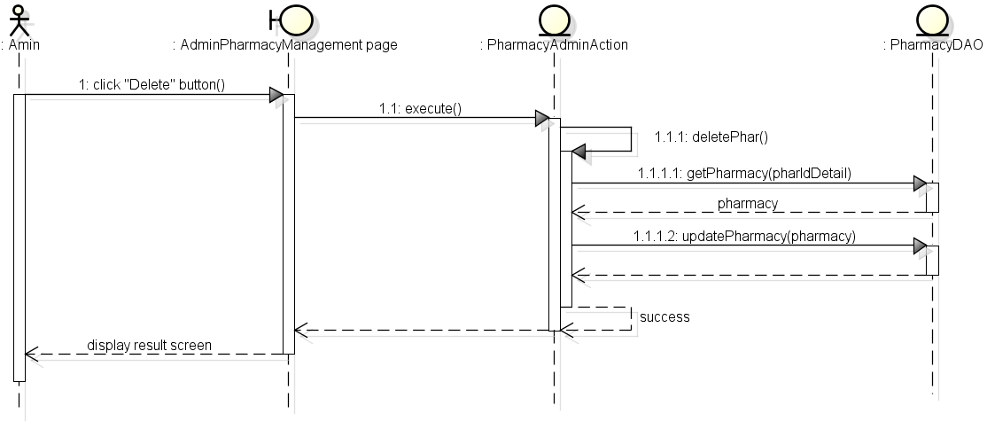

**Figure 4-70:** Sequence diagram- Manage pharmacy information- Delete pharmacy

### UC 023 - Restore Pharmacy

#### Screen Design

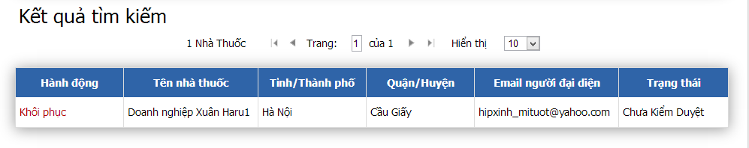

**Figure 4-71:** Manage pharmacy information- Restore pharmacy

**Table 4-26:** Manage pharmacy information- Restore pharmacy

|  |  |  |  |  |  |  |
| --- | --- | --- | --- | --- | --- | --- |
| **No** | **Object/Control Name** | **Object/Control Name in English** | **Type** | **Required** | **Length** | **Description** |
| 1 | Khôi phục | Restore | Link | N | N/A | Update deleteFlag of pharmacy to “N” |
| 2 | Tên nhà thuốc | Pharmacy name | Text | N | N/A | Name of pharmacy |
| 3 | Tỉnh/ Thành phố | Province/ City | Text | N | N/A | Name of province or city of pharmacy |
| 4 | Quận/ Huyện | District | Text | N | N/A | District of pharmacy |
| 5 | Email người đại diện | Representative’s email | Text | N | N/A | Representative’s email |
| 6 | Trạng thái | Status | Text | N | N/A | Pharmacy status |

#### Sequence Diagram

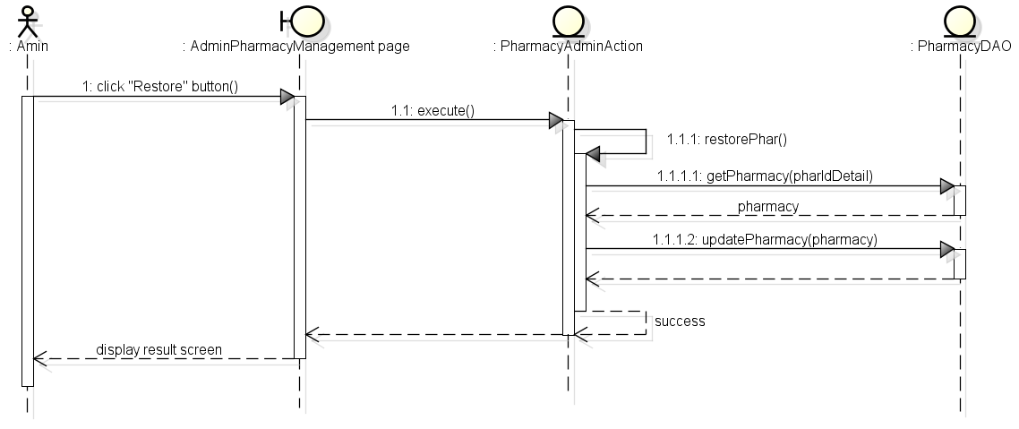

**Figure 4-72:** Sequence diagram- Manage pharmacy information- Restore pharmacy

## UC 024 – Pharmacy Change Info

### Class Diagram

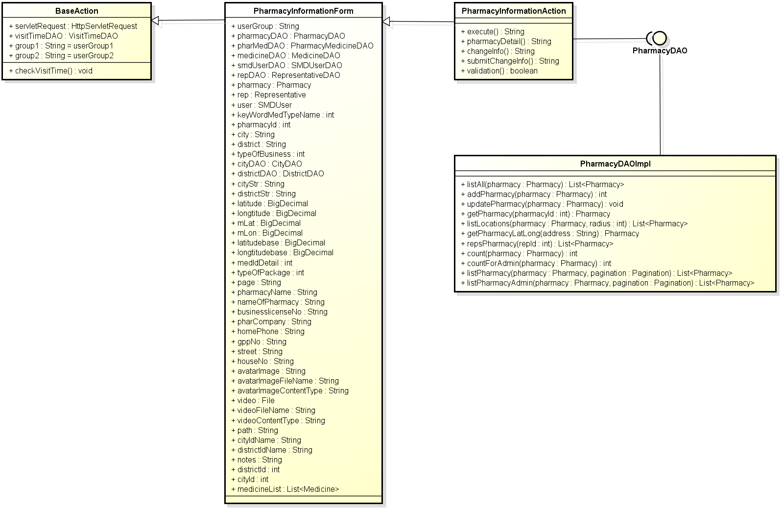

**Figure 4-73:** Class diagram- Pharmacy change info

### Class Description

#### PharmacyInfomationForm

|  |  |  |  |  |
| --- | --- | --- | --- | --- |
| Class | PharmacyInfomationForm | | | |
| **Description** | Contains declare and constructor for all PharmacyInfomationAction’s attributes. | | | |
| **Base Class** | BaseAction | | | |
| **Constructor** | N/A | | | |
| **Prototype** | N/A | | | |
| **Source File** | PharmacyInfomationForm.java | | | |
| **Namespace** | com.med.dic.form | | | |
| A**ttributes** | userGroup… (see Figure 4-72) | | | |
| **Methods** | Name | Input | Output | Description |
| N/A | N/A | N/A | N/A |

#### PharmacyInformationAction

|  |  |  |  |  |
| --- | --- | --- | --- | --- |
| Class | PharmacyInformationAction | | | |
| **Description** | Contains pharmacy changeInfo methods. | | | |
| **Base Class** | PharmacyInfomationForm | | | |
| **Constructor** | N/A | | | |
| **Prototype** | N/A | | | |
| **Source File** | PharmacyInfomationAction.java | | | |
| **Namespace** | com.med.dic.action | | | |
| A**ttributes** | Name | Type | Description | |
| (see figure) | N/A | N/A | |
| **Methods** | Name | Input | Output | Description |
| validation | N/A | Boolean | Method check pharmacy input keywords. |
| submitChangeInfo | N/A | String | Method update medicine info into DB. |

#### PharmacyDAOImpl

|  |  |  |  |  |
| --- | --- | --- | --- | --- |
| Class | PharmacyDAOImpl | | | |
| **Description** | Implements all PharmacyDAO interface’s methods. | | | |
| **Base Class** | N/A | | | |
| **Constructor** | N/A | | | |
| **Prototype** | N/A | | | |
| **Source File** | PharmacyDAOImpl.java | | | |
| **Namespace** | com.med.dic.dao.impl | | | |
| A**ttributes** | Name | Type | Description | |
| N/A | N/A | N/A | |
| **Methods** | Name | Input | Output | Description |
| getPharmacy | pharmacyId | Pharmacy | Methods get pharmacy info by id. |
| updatePharmacy | pharmacy | void | Methods update pharmacy info into DB. |

### Screen Design

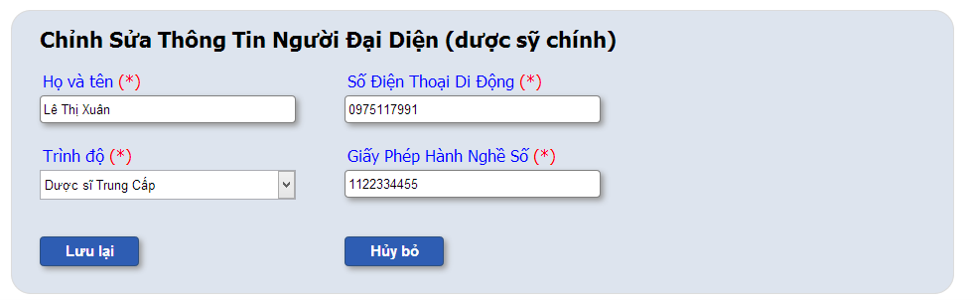

**Figure 4-74:** Pharmacy change info

**Table 4-27:** Pharmacy change info

|  |  |  |  |  |  |  |
| --- | --- | --- | --- | --- | --- | --- |
| **No** | **Object/Control Name** | **Object/Control Name in English** | **Type** | **Required** | **Length** | **Description** |
| 1 | Họ và tên | Name | Text | Y | 150 | New representative name |
| 2 | Số điện thoại di động | Mobile phone | Number | Y | 15 | New representative mobile phone number |
| 3 | Trình độ | Degree | Combo box | Y | N/A | New representative degree |
| 4 | Giấy phép hành nghề số | Licensure No | Text | Y | 100 | New representative licensure number |
| 5 | Lưu lại | Save | Button | N | N/A | Update representative changes infomation |
| 6 | Hủy bỏ | Cancel | Button | N | N/A | Cancel update |

### Sequence Diagram



**Figure 4-75:** Sequence diagram- Pharmacy change info

## Manage News

### Class Diagram

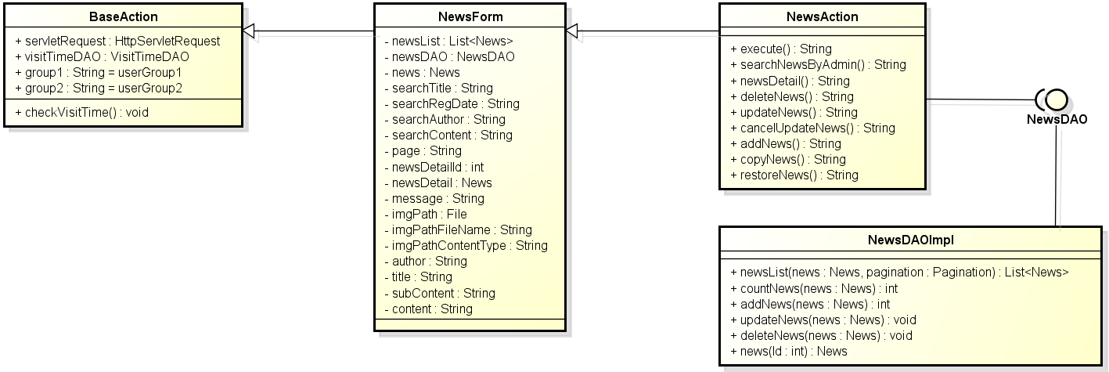

**Figure 4-76:** Class diagram- Manage news

### Class Description

#### NewsForm

|  |  |  |  |  |
| --- | --- | --- | --- | --- |
| Class | NewsForm | | | |
| **Description** | Contains declare and constructor for all NewsAction’s attributes. | | | |
| **Base Class** | BaseAction | | | |
| **Constructor** | N/A | | | |
| **Prototype** | N/A | | | |
| **Source File** | NewsForm.java | | | |
| **Namespace** | com.med.dic.form | | | |
| A**ttributes** | newList… (see Figure 4-75) | | | |
| **Methods** | Name | Input | Output | Description |
| N/A | N/A | N/A | N/A |

#### NewsAction

|  |  |  |  |  |
| --- | --- | --- | --- | --- |
| Class | NewsAction | | | |
| **Description** | Contains news modify methods. | | | |
| **Base Class** | NewsForm | | | |
| **Constructor** | N/A | | | |
| **Prototype** | N/A | | | |
| **Source File** | NewsAction.java | | | |
| **Namespace** | com.med.dic.action | | | |
| A**ttributes** | N/A | | | |
| **Methods** | Name | Input | Output | Description |
| execute | N/A | String | Is a root method of all other methods in class, responsibility counts visitor. |
| deleteNews | N/A | String | Methods delete news. |
| restoreNews | N/A | String | Methods restore news. |
| searchNewByAdmin | N/A | String | Methods search news. |
| addNew | N/A | String | Methods add new news into DB. |

#### NewsDAOImpl

|  |  |  |  |  |
| --- | --- | --- | --- | --- |
| Class | NewsDAOImpl | | | |
| **Description** | Implement all NewsDAO interface’s methods. | | | |
| **Base Class** | N/A | | | |
| **Constructor** | N/A | | | |
| **Prototype** | N/A | | | |
| **Source File** | NewsDAOImpl.java | | | |
| **Namespace** | com.med.dic.dao.impl | | | |
| A**ttributes** | N/A | | | |
| **Methods** | Name | Input | Output | Description |
| countNews | N/A | String | Is a root method of all other methods in class, responsibility counts visitor. |
| news | news | int | Methods count number of news contains keywords. |
| updateNews | news | void | Methods update news into DB. |
| deleteNews | news | void | Methods delete news. |
| addNews | news | int | Methods add news into DB. |
| newsList | News, pagination | List<News> | Methods list news. |

### UC025 – Add News

#### Screen Design

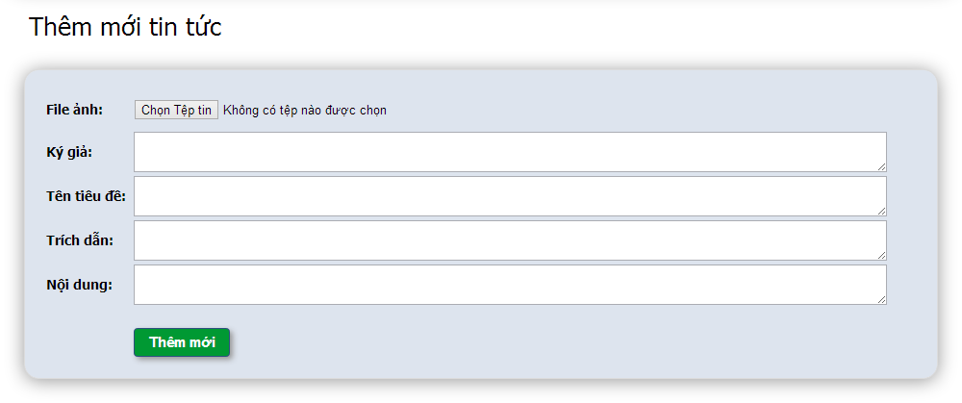**Figure 4-77:** Manage news- Add news

**Table 4-28:** Manage news- Add news

|  |  |  |  |  |  |  |
| --- | --- | --- | --- | --- | --- | --- |
| **No** | **Object/Control Name** | **Object/Control Name in English** | **Type** | **Required** | **Length** | **Description** |
| 1 | File ảnh | Image file | File | Y | N/A | Image of news |
| 2 | Ký giả | Author | Text area | Y | 150 | Name of news’s author |
| 3 | Tên tiêu đề | Title | Text area | Y | 150 | Title of news |
| 4 | Trích dẫn | Sub content | Text area | Y | 500 | Sub content of news |
| 5 | Nội dung | Content | Text area | Y | 5000 | Content of news |
| 6 | Thêm mới | Add | Button | Y | N/A | Add news into system |

#### Sequence Diagram

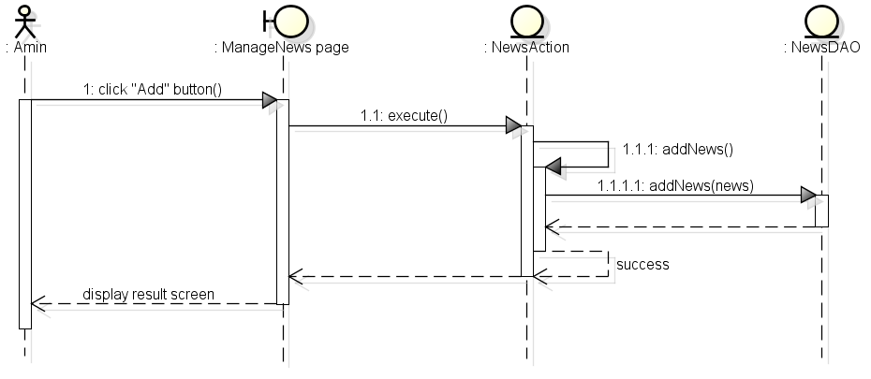

**Figure 4-78:** Sequence diagram- Manage news- Add news

### UC 026 – Update News

#### Screen Design

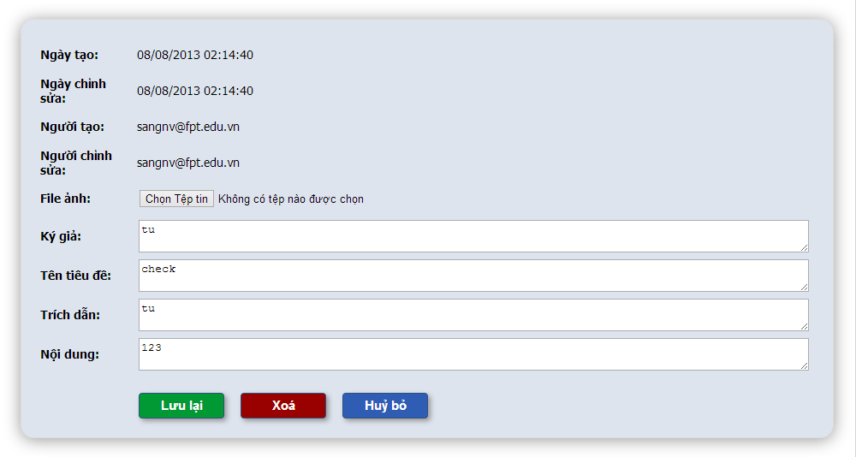

**Figure 4-79:** Manage news- update news

**Table 4-29:** Manage news- update news

|  |  |  |  |  |  |  |
| --- | --- | --- | --- | --- | --- | --- |
| **No** | **Object/Control Name** | **Object/Control Name in English** | **Type** | **Required** | **Length** | **Description** |
| 1 | Ngày tạo | Created date | Text | Y | N/A | News created date |
| 2 | Ngày chỉnh | Modified date | Text | Y | N/A | News modified date |
| 3 | Người tạo | Register user | Text | Y | N/A | News register user name |
| 4 | Người chỉnh sửa | Modify user | Text | Y | N/A | News modify user name |
| 5 | File ảnh | Image file | File | Y | N/A | Image of news |
| 6 | Ký giả | Author | Text area | Y | 150 | Name of news’s author |
| 7 | Tên tiêu đề | Title | Text area | Y | 150 | Title of news |
| 8 | Trích dẫn | Sub content | Text area | Y | 500 | Sub content of news |
| 9 | Nội dung | Content | Text area | Y | 5000 | Content of news |
| 10 | Lưu lại | Save | Button | Y | N/A | Update new news information into system |
| 11 | Xóa | Delete | Button + confirm popup | N | N/A | Update deleteFlag of news to “Y” |
| 12 | Hủy bỏ | Cancel | Button | N | N/A | Cancel edit news |

#### Sequence Diagram

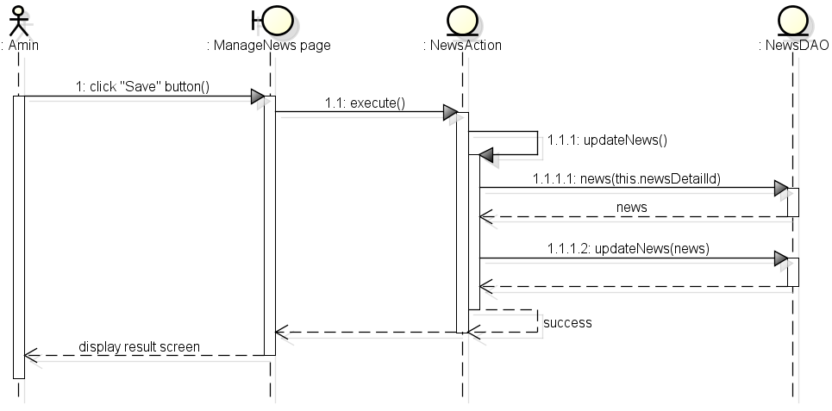

**Figure 4-80:** Sequence diagram- Manage news- Update news

### UC 027 - Delete News

#### Screen Design



**Figure 4-81:** Manage news- Delete news

**Table 4-30:** Manage news- Delete news

|  |  |  |  |  |  |  |
| --- | --- | --- | --- | --- | --- | --- |
| **No** | **Object/Control Name** | **Object/Control Name in English** | **Type** | **Required** | **Length** | **Description** |
| 1 | Ngày tạo | Created date | Text | N | N/A | News created date |
| 2 | Ngày chỉnh | Modified date | Text | N | N/A | News modified date |
| 3 | Người tạo | Register user | Text | N | N/A | News register user name |
| 4 | Người chỉnh sửa | Modify user | Text | N | N/A | News modify user name |
| 5 | File ảnh | Image file | File | N | N/A | Image of news |
| 6 | Ký giả | Author | Text area | N | 150 | Name of news’s author |
| 7 | Tên tiêu đề | Title | Text area | N | 150 | Title of news |
| 8 | Trích dẫn | Sub content | Text area | N | 500 | Sub content of news |
| 9 | Nội dung | Content | Text area | N | 5000 | Content of news |
| 10 | Lưu lại | Save | Button | N | N/A | Update new news information into system |
| 11 | Xóa | Delete | Button + confirm popup | Y | N/A | Update deleteFlag of news to “Y” |
| 12 | Hủy bỏ | Cancel | Button | N | N/A | Cancel edit news |

#### Sequence Diagram

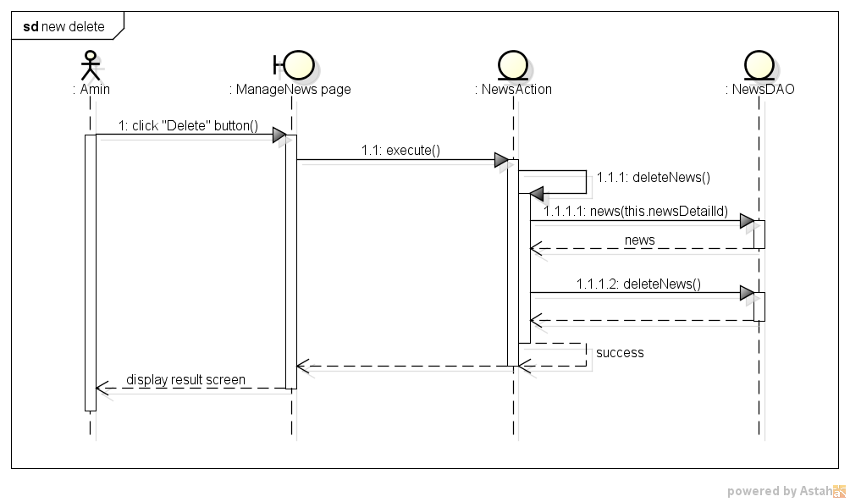

**Figure 4-82:** Sequence diagram- Manage news- Delete news

### UC 028 – Restore News

#### Screen Design

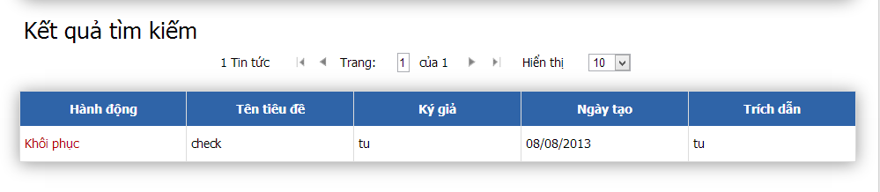

**Figure 4-83:** Manage news- Restore news

**Table 4-31:** Manage news- Restore news

|  |  |  |  |  |  |  |
| --- | --- | --- | --- | --- | --- | --- |
| **No** | **Object/Control Name** | **Object/Control Name in English** | **Type** | **Required** | **Length** | **Description** |
| 1 | Khôi phục | Restore | Link | Y | N/A | Update deleteFlag of news to “N” |
| 2 | Tên tiêu đề | Title | Text | N | N/A | Title of news |
| 3 | Ký giả | Author | Text | N | N/A | Author of news |
| 4 | Ngày tạo | Created date | Text | N | N/A | Created date of news |
| 5 | Trích dẫn | Sub content | Text | N | N/A | Sub content of news |

#### Sequence Diagram

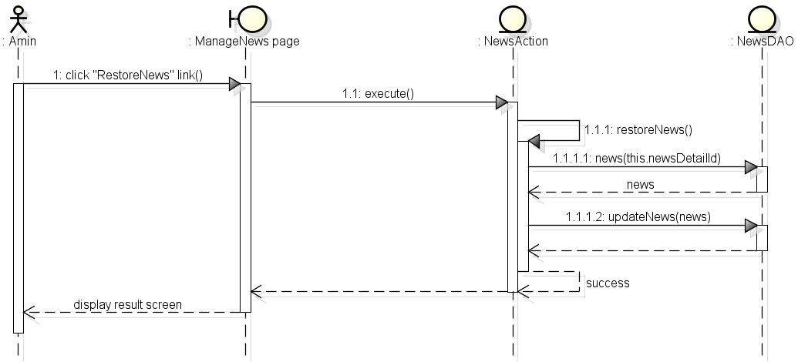

**Figure 4-84:** Sequence diagram- Manage news- Restore news

### UC 029 - Search News

#### Screen Design

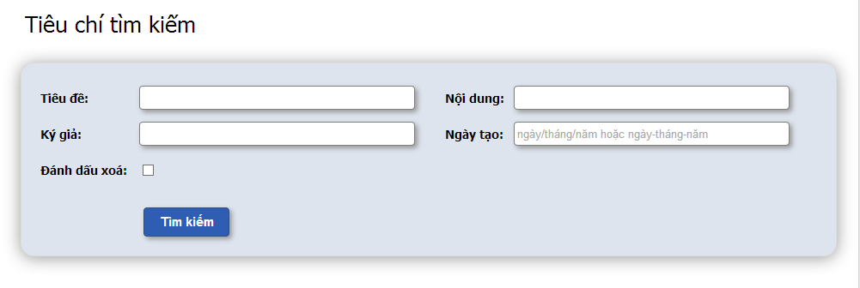

**Figure 4-85:** Manage news- Search news

**Table 4-32:** Manage news- Search news

|  |  |  |  |  |  |  |
| --- | --- | --- | --- | --- | --- | --- |
| **No** | **Object/Control Name** | **Object/Control Name in English** | **Type** | **Required** | **Length** | **Description** |
| 1 | Tên tiêu đề | Title | Text | Y | 150 | Title of news |
| 2 | Nội dung | Content | Text | Y | 5000 | Content of news |
| 3 | Ký giả | Author | Text | Y | 150 | Name of news’s author |
| 4 | Ngày tạo | Create date | Text + date format | Y | N/A | Create date of news |
| 5 | Tìm kiếm | Search | Button | Y | N/A | Search news into system |

#### Sequence Diagram

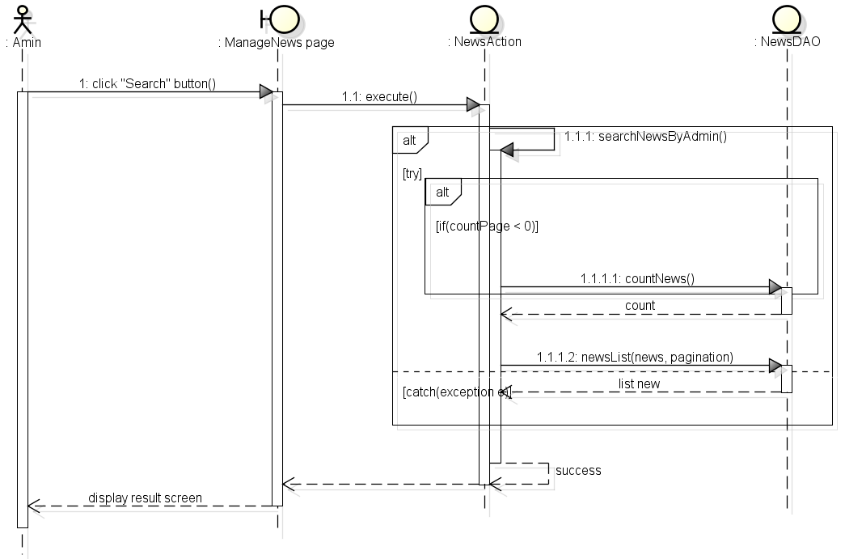

**Figure 4-86:** Manage news- Search news

### UC 030 – View News

#### Screen Design

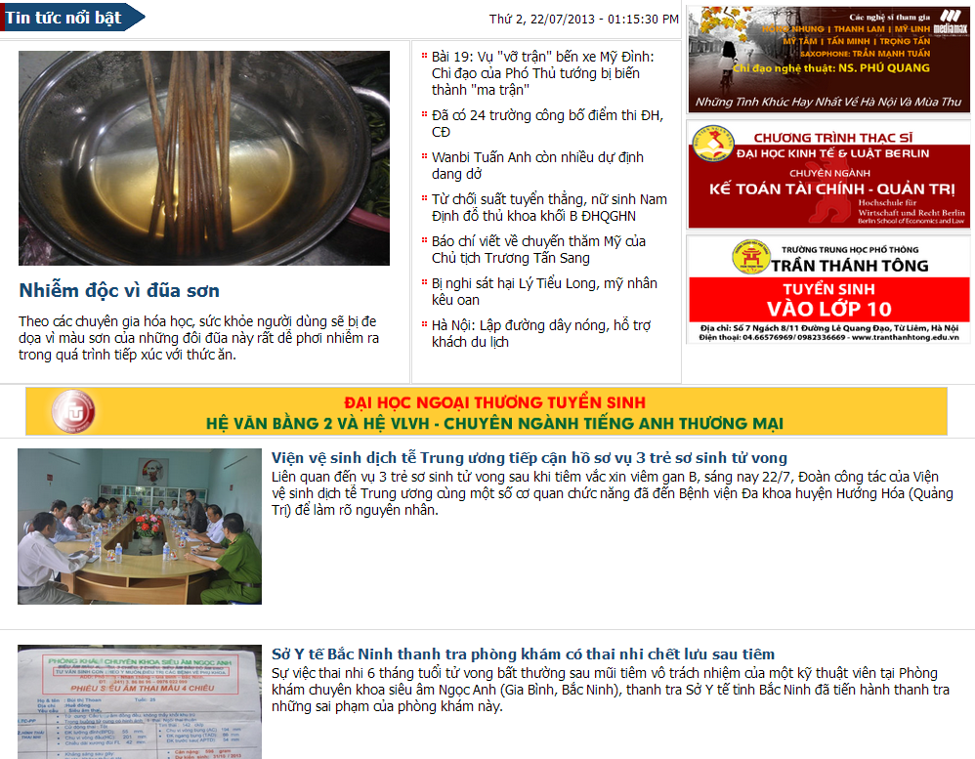

**Figure 4-87:** Manage news- View news

**Table 4-33:** Manage news- View news

|  |  |  |  |  |  |  |
| --- | --- | --- | --- | --- | --- | --- |
| **No** | **Object/Control Name** | **Object/Control Name in English** | **Type** | **Required** | **Length** | **Description** |
| 1 | Tin tức nổi bật | Hight light news | Form | N | N/A | The biggest and hottest news |
| 2 | Những tin tức đáng chú ý | Noteworthy news | Form | N | N/A | Top 7 Noteworthy news |
| 3 | Tin tức thường | Normal news | Form | N | N/A | Normal news |

#### Sequence Diagram

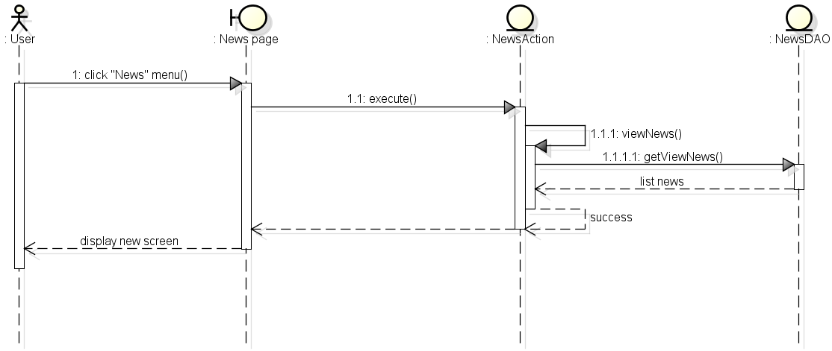

**Figure 4-88:** Manage news- View news

## UC 031 – View Detail Medicine Info

### Class Diagram

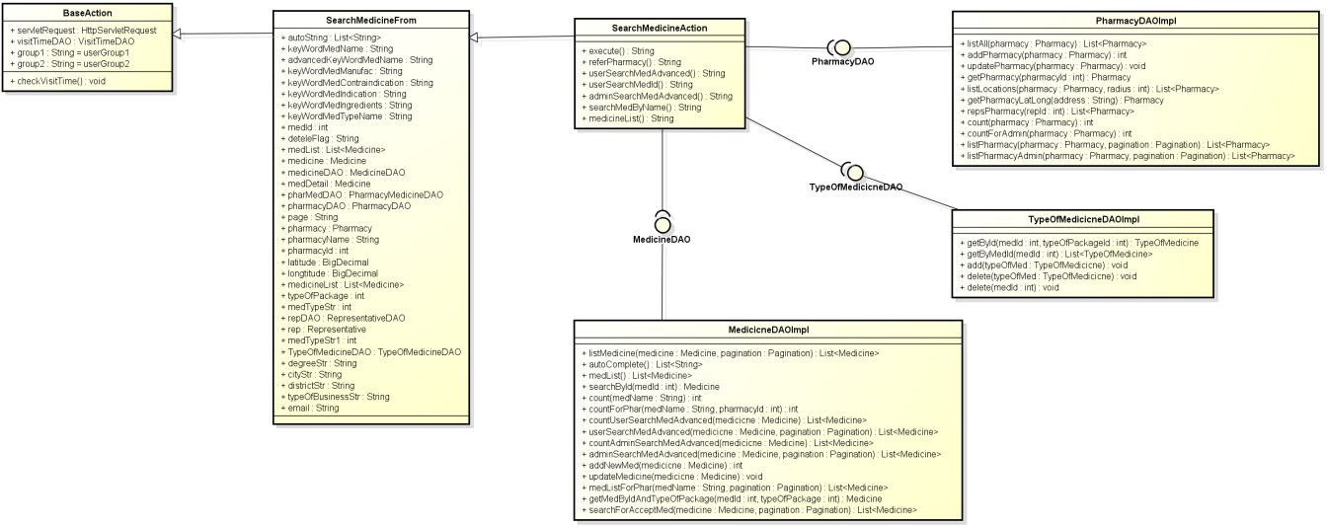

**Figure 4-89:** Class diagram- View detail medicine info

### Class Description

#### SearchMedicineForm

|  |  |  |  |  |
| --- | --- | --- | --- | --- |
| Class | SearchMedicineForm | | | |
| **Description** | Contains declare and constructor for all SearchMedicineAction’s attributes. | | | |
| **Base Class** | BaseAction | | | |
| **Constructor** | N/A | | | |
| **Prototype** | N/A | | | |
| **Source File** | SearchMedicineForm.java | | | |
| **Namespace** | com.med.dic.form | | | |
| A**ttributes** | autoString… (see Figure 4-88) | | | |
| **Methods** | Name | Input | Output | Description |
| N/A | N/A | N/A | N/A |

#### SearchMedicineAction

|  |  |  |  |  |
| --- | --- | --- | --- | --- |
| Class | SearchMedicineAction | | | |
| **Description** | Contains searching medicine methods. | | | |
| **Base Class** | SearchMedicineActionForm | | | |
| **Constructor** | N/A | | | |
| **Prototype** | N/A | | | |
| **Source File** | SearchMedicineAction.java | | | |
| **Namespace** | com.med.dic.action | | | |
| A**ttributes** | N/A | | | |
| **Methods** | Name | Input | Output | Description |
| execute | N/A | String | Is a root method of all other methods in class, responsibility counts visitor. |
| userSearchMedByName | N/A | String | Method search medicines by name. |

#### MedicineDAOImpl

|  |  |  |  |  |
| --- | --- | --- | --- | --- |
| Class | MedicineDAOImpl | | | |
| **Description** | Implement MedicineDAO interface’s methods | | | |
| **Base Class** | N/A | | | |
| **Constructor** | N/A | | | |
| **Prototype** | N/A | | | |
| **Source File** | MedicineDAOImpl.java | | | |
| **Namespace** | com.med.dic.dao.impl | | | |
| A**ttributes** | N/A | | | |
| **Methods** | Name | Input | Output | Description |
| searchById | medId | Medicine | Method search medicine by id |

#### TypeOfMedicineDAOImpl

|  |  |  |  |  |
| --- | --- | --- | --- | --- |
| Class | TypeOfMedicineDAOImpl | | | |
| **Description** | Implement all TypeOfMedicineDAO interface’s methods. | | | |
| **Base Class** | N/A | | | |
| **Constructor** | N/A | | | |
| **Prototype** | N/A | | | |
| **Source File** | TypeOfMedicineDAOImpl.java | | | |
| **Namespace** | com.med.dic.dao.impl | | | |
| A**ttributes** | N/A | | | |
| **Methods** | Name | Input | Output | Description |
| getByMedId | medId | List<TypeOfMed> | Methods list all type of med by medId. |
| getPharmacy | pharId | Pharmacy | Methods get pharmacy by id |

### Screen Design

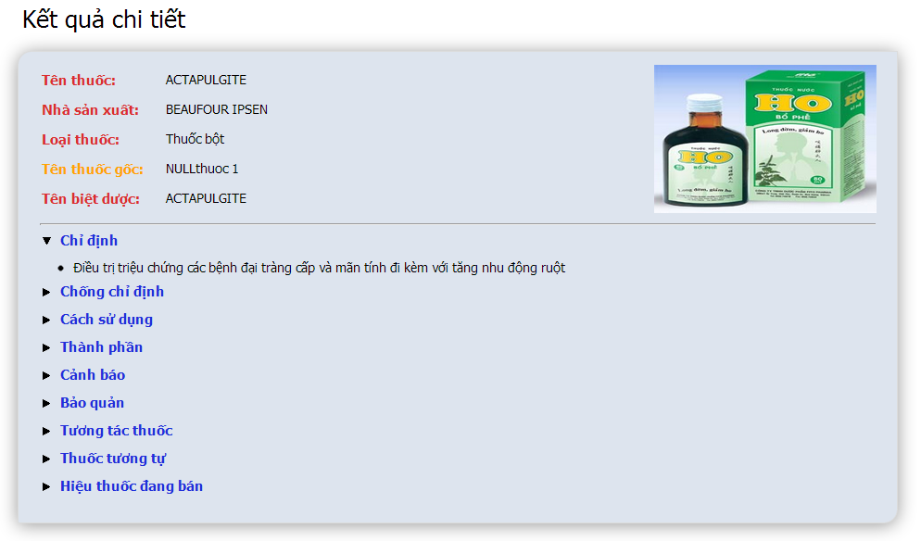

**Figure 4-90:** View detail medicine info

**Table 4-34:** View detail medicine info

|  |  |  |  |  |  |  |
| --- | --- | --- | --- | --- | --- | --- |
| **No** | **Object/Control Name** | **Object/Control Name in English** | **Type** | **Required** | **Length** | **Description** |
| 1 | Tên thuốc | Name | Text | N | N/A | Medicine name |
| 2 | Nhà sản xuất | Manufacturer | Text | N | N/A | Medicine name |
| 3 | Loại thuốc | Types of medicine | Text | N | N/A | Medicine types |
| 4 | Tên thuốc gốc | Generic medicine | Text | N | N/A | Generic name of medicine |
| 5 | Tên biệt dược | Brand name | Text | N | N/A | Brand name of medicine |
| 6 | Chỉ định | Indication | Text + dynamic drop down | N | N/A | Medicine indication |
| 7 | Chống chỉ định | Contraindication | Text + dynamic drop down | N | N/A | Medicine contraindication |
| 8 | Cách sử dụng | Dosing and use | Text + dynamic drop down | N | N/A | Dosing and use of medicine |
| 9 | Thành phần | Ingredient | Text + dynamic drop down | N | N/A | Medicine ingredients |
| 10 | Cảnh bảo | Warring | Text + dynamic drop down | N | N/A | Medicine warring |
| 11 | Bảo quản | Storage | Text + dynamic drop down | N | N/A | Medicine storage |
| 12 | Tương tác thuốc | Interaction medicine | Text + dynamic drop down | N | N/A | Medicines interaction with the medicine |
| 13 | Thuốc tương tự | Similar medicine | Text + dynamic drop down | N | N/A | Medicines similar with the medicine |
| 14 | Hiệu thuốc đang bán | Selling pharmacy | Link + dynamic drop down | N | N/A | Pharmacies selling this medicine |

### Sequence Diagram

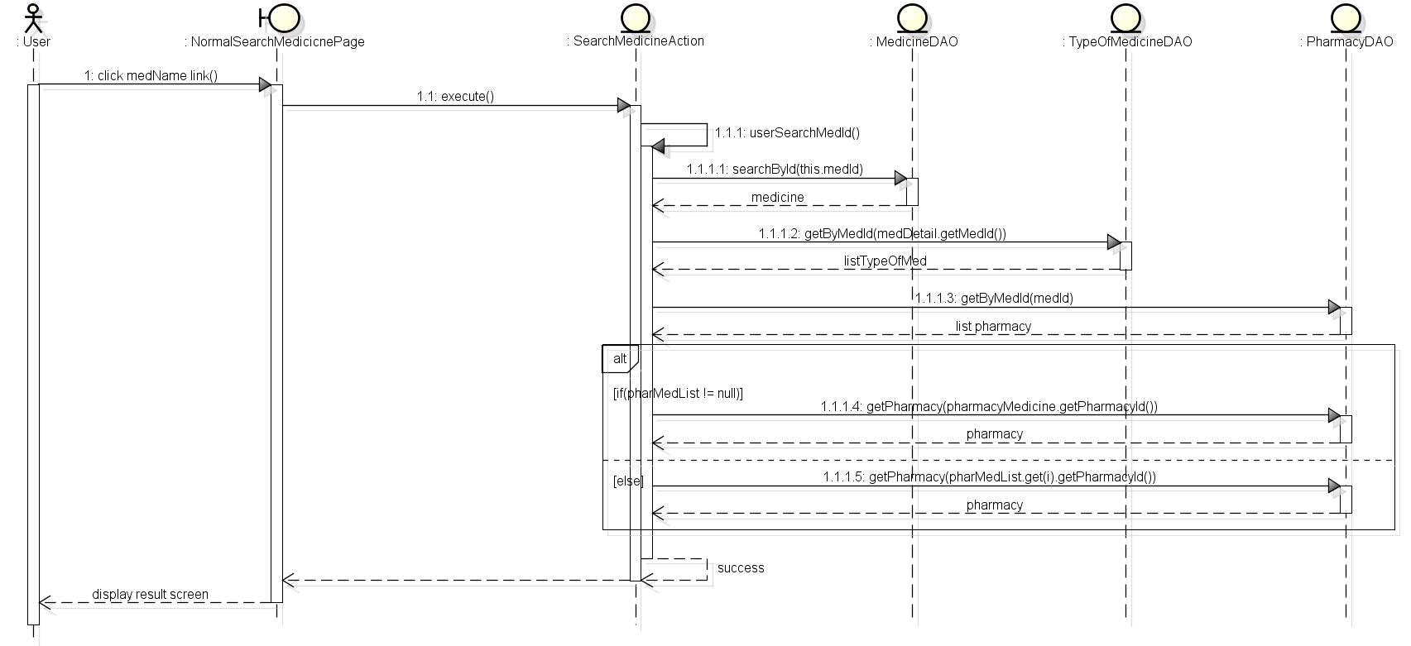

**Figure 4-91:** Sequence diagram- View detail medicine info

## UC 032 – View Detail Pharmacy Info

### Class Diagram

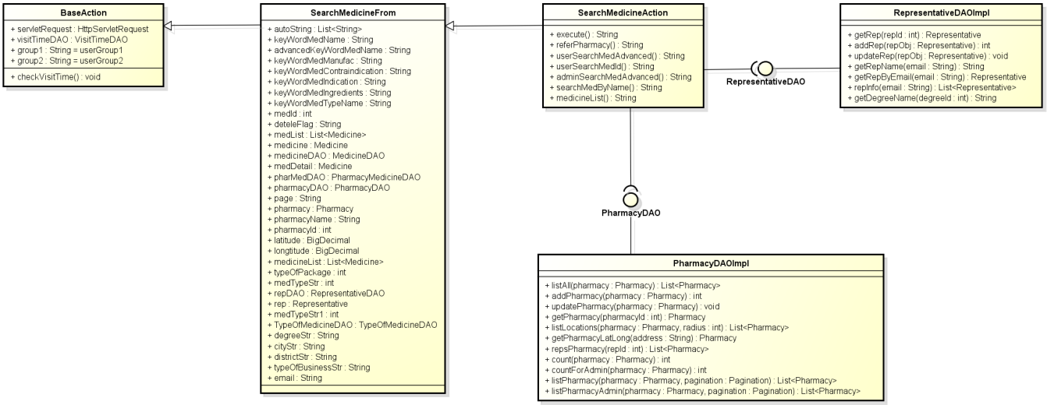

**Figure 4-92:** Class diagram- View detail pharmacy info

### Class Description

#### SearchMedicineForm

|  |  |  |  |  |
| --- | --- | --- | --- | --- |
| Class | SearchMedicineForm | | | |
| **Description** | Contains declare and constructor for all SearchMedicineAction’s attributes. | | | |
| **Base Class** | BaseAction | | | |
| **Constructor** | N/A | | | |
| **Prototype** | N/A | | | |
| **Source File** | SearchMedicineForm.java | | | |
| **Namespace** | com.med.dic.form | | | |
| A**ttributes** | autoString… (see Figure 4-91) | | | |
| **Methods** | Name | Input | Output | Description |
| N/A | N/A | N/A | N/A |

#### SearchMedicineAction

|  |  |  |  |  |
| --- | --- | --- | --- | --- |
| Class | SearchMedicineAction | | | |
| **Description** | Contains searching medicine methods. | | | |
| **Base Class** | SearchMedicineActionForm | | | |
| **Constructor** | N/A | | | |
| **Prototype** | N/A | | | |
| **Source File** | SearchMedicineAction.java | | | |
| **Namespace** | com.med.dic.action | | | |
| A**ttributes** | N/A | | | |
| **Methods** | Name | Input | Output | Description |
| execute | N/A | String | Is a root method of all other methods in class, responsibility counts visitor. |
|  | ReferPharmacy | N/A | String | Methods refer pharmacy. |

#### PharmacyDAOImpl

|  |  |  |  |  |
| --- | --- | --- | --- | --- |
| Class | PharmacyDAOImpl | | | |
| **Description** | Implement PharmacyDAO interface’s methods | | | |
| **Base Class** | N/A | | | |
| **Constructor** | N/A | | | |
| **Prototype** | N/A | | | |
| **Source File** | PharmacyDAOImpl.java | | | |
| **Namespace** | com.med.dic.dao.impl | | | |
| A**ttributes** | N/A | | | |
| **Methods** | Name | Input | Output | Description |
| getPharmacy | pharId | Pharmacy | Methods get pharmacy by id. |

#### RepresentativeDAOImpl

|  |  |  |  |  |
| --- | --- | --- | --- | --- |
| Class | RepresentativeDAOImpl | | | |
| **Description** | Implement RepresentaiveDAO interface’s methods | | | |
| **Base Class** | N/A | | | |
| **Constructor** | N/A | | | |
| **Prototype** | N/A | | | |
| **Source File** | RepresentativeDAOImpl.java | | | |
| **Namespace** | com.med.dic.dao.impl | | | |
| A**ttributes** | N/A | | | |
| **Methods** | Name | Input | Output | Description |
| GetRep | pharId | Pharmacy | Methods get pharmacy by id. |

### Screen Design

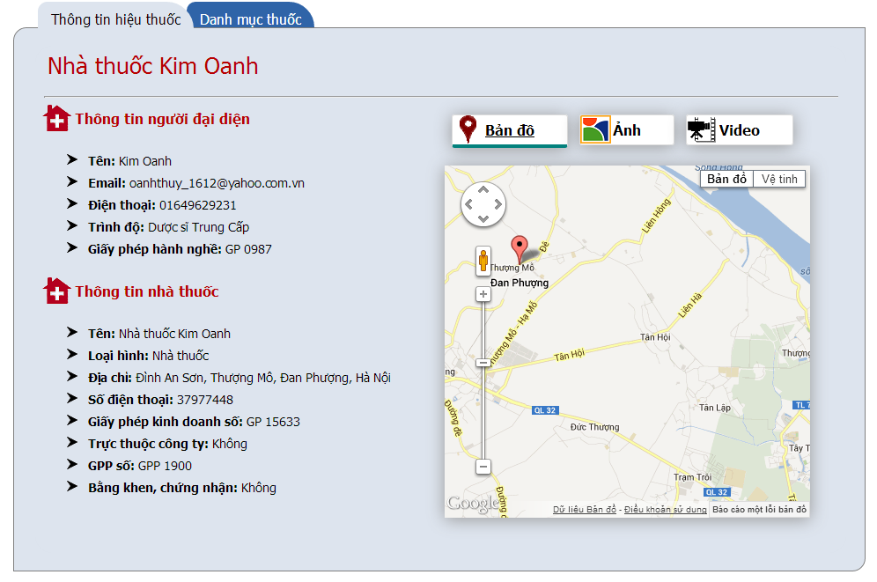

**Figure 4-93:** View detail pharmacy info

**Table 4-35:** View detail pharmacy info

|  |  |  |  |  |  |  |
| --- | --- | --- | --- | --- | --- | --- |
| **No** | **Object/Control Name** | **Object/Control Name in English** | **Type** | **Required** | **Length** | **Description** |
| 1 | Thông tin người đại diện | Representative information | Form | N | N/A | Representative form with 5 detail info ‘Tên’, ‘Email’, ‘Điện thoại’, ‘Trình độ’ and ‘Giấy phép hành nghề’ |
| 2 | Thông tin nhà thuốc | Pharmacy information | Form | N | N/A | Pharmacy information with 8 detail info ‘Tên’, ‘Loại hình’, ‘Địa chỉ’, ‘Số điện thoại’, ‘Giấy phép kinh doanh số’, ‘Trực thuộc công ty’, ‘GPP số’ and ‘Bằng khen, chứng nhận’ |
| 3 | Bản đồ | Map | Tab | N | N/A | Show pharmacy location on google map |
| 4 | Hình ảnh | Image | Tab | N | N/A | Show pharmacy image |
| 5 | Video | Video | Tab | N | N/A | Show pharmacy video |

### Sequence Diagram

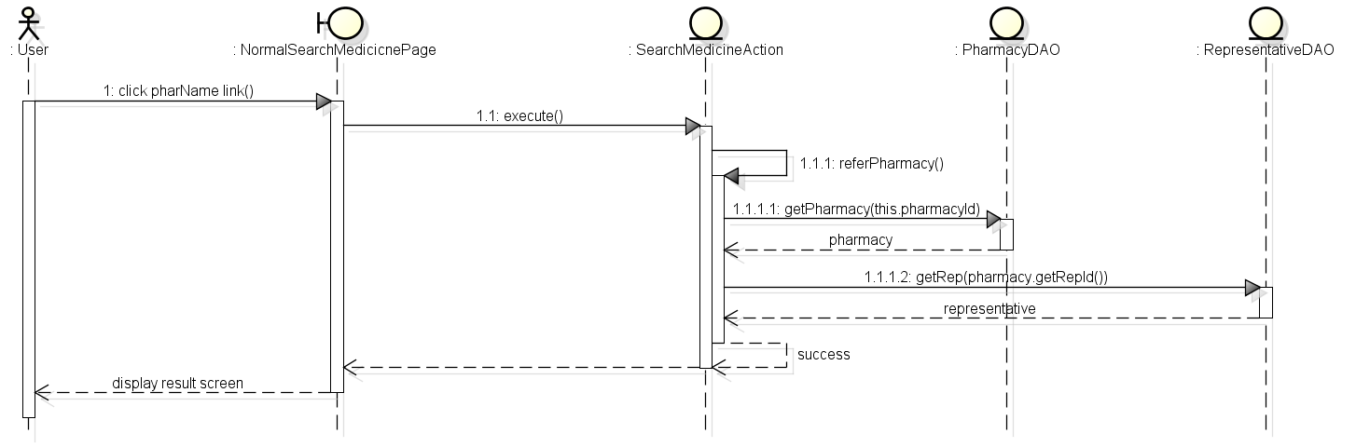

**Figure 4-94:** Sequence diagram- View detail pharmacy info

# Database Design

## Entity Relationship Diagram

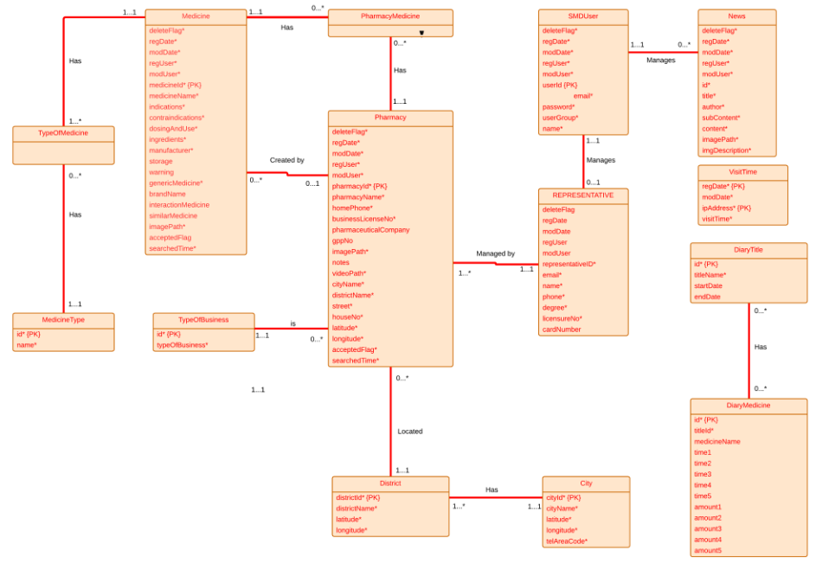

**Figure 4-95:** Entity relationship diagram

## Database Diagram

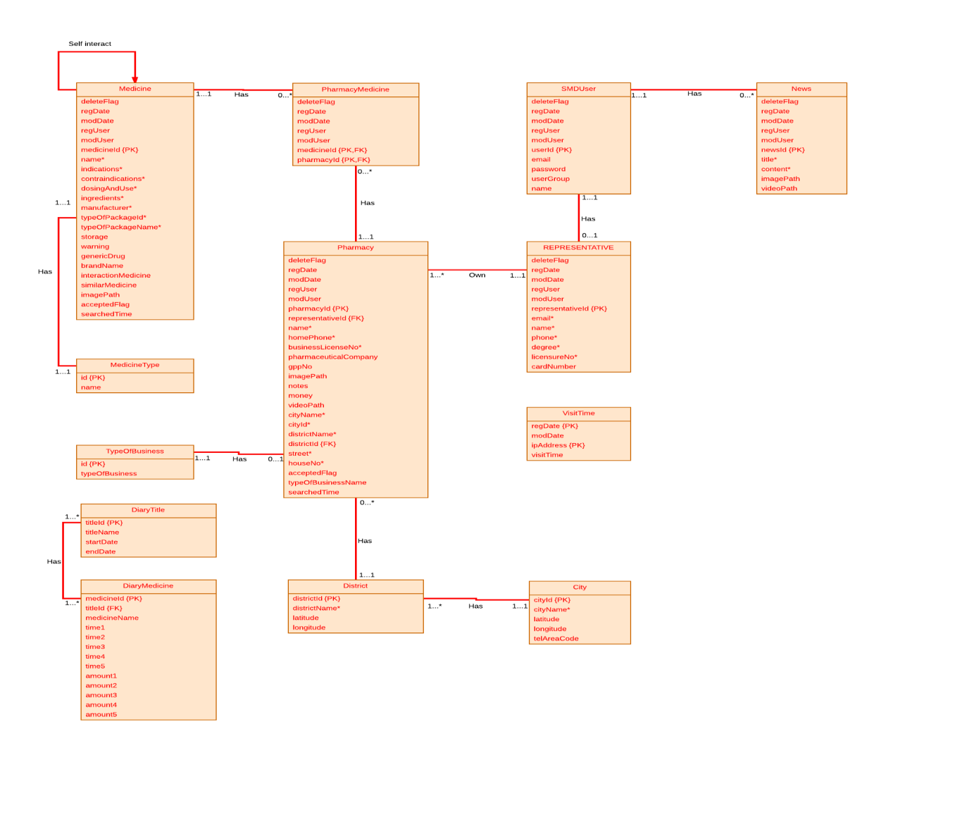**Figure 4-96:** Database diagram

## Table Descriptions

### Table Medicine

|  |  |  |  |  |
| --- | --- | --- | --- | --- |
| No. | Attribute | Type | Constraints | Description |
| 1 | MEDICINE_ID | INT(11) | Not null,  primary key | The primary key auto generated by the system |
| 2 | DELETE_FLAG | VARCHAR(1) | Not null | Marked deleted |
| 3 | REG_DATE | DATE | Not null | Date register medicine |
| 4 | MOD_DATE | DATE | Not null | Date modify medicine |
| 5 | REG_USER | VARCHAR  (150) | Not null | User register medicine |
| 6 | MOD_USER | VARCHAR  (150) | Not null | User modify medicine |
| 7 | PHARMACY_ID | INT(11) | Not null | Pharmacy register the medicine |
| 8 | MEDICINE_NAME | VARCHAR  (150) | Not null | Name of medicine |
| 9 | INDICATIONS | VARCHAR  (3000) | Not null | Indication of medicine |
| 10 | CONTRAINDICATIONS | VARCHAR  (3000) | Not null | Contraindications of medicine |
| 11 | DOSING_AND_USE | VARCHAR  (3000) | Not null | Dosing and use of  medicine |
| 12 | INGREDIENTS | VARCHAR  (3000) | Not null | Ingredients of medicine |
| 13 | MANUFACTURER | VARCHAR  (150) | Not null | Manufacturer of medicine |
| 14 | TYPE_OF_PACKAGE  _ID | INT(11) | Not null,  foreign key | Type of package id of medicine |
| 15 | TYPE_OF_PACKAGE  _NAME | VARCHAR  (150) | Not null | Type of package name of medicine |
| 16 | STORAGE | VARCHAR  (3000) |  | Storage medicine |
| 17 | WARNING | VARCHAR  (3000) |  | Warning of medicine |
| 18 | GENERIC_MEDICINE | VARCHAR  (150) | Not null | Name generic of medicine |
| 19 | BRANDNAME | VARCHAR  (150) |  | Brand name of medicine |
| 20 | INTERACTION_  MEDICINE | VARCHAR  (1500) |  | Interaction of medicine |
| 21 | SIMILAR_MEDICINE | VARCHAR  (1000) |  | Name of similar medicine |
| 22 | IMAGE_PATH | VARCHAR  (150) | Not null | Path to image of medicine |
| 23 | ACCEPTED_FLAG | VARCHAR(1) | Not null | Marked accepted |
| 24 | SEARCH_TIME | INT(11) | Not null | Time to search |

### Table Pharmacy

|  |  |  |  |  |
| --- | --- | --- | --- | --- |
| No. | Attribute | Type | Constraints | Description |
| 1 | PHARMACY_ID | INT(11) | Not null, primary key | The primary key auto generated by the system |
| 2 | DELETE_FLAG | VARCHAR(1) | Not null | Marked deleted |
| 3 | REG_DATE | DATE | Not null | Date register pharmacy |
| 4 | MOD_DATE | DATE | Not null | Date modify pharmacy |
| 5 | REG_USER | VARCHAR(150) | Not null | User register pharmacy |
| 6 | MOD_USER | VARCHAR(150) | Not null | User modify pharmacy |
| 7 | PHARMACY_NAME | VARCHAR(200) | Not null | Name of pharmacy |
| 8 | HOME_PHONE | VARCHAR(10) | Not null | Home phone number of pharmacy |
| 9 | BUSINESS_LICENSE_NO | VARCHAR(100) | Not null | Number business license of pharmacy |
| 10 | PHARMACEUTICAL_COMPANY | VARCHAR(200) |  | Name of pharmaceutical company |
| 11 | GPP_NO | VARCHAR(45) |  | Number of GPP |
| 12 | NOTES | VARCHAR(1000) |  | Notes about pharmacy |
| 13 | IMAGE_PATH | VARCHAR(150) |  | Path to image of pharmacy |
| 14 | VIDEO_PATH | VARCHAR(150) |  | Path to video of pharmacy |
| 15 | REPRESENTATIVE_ID | INT(11) | Not null, foreign key | ID of representative |
| 16 | CITY_NAME | VARCHAR(100) | Not null | City of pharmacy |
| 17 | DISTRICT_NAME | VARCHAR(100) | Not null | District of pharmacy |
| 18 | CITY_ID | INT(11) | Not null | ID of city |
| 19 | DISTRICT_ID | INT(11) | Not null | ID of district |
| 20 | STREET | VARCHAR(100) | Not null | Street of pharmacy |
| 21 | HOUSE_NO | VARCHAR(50) | Not null | Number house of pharmacy |
| 22 | LATITUDE | DOUBLE | Not null | Latitude of pharmacy |
| 23 | LONGTITUDE | DOUBLE | Not null | Longitude of pharmacy |
| 24 | ACCEPTED_FLAG | VARCHAR(1) | Not null | Marked accepted |
| 25 | SEARCHED_TIME | INT(11) | Not null | Time to search |
| 26 | TYPE_OF_BUSINESS | VARCHAR(45) | Not null | Name of type business |

### Table Pharmacy_Medicine

|  |  |  |  |  |
| --- | --- | --- | --- | --- |
| No. | Attribute | Type | Constraints | Description |
| 1 | PHARMACY_ID | INT(11) | Not null, primary key, foreign key | ID of pharmacy |
| 2 | MEDICINE_ID | INT(11) | Not null, primary key, foreign key | ID of medicine |
| 3 | DELETE_FLAG | VARCHAR(1) | Not null | Marked deleted |
| 4 | REG_DATE | DATE | Not null | Date register medicine |
| 5 | MOD_DATE | DATE | Not null | Date modify medicine |
| 6 | REG_USER | VARCHAR(150) | Not null | User register medicine |
| 7 | MOD_USER | VARCHAR(150) | Not null | User modify medicine |

### Table SMD_User

|  |  |  |  |  |
| --- | --- | --- | --- | --- |
| No. | Attribute | Type | Constraints | Description |
| 1 | USER_ID | INT(11) | Not null, primary key | The primary key auto generated by the system |
| 2 | DELETE_FLAG | VARCHAR(1) | Not null | Marked deleted |
| 3 | REG_DATE | DATE | Not null | Date register medicine |
| 4 | MOD_DATE | DATE | Not null | Date modify medicine |
| 5 | REG_USER | VARCHAR(150) | Not null | User register medicine |
| 6 | MOD_USER | VARCHAR(150) | Not null | User modify medicine |
| 7 | EMAIL | VARCHAR(100) | Not null | Email of User |
| 8 | PASSWORD | VARCHAR(100) | Not null | Password of User |
| 9 | NAME | VARCHAR(150) | Not null | Name of User |
| 10 | USER_GROUP | INT(11) | Not null | Group of User |

### Table Representative

|  |  |  |  |  |
| --- | --- | --- | --- | --- |
| No. | Attribute | Type | Constraints | Description |
| 1 | REPRESENTATIVE_ID | INT(11) | Not null, primary key | The primary key auto generated by the system |
| 2 | DELETE_FLAG | VARCHAR(1) | Not null | Marked deleted |
| 3 | REG_DATE | DATE | Not null | Date register medicine |
| 4 | MOD_DATE | DATE | Not null | Date modify medicine |
| 5 | REG_USER | VARCHAR(150) | Not null | User register medicine |
| 6 | MOD_USER | VARCHAR(150) | Not null | User modify medicine |
| 7 | EMAIL | VARCHAR(150) | Not null | Email of representative |
| 8 | NAME | VARCHAR(150) | Not null | Name of representative |
| 9 | PHONE | VARCHAR(11) | Not null | Phone of representative |
| 10 | DEGREE | VARCHAR(11) | Not null | Degree of representative |
| 11 | LICENSURE_NO | VARCHAR(100) | Not null | Licensure number of representative |
| 12 | CARD_NUMBER | VARCHAR(45) |  | Number card of representative |

### Table Medicine_Type

|  |  |  |  |  |
| --- | --- | --- | --- | --- |
| No. | Attribute | Type | Constraints | Description |
| 1 | PACKAGE_ID | INT(11) | Not null, primary key | Id of medicine type |
| 2 | PACKAGE_NAME | VARCHAR(150) | Not null | Name of medicine type |

### Table City

|  |  |  |  |  |
| --- | --- | --- | --- | --- |
| No. | Attribute | Type | Constraints | Description |
| 1 | CITY_ID | INT(11) | Not null, primary key | Id of City |
| 2 | DELETE_FLAG | VARCHAR(1) | Not null | Marked deleted |
| 3 | REG_DATE | DATE | Not null | Date register medicine |
| 4 | MOD_DATE | DATE | Not null | Date modify medicine |
| 5 | REG_USER | VARCHAR(150) | Not null | User register medicine |
| 6 | MOD_USER | VARCHAR(150) | Not null | User modify medicine |
| 7 | CITY_NAME | VARCHAR(50) | Not null | Name of city |
| 8 | LATITUDE | DOUBLE | Not null | Latitude of city |
| 9 | LONGITUDE | DOUBLE | Not null | Longitude of city |
| 10 | TEL_AREA_CODE | INT(11) | Not null | Tel area code of city |

### Table District

|  |  |  |  |  |
| --- | --- | --- | --- | --- |
| No. | Attribute | Type | Constraints | Description |
| 1 | DISTRICT_ID | INT(11) | Not null, primary key | Id of District |
| 2 | DELETE_FLAG | VARCHAR(1) | Not null | Marked deleted |
| 3 | REG_DATE | DATE | Not null | Date register medicine |
| 4 | MOD_DATE | DATE | Not null | Date modify medicine |
| 5 | REG_USER | VARCHAR(150) | Not null | User register medicine |
| 6 | MOD_USER | VARCHAR(150) | Not null | User modify medicine |
| 7 | DISTRICT_NAME | VARCHAR(100) | Not null | Name of District |
| 8 | CITY_ID | INT(11) | Not null, foreign key | Latitude of district |
| 9 | LATITUDE | DOUBLE | Not null | Longitude of district |
| 10 | LONGITUDE | DOUBLE | Not null | ID of City |

### Table News

|  |  |  |  |  |
| --- | --- | --- | --- | --- |
| No. | Attribute | Type | Constraints | Description |
| 1 | NEWS_ID | INT(11) | Not null, primary key | The primary key auto generated by the system |
| 2 | DELETE_FLAG | VARCHAR(1) | Not null | Marked deleted |
| 3 | REG_DATE | DATE | Not null | Date register medicine |
| 4 | MOD_DATE | DATE | Not null | Date modify medicine |
| 5 | REG_USER | VARCHAR(150) | Not null | User register medicine |
| 6 | MOD_USER | VARCHAR(150) | Not null | User modify medicine |
| 7 | TITLE | VARCHAR(200) | Not null | Title of News |
| 8 | CONTENT | VARCHAR(3000) | Not null | Content of News |
| 9 | IMAGE_PATH | VARCHAR(150) | Not null | Path to image of News |
| 10 | VIDEO_PATH | VARCHAR(150) | Not null | Path to video of News |

### Table Type_Of_Business

|  |  |  |  |  |
| --- | --- | --- | --- | --- |
| No. | Attribute | Type | Constraints | Description |
|  | NEWS_ID | INT(11) | Not null, primary key | ID of type |
|  | TYPE_OF_BUSINESS | VARCHAR(100) | Not null | Type of business |

### Table Visit_Time

|  |  |  |  |  |
| --- | --- | --- | --- | --- |
| No. | Attribute | Type | Constraints | Description |
|  | REG_DATE | DATETIME | Not null, primary key | Date register |
|  | MOD_DATE | DATETIME | Not null | Date modify |
|  | IP_ADDRESS | VARCHAR(15) | Not null, primary key | IP of address |
|  | VISIT_TIME | INT(11) | Not null | Time to visit |

### Table Diary_Title

|  |  |  |  |  |
| --- | --- | --- | --- | --- |
| No. | Attribute | Type | Constraints | Description |
|  | TITLE_ID | TEXT | Not null, primary key | Title’sid of Diary |
|  | TITLE_NAME | TEXT | Not null | Title’s name of Diary |
|  | START_DATE | TEXT | Not null | Date’s start of Diary |
|  | END_DATE | TEXT | Not null | Date’s end of Diary |

### Table Diary_Medicine

|  |  |  |  |  |
| --- | --- | --- | --- | --- |
| No. | Attribute | Type | Constraints | Description |
|  | MEDICINE_ID | TEXT | Not null, primary key | Medicine’s id of Diary |
|  | TITLE_ID | TEXT | Not null, foreign key | Title’s id of Diary |
|  | MEDICINE_NAME | TEXT | Not null | Medicine’s name of Diary |
|  | TIME1 | TEXT | Not null | Using time of medicine no.1 |
|  | TIME2 | TEXT | Not null | Using time of medicine no.2 |
|  | TIME3 | TEXT | Not null | Using time of medicine no.3 |
|  | TIME4 | TEXT | Not null | Using time of medicine no.4 |
|  | TIME5 | TEXT | Not null | Using time of medicine no.5 |
|  | AMOUNT1 | TEXT | Not null | Amount medicine for time no.1 |
|  | AMOUNT2 | TEXT | Not null | Amount medicine for time no.2 |
|  | AMOUNT3 | TEXT | Not null | Amount medicine for time no.3 |
|  | AMOUNT4 | TEXT | Not null | Amount medicine for time no.4 |
|  | AMOUNT5 | TEXT | Not null | Amount medicine for time no.5 |